

Domaine AF Gros Moulin à Vent « En Mortperay »

En 2017, le Domaine AF GROS a acquis une parcelle de 3,8 Ha sur l’appellation Moulin à Vent en Mortperay.
Les sols granitiques patinés des sols sont minces, avec des poches sableuses, enrichies en nutriments minéraux et d’un substrat granitique riche en filons de manganèse, de cuivre, de fer et oxydes métalliques.
L’orientation Sud / Sud-Est du vignoble optimise la maturation, tandis les vents forts et fréquents de la région favorisent la concentration des raisins.
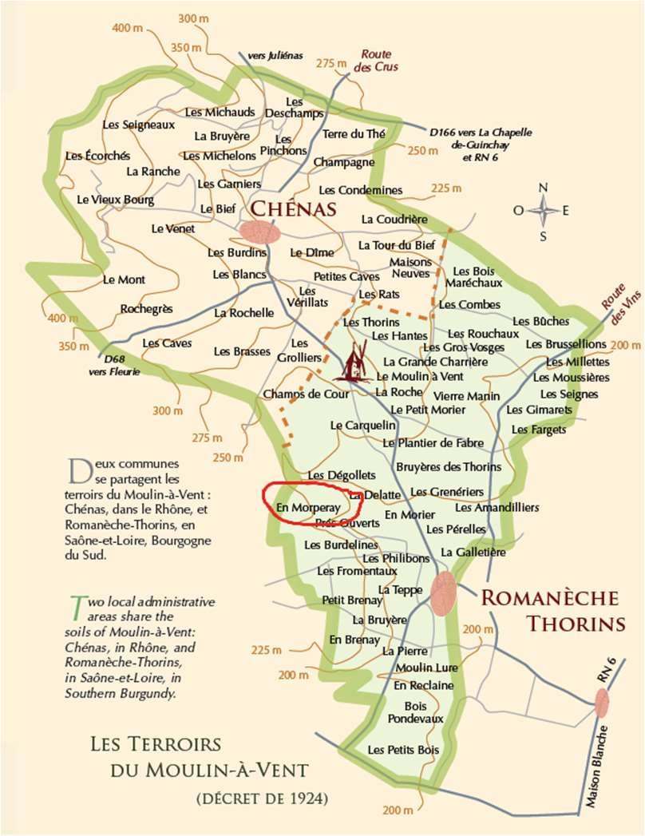
Viticulture: The culture of the vineyard is traditional, with careful Human Intervention, focused on observation and sustainability principles. Selective pruning to optimize yield and vigour, along with adapted leaf pulling, green harvest when needed, and ploughing of the soils.

Harvest and winemaking practices:

The harvest is 100% manual.

During an average year with no hail or freeze over: The clusters of grapes arrive at the winery in small cases, and in air-conditioned trucks. The grapes are first sorted on a vibrating table to eliminate any water, insects and leaves. Whole bunches are sorted manually, then distributed among 3 different tanks.

Between 2018 and 2021:

Tank n°1 (1/3 of the harvest): is completely closed for carbonic fermentation for 6 to 8 days. The fermentation is done ¾ of the
way, then the grapes are devatted and pressed (pneumatic pump for 1.15 hours at a maximum 17 pounds/square inch). The juice is placed in tanks to finalize the fermentation process and optimize oxygenation of the yeasts. This maneuver allows for a very fruity and aromatic wine.

Tanks n°2 and 3: are open tanks with whole bunches. The fermentation is started directly. Daily pumping over the must, daily crushing of the cap to liberate the sugar levels in the berries, and feed sugar to the yeasts. The vatting lasts about 15 days. The grapes are then devatted and pressed (pneumatic pump for 2 hours at a maximum 17 pounds/square inch). The wines are left to settle for 4 to 5 days before cask funneling.

They mature for 8 to 9 months, partially in a large wooden tank, called a “foudre”, of 5000 liters (about 50% of the crop), and the rest in three-four years old 228L barrels.

The wines are racked, then blended for 1 month in stainless steel tanks. They are filtered, if necessary, their SO2 and CO2 levels adjusted, and finally bottled by gravity. We pay attention to order our bottles with a bottleneck of 63 mm to avoid as much as possible leakage of the corks.

Since 2022: No more carbonic fermentation.

