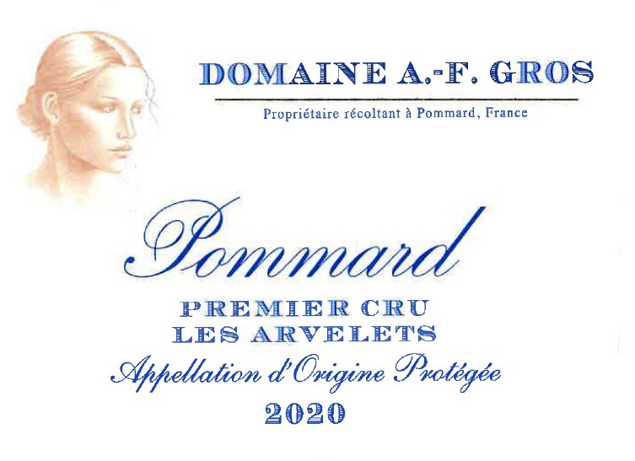
Domaine A.F Gros Pommard 1er Cru Les Arvelets

100% Pinot Noir
Our 0.31 ha vineyard is located in the Eastern part of the appellation, close to its geological fault. That area is known for its elegant and deep, rich wines.
Clay-limestone soils with good drainage at an average altitude of 300 meters.
Traditional vineyard management based on sustainability principles.
We engage in selective pruning, along with optimized leaf pulling, green harvest when needed, and ploughing of the soils.
The grapes, once cut, are brought back to the winery within 20 minutes to ensure freshness.
100% manual harvesting.

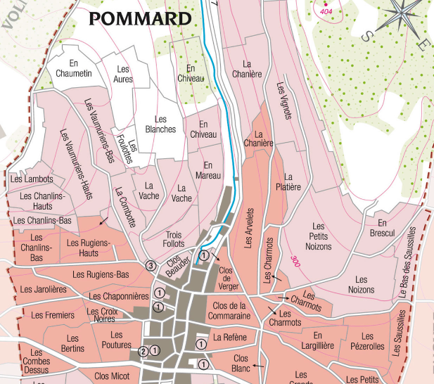
Winemaking
For the winemaking process, we use stainless steel tanks and oak barrels.
Cold maceration (5°C) is done for about 3-5 days to extract flavor and color. During that time, we do some remontage (pump over) to keep a good contact between solid and liquid parts. After 5 days, the tanks are heated up to 25-30°C for over 10 days.
The wood for the oak barrels comes primarily from forests of Chatillonais and Fontainebleau. This wine is aged for an average of 18 months (65% new barrels).

Tasting notes
Deep, dark red color. Aromas of blackberry and blackcurrants. Often, wild and feline notes develop with age. At full maturity, it tends towards leather, chocolate and pepper.
It needs to be given time to open up to its fullest extent and to display its mouth-filling texture, its firm but delicate structure.

