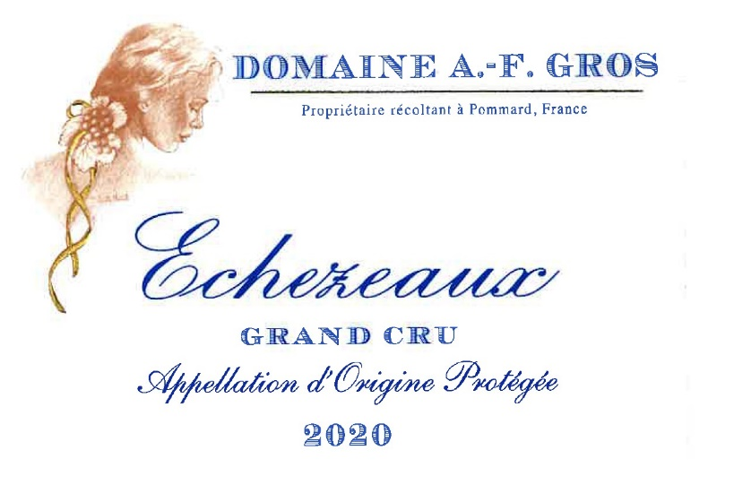
Domaine A.F Gros Echezeaux

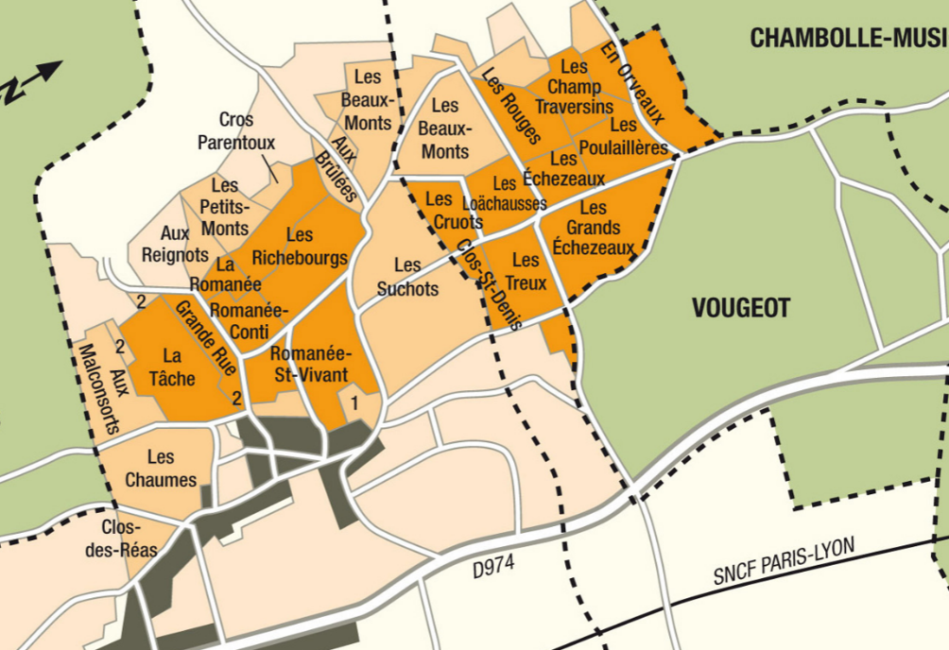
100% Pinot Noir
Our 0.26 ha vineyard is more than 100 years old and is located in the “Champs Traversins” section of the appellation.
Shallow soils, 13% steep incline, with gravel and limestone rocks that allow for aeration and deep root penetration.
Traditional vineyard management based on sustainability principles.
We engage in selective pruning, along with optimized leaf pulling, green harvest when needed, and ploughing of the soils.
The grapes, once cut, are brought back to the winery in less than 20 minutes.
100% manual harvesting. 30% of whole bunch.

Winemaking
For the winemaking process, we use stainless steel tanks and oak barrels.
Cold maceration (5°C) is done for about 3-5 days to extract flavor and color. During that time, we do some remontage (pump over) to keep a good contact between solid and liquid parts. After 5 days, the tanks are heated up to 25-30°C for over 10 days.
The wood for the oak barrels comes primarily from forests of Châtillonais and Fontainebleau. This wine is aged for an average of 18 months (100% new oak).

Tasting notes

Deep ruby color, shading towards the darker tones of magenta and purple. Its bouquet is redolent of animal, spice notes, underbrush, and prune, evolving with age towards musk, leather, fur and mushroom. When young, its aromas suggest rose, violet and fresh cherry. The dense texture and tight grain of these wines fully open after 6 to10 years in the cellar.

