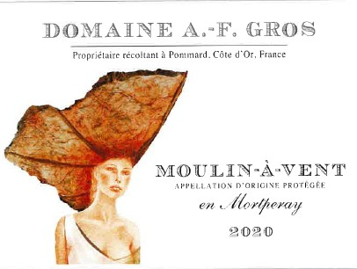
Domaine A.F Gros Moulin à Vent (en Mortperay)

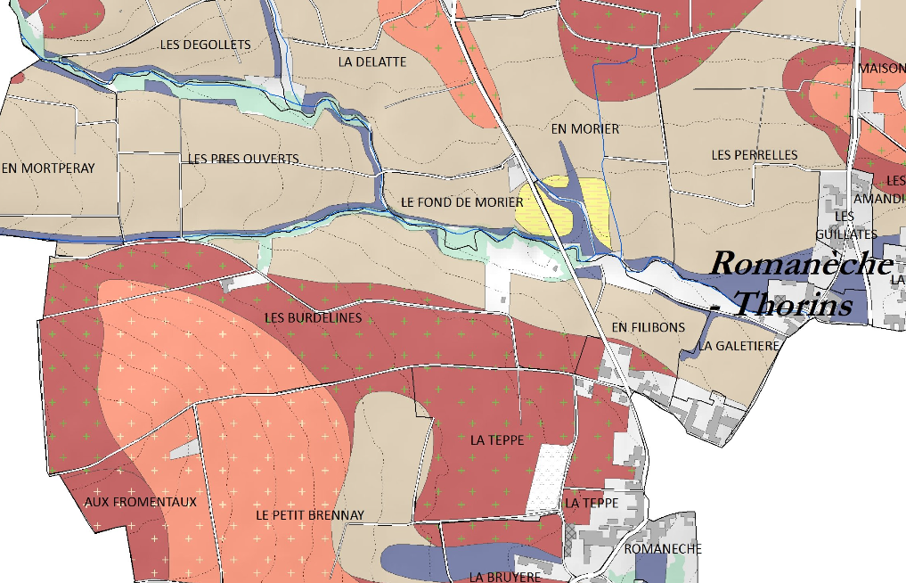
Tasting notes
The highest rated of all the Beaujolais Crus, our Moulin-à-Vent is ruby to dark garnet in color with floral and fruity aromas. Full-bodied and complex, it has hints of iris, spice and ripe fruit.
When young, dominance of violet and cherry flavors. After a few years, the bouquet develops aromas of iris, spice and ripe fruit. Later, undergrowth and truffle aromas begin to come through, followed by musk and game. Long term cellaring can be famously rewarding.

Winemaking
For the winemaking process, we use stainless steel tanks and oak barrels.
Cold maceration (5°C) is done for about 3-5 days to extract flavor and color. During that time, we do some remontage (pump over) to keep a good contact between solid and liquid parts. After 5 days, the tanks are heated up to 25-30°C for over 10 days.
The wood for the oak barrels comes primarily from forests of Chatillonais and Fontainebleau. This wine is aged for an average of 8 months (2 to 3year old barrels).

100% Gamay
Our 3.80 ha vineyard is located in the Mortperay section of the appellation.
Soils coming from the degradation of the granite bedrock, with pockets of sand that are full of minerals like iron, manganese, copper and more.
Traditional vineyard management based on sustainability principles.
We engage in selective pruning, along with optimized leaf pulling, green harvest when needed, and ploughing of the soils.
The grapes, once cut, are brought back to the winery very rapidly in temperature-controlled trucks.
100% manual harvesting.

