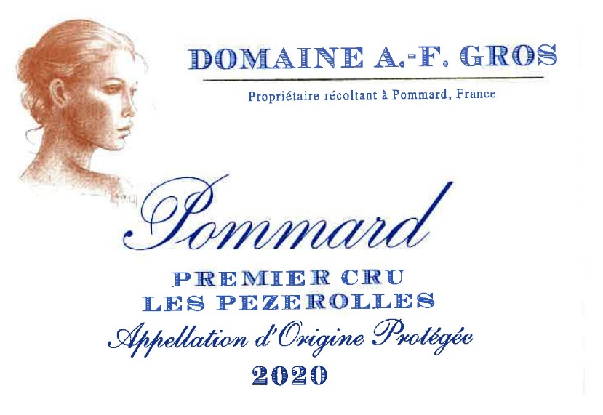
Domaine A.F Gros Pommard 1er Cru Les Pezerolles

100% Pinot Noir
Our vineyard is located in the Eastern part of the appellation, close to its geological fault. The name comes from the old French "Poizerolles", which meant "chickpeas”, likely cultivated next to the vines in the Middle Ages. Clay-limestone soils with good drainage at an average altitude of 300 meters.
Traditional vineyard management based on sustainability principles.
We engage in selective pruning, along with optimized leaf pulling, green harvest when needed, and ploughing of the soils.
The grapes, once cut, are brought back to the winery within 20 minutes to ensure freshness.
100% manual harvesting.

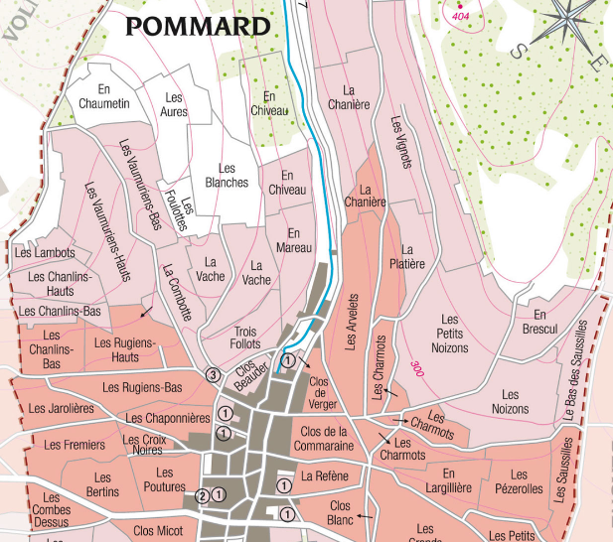
Winemaking
For the winemaking process, we use stainless steel tanks and oak barrels.
Cold maceration (5°C) is done for about 3-5 days to extract flavor and color. During that time, we do some remontage (pump over) to keep a good contact between solid and liquid parts. After 5 days, the tanks are heated up to 25-30°C for over 10 days.
The wood for the oak barrels comes primarily from forests of Chatillonais and Fontainebleau. This wine is aged for an average of 18 months (65% new barrels).

Tasting notes
Its color is the deep, dark red with mauve highlights which caused Victor Hugo to speak of it as “night in combat with day”. Its aromas are redolent of blackberry, bilberry, or gooseberry, cherry pit and ripe plum. At full maturity, after 5 to 10 years of cellaring, it tends towards leather, chocolate and pepper. In exceptional years, the wine can age and improve much longer.

