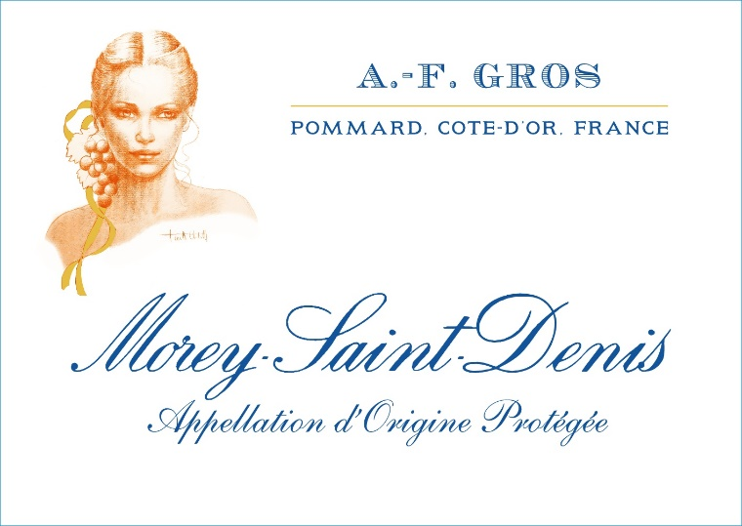
AF Morey Saint Denis

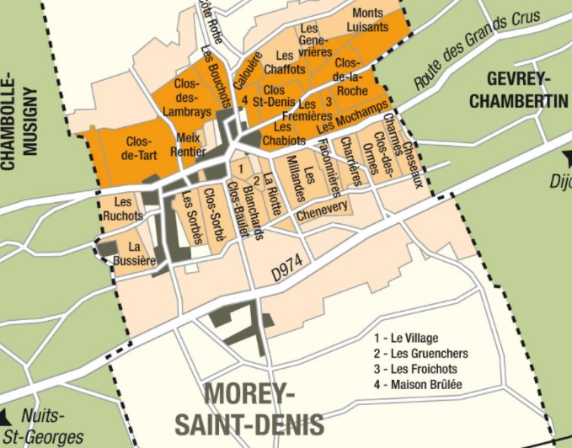
Winemaking
For the winemaking process, we use stainless steel tanks and oak barrels.
Cold maceration (5°C) is done for about 3-5 days to extract flavor and color. During that time, we do some remontage (pump over) to keep a good contact between solid and liquid parts. After 5 days, the tanks are heated up to 25-30°C for over 10 days.
The wood for the oak barrels comes primarily from forests of Châtillonais and Fontainebleau. This wine is aged for an average of 18 months (65% new barrels).

Tasting notes
Intense red garnet color. Bouquet of blackcurrant and cherries. With age, scents of game, leather, and moss, even truffle. Rich structure, rounded tannins and mouth-filling texture, it is a very elegant wine.
100% Pinot Noir
Limestone and clay-limestone soils dating back to the Middle Jurassic era. White Bathonian Oolite up-slope and fossiliferous Barocline limestone at the foot.
The vineyards are east-facing at altitudes of 220-270m. Below the village the slopes are differently oriented and the soil marlier.

Organic vineyard management :
No man-made chemicals customarily used. Selective pruning, along with optimized leaf pulling, green harvest when needed, and weed tilling.
The grapes, once cut, are brought back to the winery within 20’ in temperature-
100% manual harvesting.

