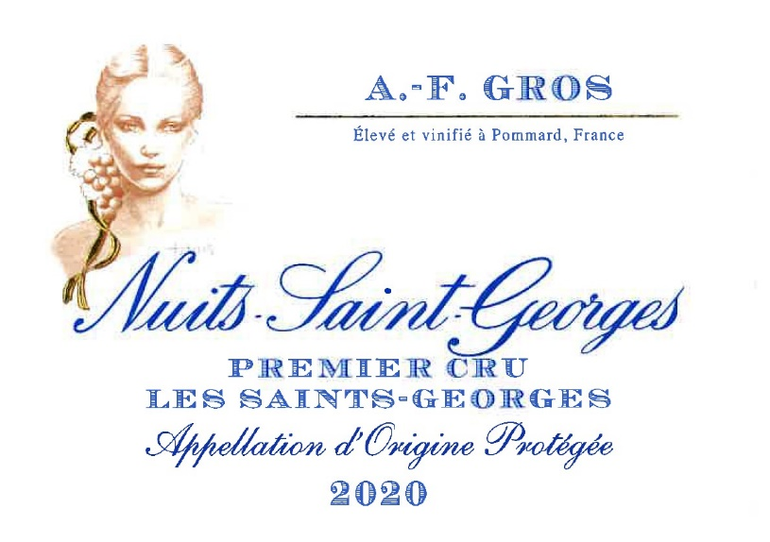
AF Nuits Saint Georges 1er Cru les Saints Georges

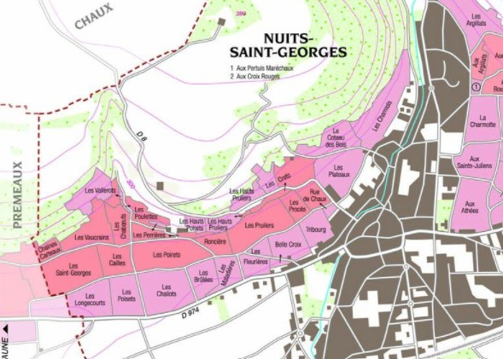
Environmental credo Organic
Viticulture adapted to the local terroir conditions. Bee protection protocols. No Carcinogenic, Mutagenic, Reprotoxic products (CMR) used in the winemaking process. Indigenous yeasts. Premium natural corks coated with beeswax instead of silicon.
Winemaking
For the winemaking process, we use stainless steel tanks and oak barrels.
Cold maceration (5°C) is done for about 3-5 days to extract flavor and color. During that time, we do some “remontage” (pump over) to keep a good contact between solid and liquid parts. After 5 days, the tanks are heated up to 25-30°C for over 10 days.
The wood for the oak barrels comes primarily from forests of Châtillonais and Fontainebleau. This wine is aged for an average of 18 months (65% new barrels).

Tasting notes
Intense crimson red color. Nose of cherry, strawberry, and blackcurrant, and eventually leather, truffle, fur, game. Muscular and vigorous, chewy, and full-bodied, its structure is both powerful and well balanced, long aftertaste. Wines built to age !
100% Pinot Noir

The soils derive from pebbly alluvium washed down from up-slope, or, in the low-lying parts, silty deposits from the river Meuzin.

Organic vineyard management

No man-made chemicals customarily used. Selective pruning, along with optimized leaf pulling, green harvest when needed, and weed tilling. The grapes, once cut, are brought back to the winery within 20’ in temperature-controlled trucks.
100% manuel harvesting.

