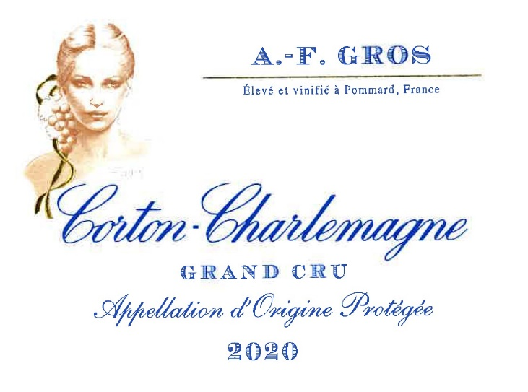
AF GROS Corton Charlemagne Grand Cru

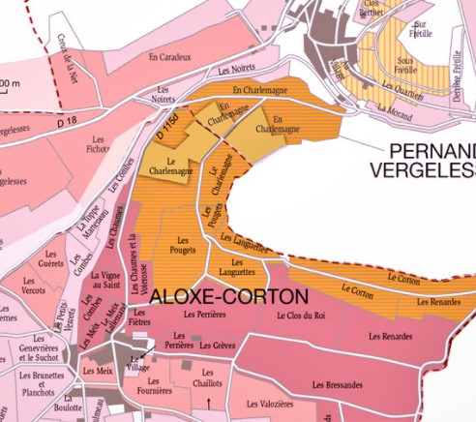

100% Chardonnay

The appellation occupies the highest portion of the Hill of Corton where the gradients are steep (20-23%). The hill itself offers an exemplary geological section through the younger (145 million years) Jurassic strata. The color of the clayrich marly soils varies from yellow from through ochre to brown. Limestone alternates with marls beneath a thin cover of rendzinas.

Organic management
No man-made chemicals customarily used. Selective pruning, along with optimized leaf pulling, green harvest when needed, and weed tilling.
The grapes, once cut, are brought back to the winery within 20’ in temperature-controlled trucks.
100% manual harvesting.
Winemaking

Grapes are rigorously sorted, then slowly pressed for 90 minutes. Racking from the steel tanks where they stay for 48 hours, then to the wood barrels, where the main fermentation immediately starts, followed by malolactic fermentation at a temperature between 18 & 20° C.
Thereafter the barrels stay in the aging cellar for a year. Usually, fining, no filtration.

Bottling in December. 100% new oak.

Tasting notes
Pale gold color with green highlights, shifting with age towards amber.
Bouquet of baked apple, citrus, pineapple, lime, bracken, juniper, cinnamon, and flint.
Honeyed notes are frequently present. Older vintages (25-30 years) reveal leather and truffle.
Outstanding !

Environmental credo
Organic viticulture adapted to the local terroir conditions. Bee protection protocols. No Carcinogenic, Mutagenic, Reprotoxic products (CMR) used in the winemaking process. Indigenous yeasts. Premium natural corks coated with beeswax instead of silicon.

