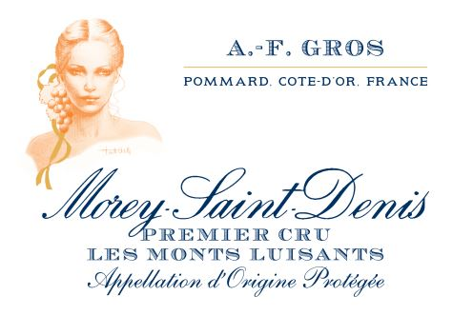
MOREY ST DENIS 1ER CRU LES MONTS LUISANTS 2019

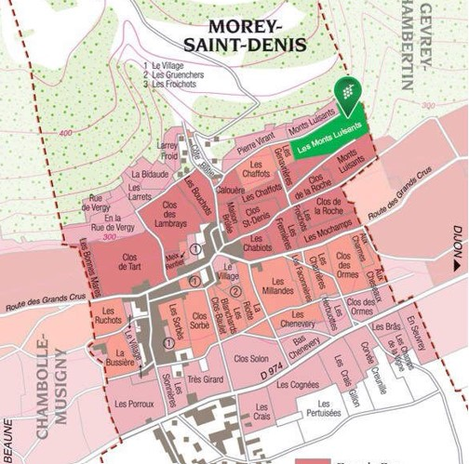
Winemaking
For the winemaking process, we use stainless steel tanks and oak barrels.
Cold maceration (5°C) is done for about 3-5 days to extract flavor and color. During that time, we do some remontage (pump over) to keep a good contact between solid and liquid parts. After 5 days, the tanks are heated up to 25-30°C for over 10 days. No pipeage at all for vintage 2019.
The wood for the oak barrels comes primarily from forests of Châtillonais and Fontainebleau. This wine is aged for an average of 18 months (40% new oak).
Morey Saint Denis 1er cru les Monts Luisants has a distinctive character from other wines from Morey St Denis which are usually deeper and richer. It is a very mineral, fine and elegant wine.

100% Pinot Noir

Purchase of grapes on a 0.3171Ha vineyard. Located just upon the grand cru Clos de la Roche on the side of Gevrey.
Very chalky slopy (30%) soil, with clay and limestone mid slope.

Traditional vineyard management based on sustainability principles.

The grapes, once cut, are brought back to the winery in less than 20 minutes.

100% manual harvesting.

Tasting notes
Morey Saint Denis has a distinctive character from the other wines of its village.
Generally deeper and richer, it is a mineral and elegant wine.
With aromas of small red stone fruits (cherry type), black fruits and sustained tannins, it offers the right balance between the strength of the body and the expression of the fruit.
If it were a voice in a Burgundian choir, it would be a tenor !
Over time, its tannins round out and it will marry perfectly on a table, roast meats, game or even a nice rib steak !

