
AF VOSNE ROMANEE 1ER CRU LES SUCHOTS

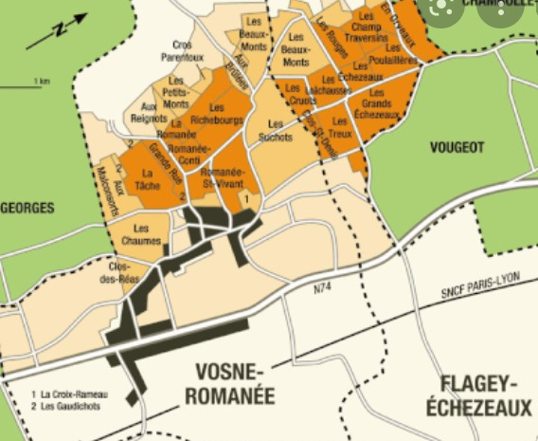
Tasting notes
The aromas of very ripe fruit, strawberry, raspberry, blueberry and blackcurrant, on a spicy background, will allow this Vosne Romanée 1er Cru les Suchots to express itself on intense flavor such as roast poultry, gamy birds. Epoisses and Citeaux will also be two cheeses that will reveal the full potential of this voluptuous wine !

Winemaking
For the winemaking process, we use stainless steel tanks and oak barrels.
Cold maceration (5°C) is done for about 3-5 days to extract flavor and color. During that time, we do some remontage (pump over) to keep a good contact between solid and liquid parts. After 5 days, the tanks are heated up to 25-30°C for over 10 days.
The wood for the oak barrels comes primarily from forests of Châtillonais and Fontainebleau. This wine is aged for an average of 18 months (65% new oak).

100% Pinot Noir

Plot closed to Romanée Saint Vivant and Richebourg.

Soils composed of marl and limestones.

Traditional vineyard management based on sustainability principles.
We engage in selective pruning, along with optimized leaf pulling, green harvest when needed, and ploughing of the soils.
The grapes, once cut, are brought back to the winery within 20 minutes to ensure optimal freshness.
100% manual harvesting.

