12 x 750 ML
Red Table Wine
BOURGOGNE PINOT NOIR
2014
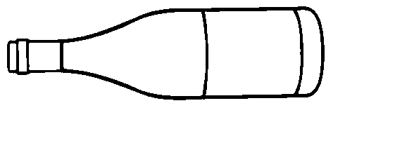

GALILEO WINE SPIRIT
c/o A.G.L.C., ST ALBERT
+ 704327

P.O. # G 1810

12 x 750 ML
Red Table Wine
BOURGOGNE PINOT NOIR
2014

GALILEO WINE SPIRIT
c/o A.G.L.C., ST ALBERT
+ 704327

P.O. # G 1810

