

Meet Impassioned Wine Growers Who Wish To Export!
The APVSA is happy to invite you to meet with a group of wine growers who are currently seeking representation in North America. Come and taste a variety of wines, which are rewarded and renowned, priced very competitively and easy to sell.
For more than 10 years, APVSA has been committed to organizing tastings to connect wine growers and agents with each other. Having started with a team of 10 members, we today count more than 300 wine growers as having joined us and who now export to North America.
Take this fabulous opportunity to meet our member wine growers to potentially form long term partnerships. You are welcome to browse the members list on our website to learn more about their terrific products ahead of time.
Tastings Tour of April: Montreal 18th, Toronto 19th, Chicago 20th, Washington 21st, Miami 22nd, Houston 25th, and New-York 26th.

Sofitel Washington Lafayette
806 15th Street NWWashington, DC 20005, USA
Thursday, April 21st: from 11 am to 6 pm

Please confirm your attendance by returning the slip by e-mail: info@apvsa.ca or by fax at 514 284-0090.

Company:
Name:
Phone:
Fax:
Web Site:

You will find a wide selection of wines and spirits for you to sample:
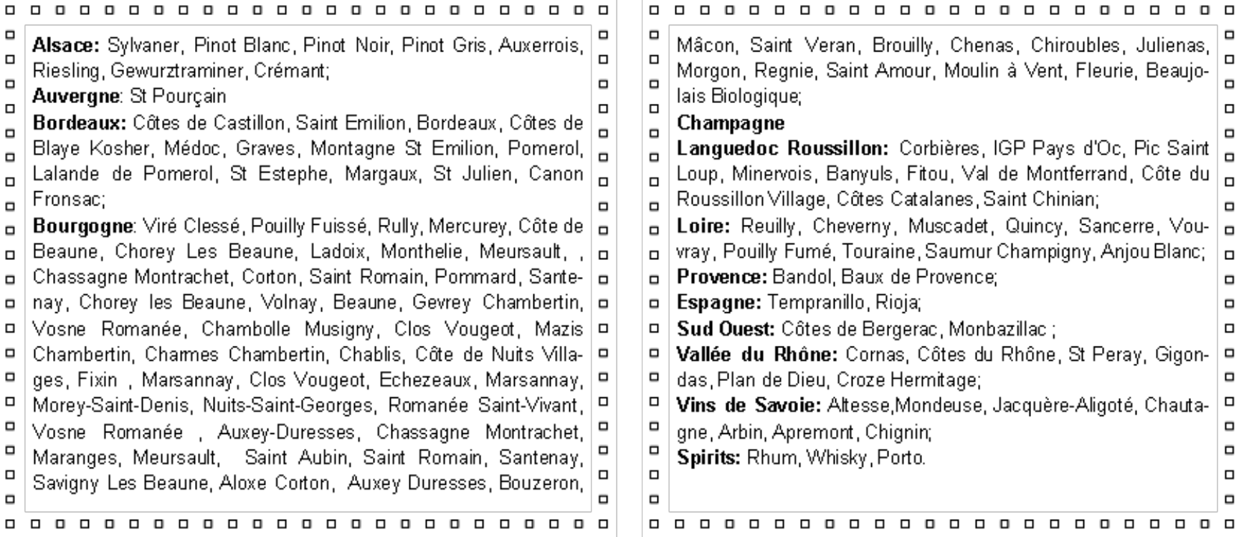

Thanks for visiting!
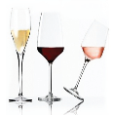

Marie Sophie LONDAIS, chargée du développement des vins.
A.P.V.S.A
416, rue McGill, #100,
Montréal, Qc, H2Y 2G1, CANADA
Ph. (001) 514-844-9993 Poste 221 / Fax. (001) 514-284-0090
E-mail : mariesophie.londais.apvsa@gmail.com / Site web : www.apvsa.ca

