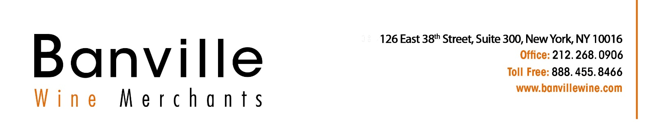

Becoming a Banville Supplier
2022

- BWM Import Appointment Letter
- New Vendor Form

We require a letter allowing us to represent you in the USA. Please fill in the red spaces in the sample letters following and put it on your company letterhead paper.

SARL CAROLINE PARENT ET ASSOCIES
10 B rue des Naigeons
21200 Beaune France

June 3.2023

Mrs. Lia Tolaini Banville
Owner
Banville Wine Merchants
126 East 38th Street
New York, NY 10016

Dear Mrs. Lia Tolaini Banville:

Please be advised that effective June 8, 2023, SARL CAROLINE PARENT ET ASSOCIES, hereby appoints Banville Wine Merchants [126 East 38th St, New York, NY 10016] (NYSLA License#1243182) as its Importer and/or Distributor for the Caroline Parent wines in the following states;

New York
New Jersey
Maryland
DC
Virginia (North counties)

SARL CAROLINE PARENT ET ASSOCIES will propose to Banville Wine Merchants a yearly allocation of Bourgognes. It must be considered as a parcel of wines to take as a whole and cannot be changed but can be reduced proportionally for all the wines that make it up.
Outside of the yearly allocation, specific wines may be proposed to and ordered by Banville Wine Merchants.
All Caroline Parent wines sold to Banville can only be proposed for sale and/or sold in the states listed above. Any exception will cause the end of the appointment and of the yearly allocation.
All purchases have to be confirmed with a formal PO, picked up within two quarters following the confirmed order. All POs are subject to final confirmation by SARL CAROLINE PARENT ET ASSOCIES. Terms are 60 days date of shipment ex-cellars if Banville Wine Merchants gets approved by our Export Insurance Company. If that company declines coverage, the order must be prepaid before its preparation in our cellars.

This appointment is valid for one year and renewable by tacit reconduction on a yearly basis unless Banville Wine Merchants or SARL CAROLINE PARENT ET ASSOCIES terminates it with a 120-day notice,

Sincerely,

Caroline Parent, CEO


new vendor FORM
invoices should be emailed to Accounting@bANVILLEWINE.com

vendor information
winery/ vendor name |  |  |  |  |  |  |  |  | sarl caroline parent et associes
ADDRESS |  |  |  | 10 b rue des naigeons
City |  |  |  |  |  |  |  |  |  |  |  | beaune |  |  |  |  |  |  |  |  | State |  |  |  | france |  |  |  | ZIP |  | 21200
Phone | +33380226185 |  |  |  |  |  |  |  |  |  |  |  | Fax |  |  |  |  |  |  |  | E-mail |  |  |  | cparentgros@gmail.com
payment terms |  |  |  |  |  |  | net 60 days date of shipment ex-cellars |  |  |  |  |  |  |  |  |  |  |  |  |  | currency for billing |  |  |  |  |  | euro
Pre-payment discount (if applicable) |  |  |  |  |  |  |  |  |  | n/a
shipping information
country of origin |  |  |  |  |  |  |  | france
inventory address
warehouse name (if different from winery) |  |  |  |  |  |  |  |  |  |  |  |  |  |  |  |  |  |  |  | domaine af gros
ADDRESS |  |  |  | 10 rue pierre joigneaux
City |  |  |  |  |  |  |  |  |  |  |  | beaune 21200 |  |  |  |  |  |  |  |  |  |  | country |  |  |  |  | france
USFDA Registration number |  |  |  |  |  |  |  |  |  |  |  | 13103653998 |  |  |  |  |  |  |  |  |  |  | ttb nUMBER (cbma) |  |  |  |  | ttb-fp-pntcode
contact name for billing |  |  |  |  |  |  |  |  |  |  | caroline parent
Phone |  | +33380226185 |  |  |  |  |  |  |  |  |  |  |  | Fax |  |  |  |  |  |  |  | E-mail |  |  |  | CPARENTGROS@GMAIL.COM
contact name for purchase orders |  |  |  |  |  |  |  |  |  |  |  |  |  |  | caroline parent
Phone |  | +33380226185 |  |  |  |  |  |  |  |  |  |  |  | Fax |  |  |  |  |  |  |  | E-mail |  |  |  | CPARENTGROS@GMAIL.COM
sample billback policy (please attach a printed copy, if available)
market visits/pre-approved events |  |  |  |  |  |  |  |  |  |  |  |  |  |  |  | on a pre-approved basis |  |  |  |  |  |  |  | salesman samples |  |  |  |  |  | 0 |  | % billback allowed
sample discount off the invoice |  |  |  |  |  |  |  |  |  |  |  |  |  |  |  | 0
bank wire information (for imported wineries only)
bank name |  |  |  |  |  | credit agricole champagne bourgogne
ADDRESS |  |  |  | beaune centre
City |  |  |  |  |  |  |  |  |  |  |  | beaune |  |  |  |  |  |  |  |  | State |  |  |  | france |  |  |  | ZIP |  | 21200
swift # |  |  | agrifrpp810
for credit to (bank account name) |  |  |  |  |  |  |  |  |  |  |  |  |  |  |  |  | sarl caroline parent et associes
IBAN # |  |  |  |  | fr76 1100 6210 0452 1067 7907 439
ADDRESS |  |  |  | 10 b rue des naigeons
City |  |  |  |  |  |  |  |  |  |  |  | beaune |  |  |  |  |  |  |  |  | State |  |  |  | france |  |  |  | ZIP |  | 21200

