Domaine A-F GROS
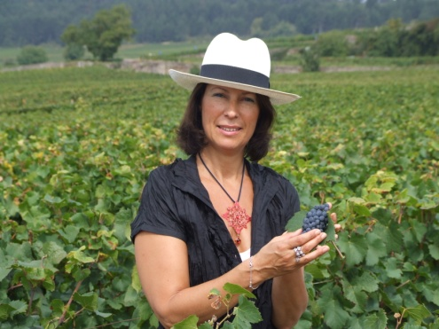
Anne-Françoise PARENT-GROS
Domaine AF GROS is one of the top estates of Burgundy. Anne Françoise is the daughter of Jean GROS. The estate was created in 1988, when her father decided to retire, and his domain was divided among Anne-Françoise (Domaine A.-F GROS), and her 2 brothers Michel (Domaine Michel GROS) and Bernard (Domaine GROS frère & soeur).
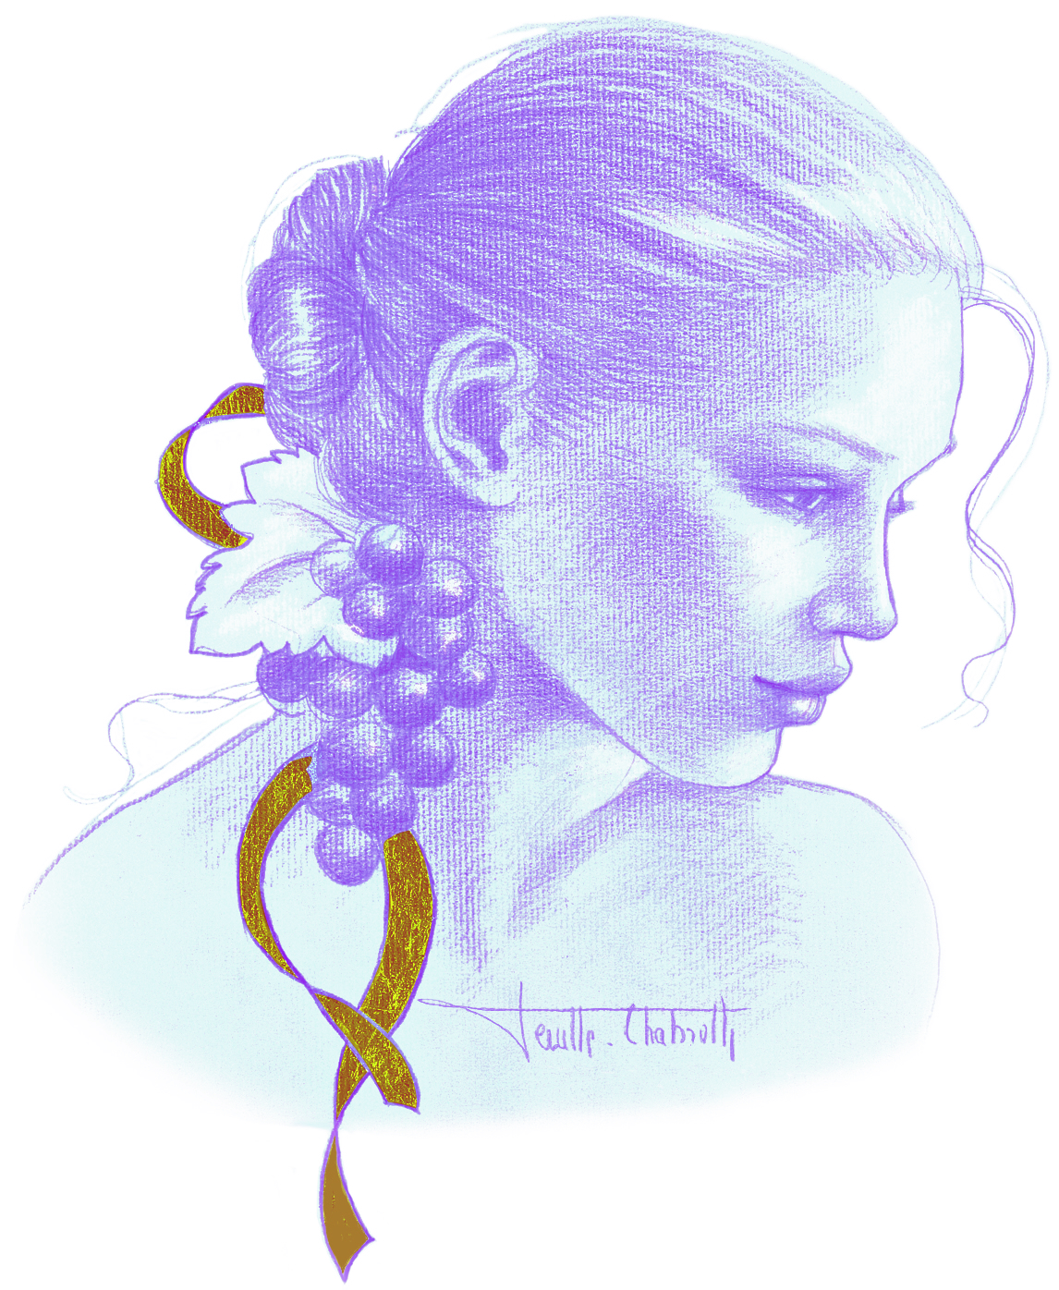
François PARENT, Anne –Francoise’s husband, is the winemaker. He is known today all over the world for his highly extracted wines, their optimal expression of the pinot noir, and their unique combination of elegance and depth. Today, 2 of their 3 children work with them on the estate, Caroline and Mathias. The estate covers 10 hectares, planted mainly in Pinot Noir, both in Cote de Beaune and in Cote de Nuits, and 4 hectares recently bought in Moulin a Vent (Beaujolais).
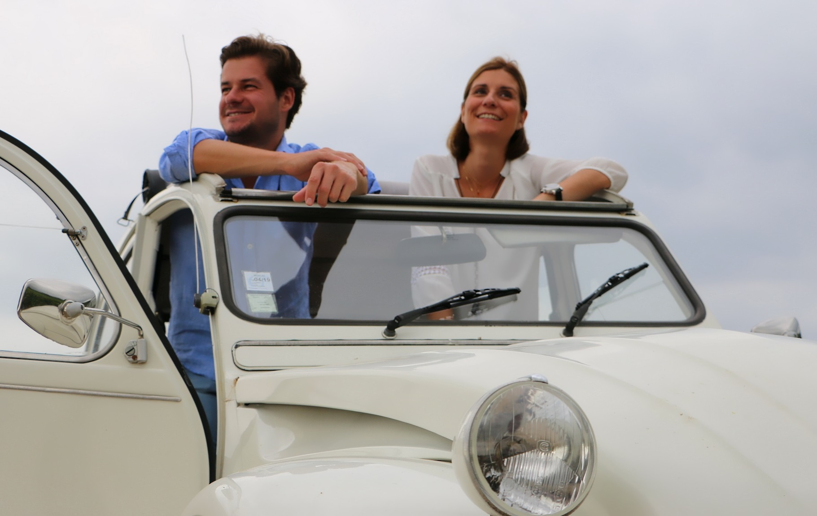
Mathias & Caroline
The culture of the soils: The culture of the vineyard is traditional, with careful Human Intervention, focused on observation and sustainability principles. François and Mathias pay a special attention to viticulture, with selective pruning to optimize yield and vigour, along with adapted leaf pulling, green harvest when needed, and ploughing of the soils.
We use no pesticides and no insecticides, and we use sexual confusion.
Harvest and winemaking practices:
The harvest is 100% manual.
The grapes are brought back to the winery in small cases to avoid any tamping down, in less than 20 minutes after they are cut.
Comprehensive sorting in 4 steps:
- In the vineyard,
- With a dynamic sorting table at the arrival in the winery,
- Manual sorting by 6 persons. The clusters are 100% de stemmed.
- Final sorting out is done after de stemming.
For the vinification, we use cimant tanks and some wood tanks. Cold maceration for about 4-5 days to extract flavours and colour.
After 5 days, the alcoholic fermentation starts. After a gentle pressing with a pneumatic press and are barrelled.
Malo-lactic fermentation is done in barrels.
Elevage: The wines are aged between 12 to 18 months in French oak barrel. The oaks come mainly from forest of Troncey in Allier, forests of Bertranges and Fontainebleau.
Generics are aged in 5000 Liters tank (60%) and in oak barrels from 2-3 wines (40%).
Elevage is done during an average of 12 months for village wines (50% new oak), 15 months for the 1er crus (65% new oak) and 18 months for the Grands Crus (100% new oak).

The wines are racked and placed in tanks for the last 3 months of elevage so that the fine lees can settle down.
We check the turbidity of the wines but we don’t filter the wines anymore since vintage 2014. No fining neither.

The wines are bottled by gravity.

