Caroline & Mathias PARENT-GROS
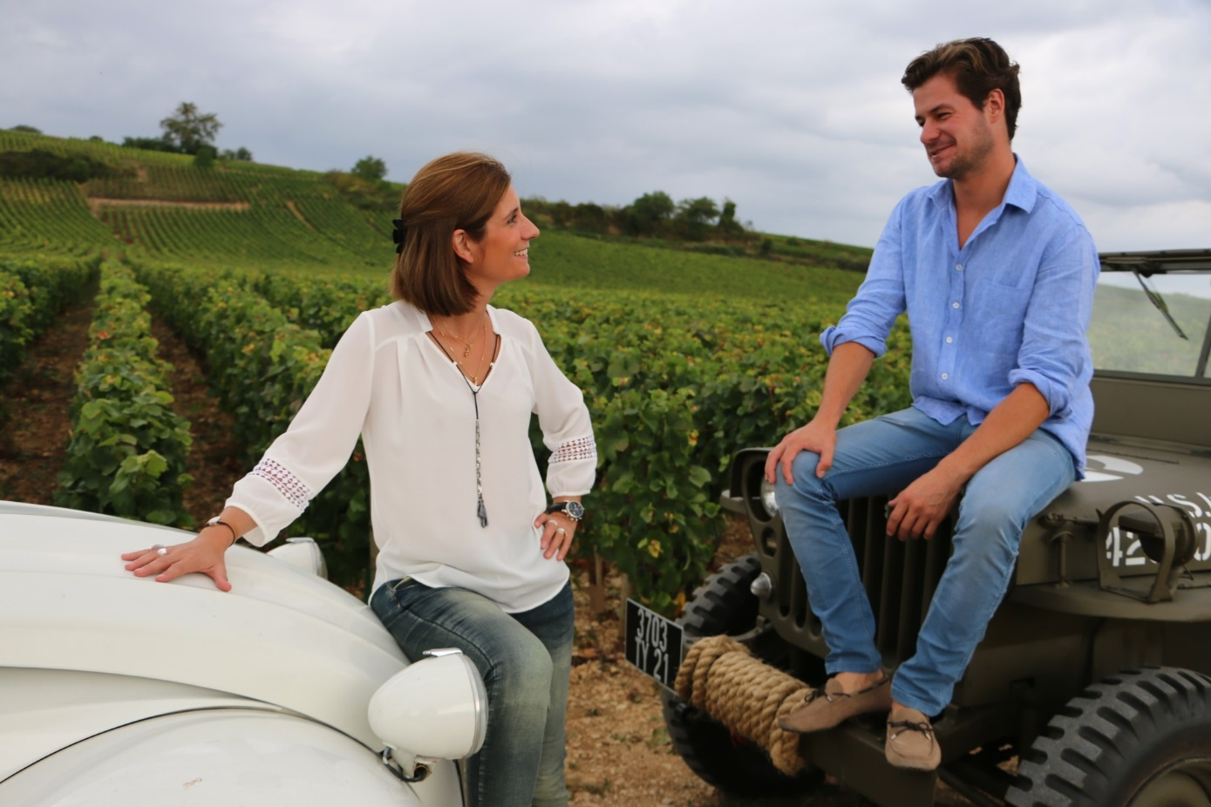
Mathias PARENT
Born in Burgundy 28 years ago, Mathias has stemmed and risen as a part of a lineage of tradition with superlative vineyard and winemaking skills. After several training periods in Australia and Oregon, he joined his father François PARENT at the winemaking of Domaine AF GROS in 201. His first vintage “in solo” was 2013.

Caroline PARENT
Born in Burgundy 41 years ago, in a family of producers from generations, Caroline studied in a Business School in Champagne, before going 2 years in Canada. This international experience followed by a banking experience, helped her when she started to work at the export department of Domaine AF GROS (her mother), and François PARENT (her father).
By regularly participating at some wine tours all over the world, and organizing some wine dinners, she learned about the marketing of wines.
In 2013, she joined the familial company to take over the commercial and administrative management of Domaine AF GROS and Maison PARENT-GROS.

