Caroline Parent’s Burgundy Collection
Coalescing tradition and classicism with precision viticulture and winemaking techniques; handmade, precise and wholesome wines.
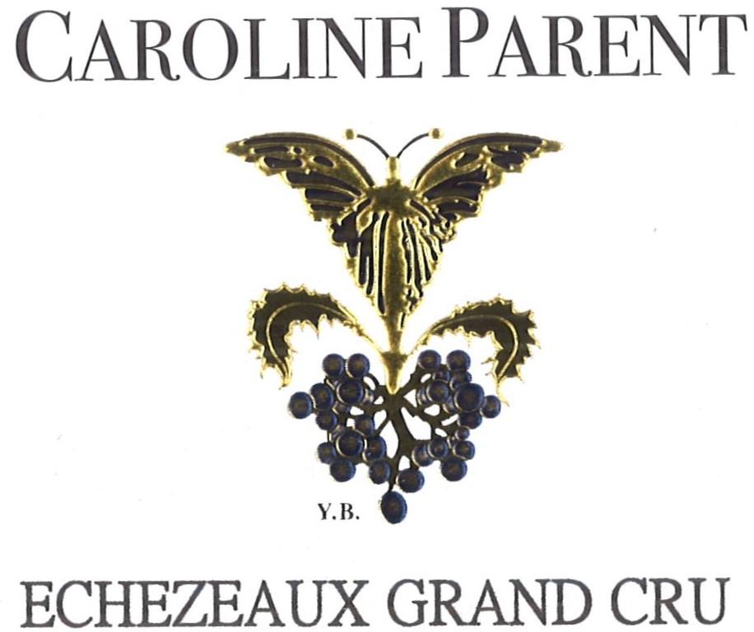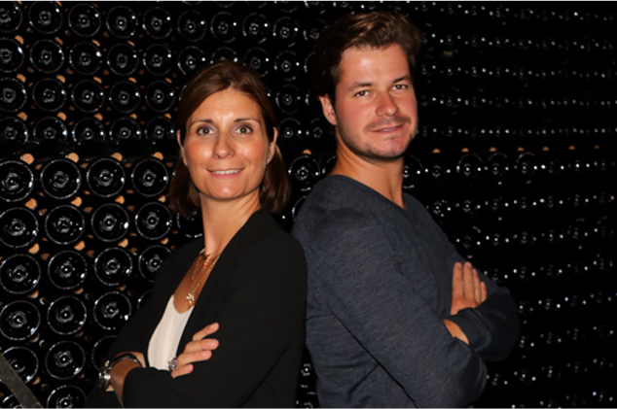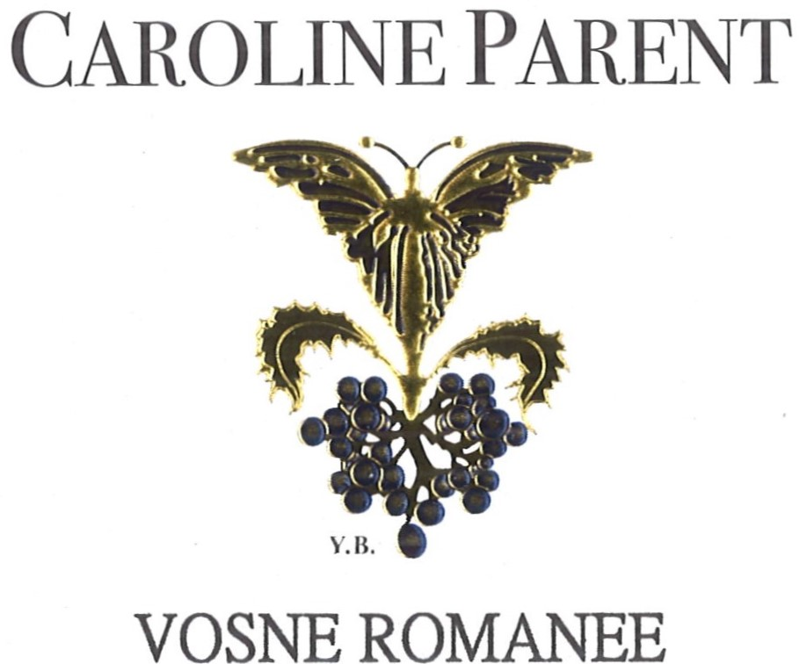
Caroline et Mathias PARENT

Mathias Parent, Caroline's brother, is the winemaker, like for Domaine A-F.Gros. The wines come from the Parent-Gros family vineyards and LT grape purchases for the reds and most of the whites.

Current list of appellations (non exhaustive)
Bourgogne Blanc
Bourgogne Blanc
Saint Romain
Meursault
Beaune 1er Cru Montrevenots
Corton Charlemagne
Bourgogne Rouge
Moulin a Vent
Bourgogne Hautes Cotes de Nuits
Pommard 1er Cru "Pezerolles"
Beaune 1er Cru "Boucherottes"
Chambolle Musigny 1er cru
Vosne Romanée
Echezeaux
Clos Vougeot

Our environmental credo
The culture of the vineyard is traditional, with careful human intervention, based on observation and sustainability principles. Mathias pays special attention to viticulture, with selective pruning to optimize yield and vigour, along with drastic crown suckering, adapted leaf pulling, green harvest when needed, and ploughing of the soils.
We use no pesticides and no insecticides, and we use sexual confusion.
No CMR (carcinogenic, mutagenic, or toxic for reproduction elements) used in the vineyard.
The harvest is 100% manual.
The grapes are brought back to the winery in small cases to avoid any tamping down, in less than 20 minutes after they are cut.
Since 2018, we have no more silicon in our cork, but they are bathed in bee wax. They are individually tested by a person to check their quality, to propose the best closure to our customers.

Vinification of Red Whites from Cote d’Or
Comprehensive sorting in 4 steps:
- In the vineyard,
- With a dynamic sorting table at the arrival in the winery,
- Manual sorting by 6 persons. The clusters are 100% de stemmed.
- Final sorting out is done after de stemming.
The new generation of de-stemmer that we use preserves the skin of the clusters (berries) so that the sugars will spread slowly and regularly to avoid any stop in the fermentation.
For the vinification, we use cement tanks and some wood tanks.
Cold maceration for 4-5 days to extract flavours and colour. We do then some remontage (pump over) to keep a good contact between solid and liquid parts, and a homogeneous 5°C .
After 5 days, the alcoholic fermentation starts. Tanks are heated up to 25-30°C for 10 days+.
“Pigeage” (punch-down), depending on the level and structure of the wine (appellation).
For each tank, we do a total of 2 to 4 “pigeages,” usually at the end of the fermentation. We complete with 2-3 daily pumping over, during all the fermentation, and 1 daily “delestage”.
After gentle pressing with a pneumatic press (1.15 hours at a maximum 17 pounds/square inch), wines are decanted during 4-5 days at 12°C, then barrelled.
Malo-lactic fermentation is done in barrels. As the wines are kept at low temperature, this fermentation starts slowly and lasts about 45 days. We follow the evolution of its completion barrel by barrel to be as accurate as possible with the SO2, which protects from Brettanomyces and from an increase of the volatile acidity. It is added by dose of 7cl, once per month, for 3 months. If necessary, after close analysis, we adjust the CO2 levels.
Elevage: The wines are aged between 12 to 18 months in French oak barrel, mainly from forests of Chatillonais and Fontainebleau. We ask our 2 main coopers for a low and long toast.
Our generic wines age in one or two-year-old barrels for 12 months.
Maturing lasts 14 months for the Village appellations (an average of 50% new barrels), 15 to 18 months for the 1er crus (65% in new barrels) and the Grands Crus (100% in new barrels).
The wines are then racked and blended for 3 months. SO2 and CO2 levels are monitored, looking for a CO2 level of 650 mg/Liter to preserve the freshness and stability of our wines.
We check the turbidity of the wines, but we don’t filter or fine. The wines are bottled by gravity.

Vinification of White Wines from Cote d’Or
The grapes are sorted manually then gently pressed, cooled at 12°C (53.6 Fahrenheit), and left to settle naturally for 24 hours. They are put in barrels where first occurs the alcohol fermentation, then the malolactic fermentation. No stirring of the lees. The CO2 and SO2 levels are adjusted after the malolactic fermentation. Maturing is done for 12 months with an average of 50% new barrels. Racking and fining ensue. Adjustment in CO2 and SO2. The wines are then bottled using gravity.
For the Moulin à Vent
The bunches are first sorted on a vibrating table to eliminate any water, insects and leaves. Whole bunches are sorted manually, then distributed among 3 different tanks.
Tank n°1 (1/3 of the harvest): carbonic fermentation for 6 to 8 days. The fermentation is done ¾ of the way, then the grapes are devatted and gently pressed. The juice is placed in tanks to end the fermentation and optimize oxygenation of the yeasts. Aiming at very fruity and aromatic wine.
Tanks n°2 and 3: are open tanks with whole bunches. The fermentation is started directly. Daily pumping over of the must, crushing of the cap to liberate the sugar levels in the berries, and feed sugar to the yeasts. The vatting lasts about 15 days. The grapes are then gently pressed and left to settle for 4 to 5 days before cask funneling. They mature for 8- 9 months, half in 5000-liter wooden tanks, “foudre”, and the rest in three-four years old regular barrels. Racking and blending ensue, filtering, if necessary, their SO2 and CO2 levels adjusted, and finally bottled.

