Domaine A-F GROS
Maison PARENT-GROS
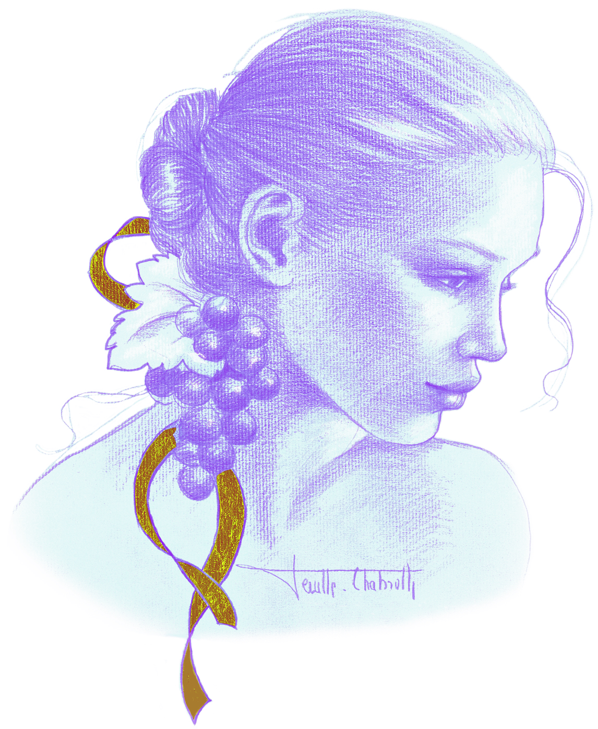
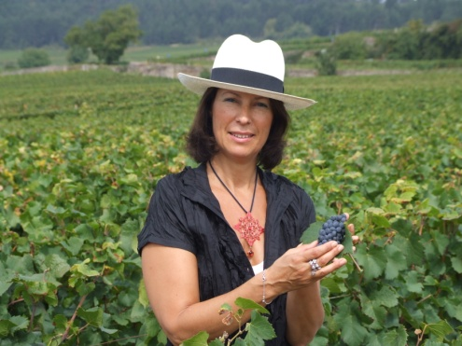
Anne-Françoise PARENT-GROS
Domaine AF GROS is one of the top estates of Burgundy. Anne Françoise is the daughter of Jean GROS. The estate was created in 1988, when her father decided to retire, and his domain was divided among Anne-Françoise (Domaine A.-F GROS), and her 2 brothers Michel (Domaine Michel GROS) and Bernard (Domaine GROS frère & soeur).
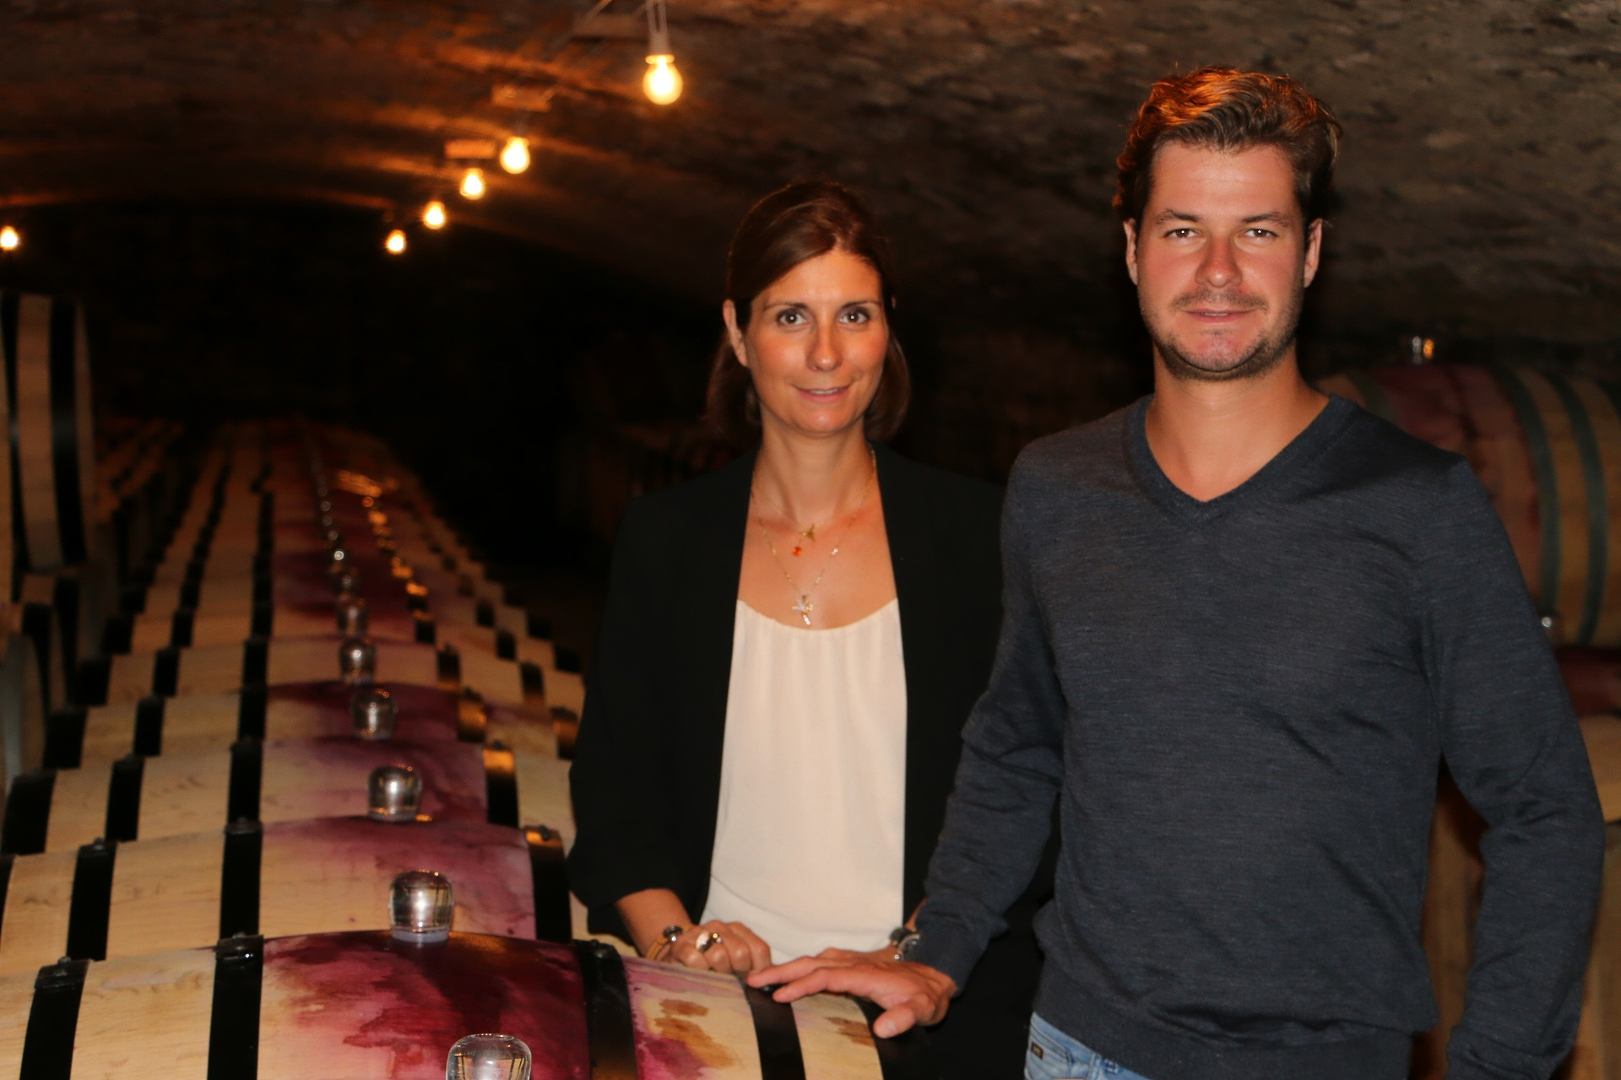
Caroline et Mathias PARENT

François PARENT, Anne –Francoise’s husband, was the winemaker. He is known today all over the world for his highly extracted wines, their optimal expression of the pinot noir, and their unique combination of elegance and depth. Today, 2 of their 3 children work with them on the estate, Caroline and Mathias. Mathias is in charge of the technical part (culture and winemaking) and Caroline in charge of the commercial and administrative part. The estate covers 15 hectares, planted mainly in Pinot Noir, both in Cote de Beaune and in Cote de Nuits, and 4 hectares recently bought in Moulin a Vent (Beaujolais).
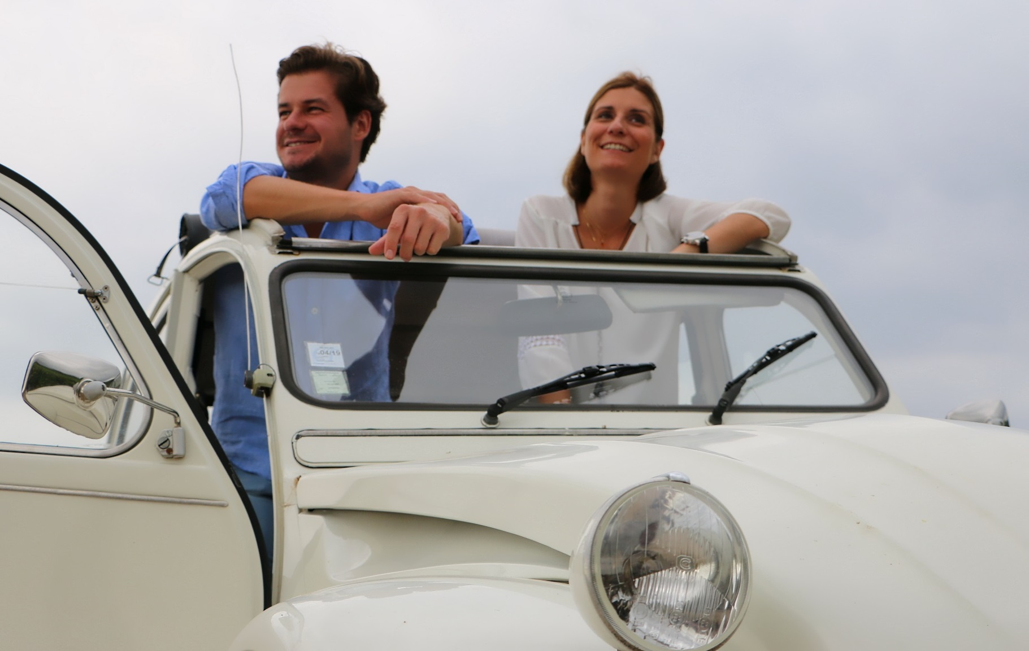
Mathias & Caroline
The culture of the soils: The culture of the vineyard is traditional, with careful Human Intervention, focused on observation and sustainability principles. François and Mathias pay a special attention to viticulture, with selective pruning to optimize yield and vigour, along with drastic crown suckering, adapted leaf pulling, green harvest when needed, and ploughing of the soils.
We use no pesticides and no insecticides, and we use sexual confusion.
From 2018, no CMR (carcinogenic, mutagenic, or toxic for reproduction) used in the vineyard.
Vinification of Red Whites from Cote d’Or
Harvest and winemaking practices:
The harvest is 100% manual.
The grapes are brought back to the winery in small cases to avoid any tamping down, in less than 20 minutes after they are cut.
Comprehensive sorting in 3 steps:
- In the vineyard,
- With a dynamic sorting table at the arrival in the winery,
- Manual sorting by 6 persons. The clusters are 100% de stemmed for generics. We have between 30% and 75% of whole bunch for the rest of the appellations.
The new generation of de-stemmer that we use preserves the skin of the clusters (berries) so that the sugars will spread slowly and regularly in order to avoid any stop in the fermentation.
For the vinification, we use cimant tanks, inox tanks and some wood tanks.
Fermentation starts 24h after the vatting and lasts 10 to 12 days.
From vintage 2020, no more pigeage (punch-down), but only a light “foulage” at the end of the fermentation to spread the sugar contained in the berries of the whole bunches.
During the fermentation, 2-3 daily pumping over, and 1 daily “delestage”.
After a gentle pressing with a pneumatic press (1.15 hours at a maximum 17 pounds/square inch), wines are decanted during 4-5 days at 12°C, and are barrelled.
Malo-lactic fermentation is done in barrels. As the wines are kept at low temperature, this fermentation starts slowly and late (usually in the spring) and lasts about 45 days. We follow the evolution of its completion barrel by barrel to be as accurate as possible with the SO2.
SO2 protects from Brettanomyces and from an increase of the volatile acidity. It is added by dose of 7cl, once per month, during 3 months. If necessary, after close analysis, we adjust the CO2 levels.
Elevage: The wines are aged between 12 to 18 months in French oak barrel. The oaks come mainly from forests of Chatillonais and Fontainebleau. We work with 3 main coopers and ask them for low and long toast.
Maturing lasts 15 to 18 months - 30% in new barrels .
The wines are then racked and aggregated. Their SO2 and CO2 levels are analyzed and adjusted accordingly. The CO2 level (650 mg/Liter) is necessary to preserve the freshness and stability of our wines.
We check the turbidity of the wines but we don’t filter the wines anymore since vintage 2014. No fining neither.

The wines are bottled by gravity.

From vintage 2023 : Elevage 50% in ceramic and 50% in a mix of new barrel and barrel of ½ years
From vintage 2025: Elevage in 70% ceramic + 30% new barrel (no more barrel of ½ years)

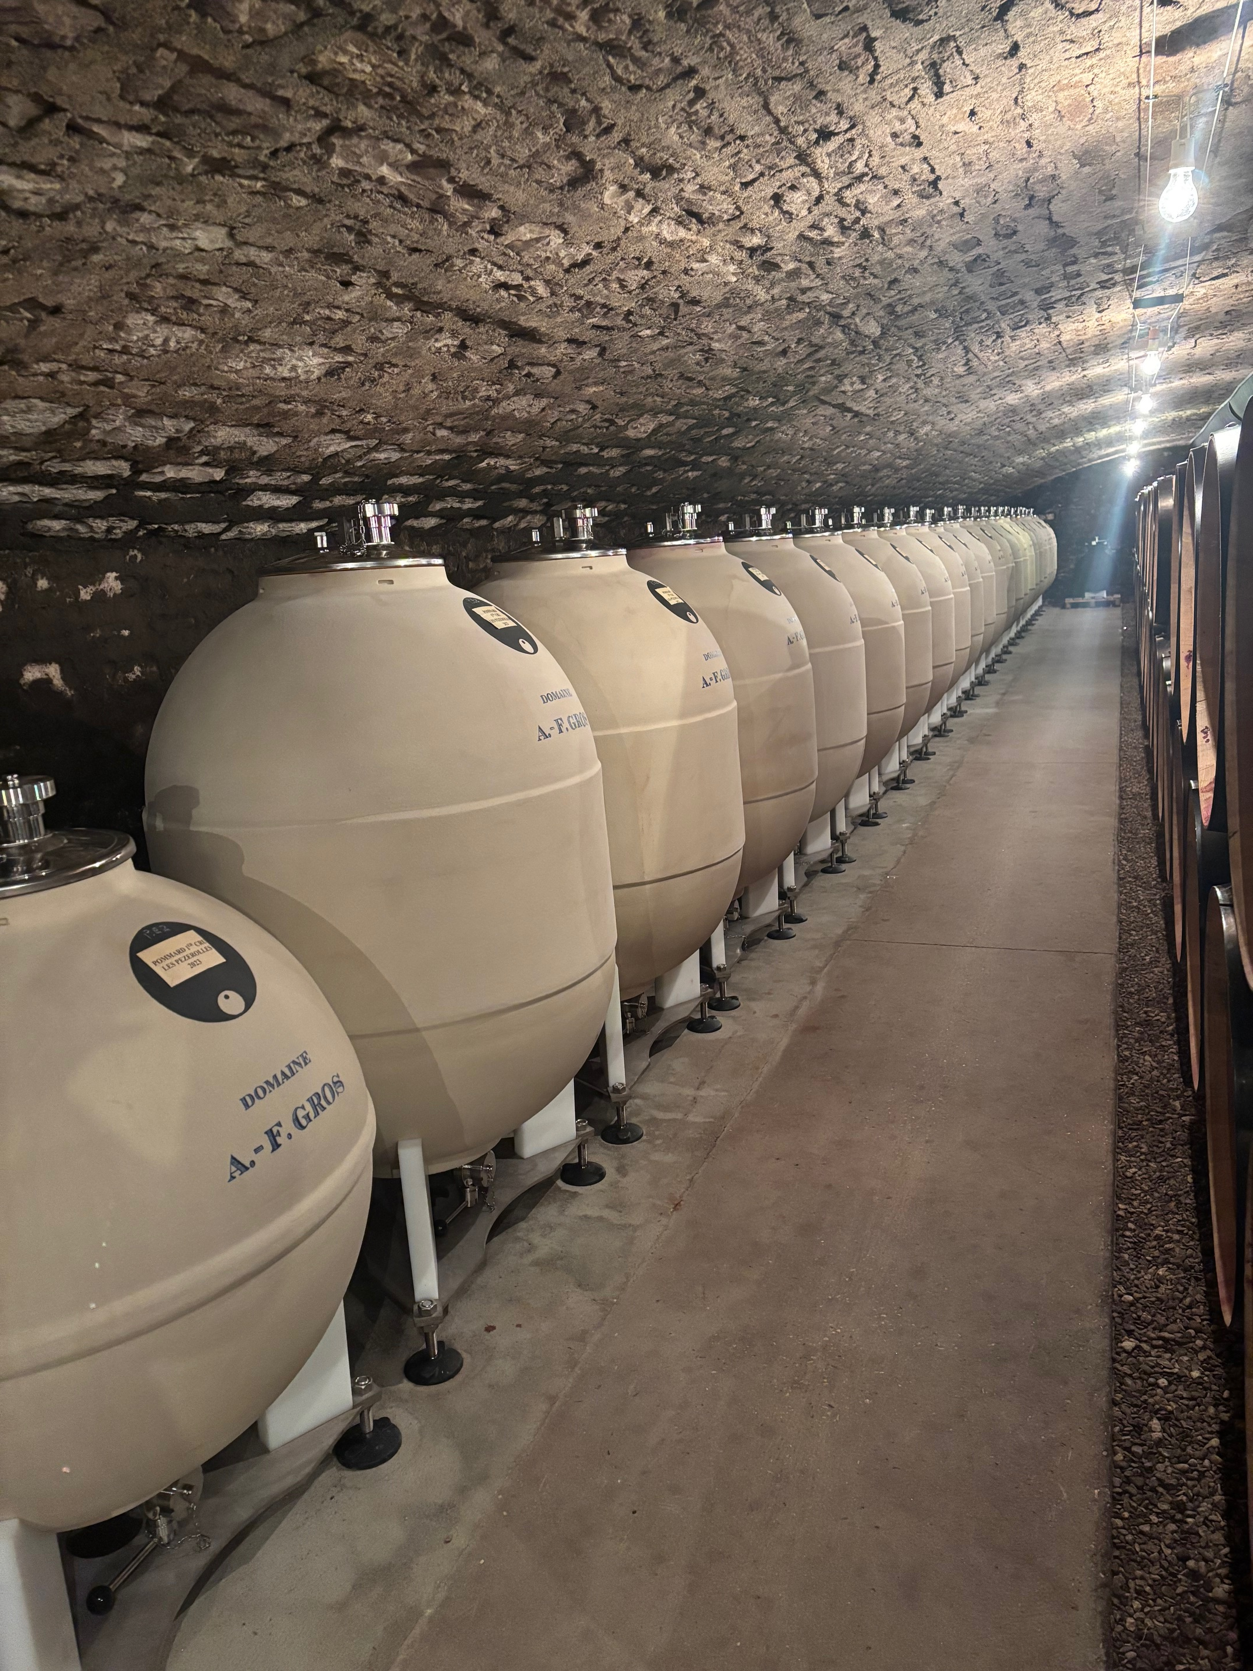

Vinification of White Wines from Cote d’Or

100% Manual harvesting
The clusters of grapes arrive at the winery in small cases, and in air-conditioned trucks. The grapes are first sorted on a vibrating table to eliminate any water, insects and leaves. They are sorted manually then pressed (pneumatic pressurizer at 25 lbs./square inch for 2 hours), cooled at 12°C (53.6 Fahrenheit), and left to settle naturally for 24 hours. They are put in barrels where first occurs the alcohol fermentation, then the malolactic fermentation. No stirring of the lees. The CO2 and SO2 levels are adjusted after the malolactic fermentation.
Maturing is done for 12 months with an average of 30% new barrels. Racking and fining ensue. Adjustment in CO2 and SO2. The wines are then bottled using gravity.

For the Moulin à Vent
During an average year with no hail or freeze over.
100% Manual harvesting
The clusters of grapes arrive at the winery in small cases, and in air-conditioned trucks. The grapes are first sorted on a vibrating table to eliminate any water, insects and leaves. Whole bunches are sorted manually, then distributed among 3 different tanks.
Tank n°1 (1/3 of the harvest): is completely closed for carbonic fermentation for 6 to 8 days. The fermentation is done ¾ of the way, then the grapes are devatted and pressed (pneumatic pump for 1.15 hours at a maximum 17 pounds/square inch). The juice is placed in tanks in order to finalize the fermentation process and optimize oxygenation of the yeasts. This maneuver allows for a very fruity and aromatic wine.
Tanks n°2 and 3: are open tanks with whole bunches. The fermentation is started directly. Daily pumping over of the must, daily crushing of the cap to liberate the sugar levels in the berries, and feed sugar to the yeasts. The vatting lasts about 15 days. The grapes are then devatted and pressed (pneumatic pump for 2 hours at a maximum 17 pounds/square inch). The wines are left to settle for 4 to 5 days before cask funneling.
They mature for 8 to 9 months, partially in a large wooden tank, called a “foudre”, of 5000 liters (about 50% of the crop), and the rest in three-four years old 228L barrels.
The wines are racked, then blended for 1 month in stainless steel tanks. Their SO2 and CO2 levels are adjusted, and wines are finally bottled.

