Le Jefferson’s Club

Wine bar

Le caveau de dégustation est situé dans une chapelle du 12e siècle. Ouverture Mardi : 10h-20h Mercredi : 10h-20h Jeudi : 10h-20h Vendredi : 10h-20h Samedi :10h-20h
Le Wine Bar le Jefferson’s Club est ouvert le vendredi et le samedi de 10h à 20h.
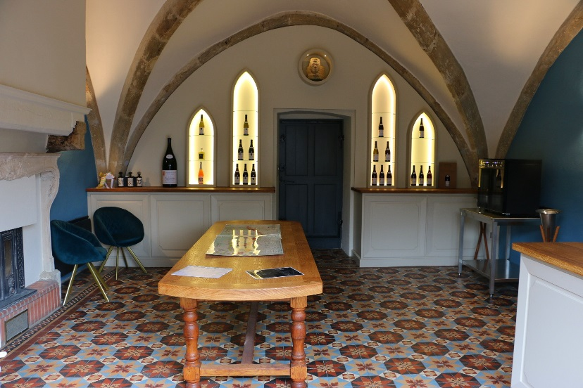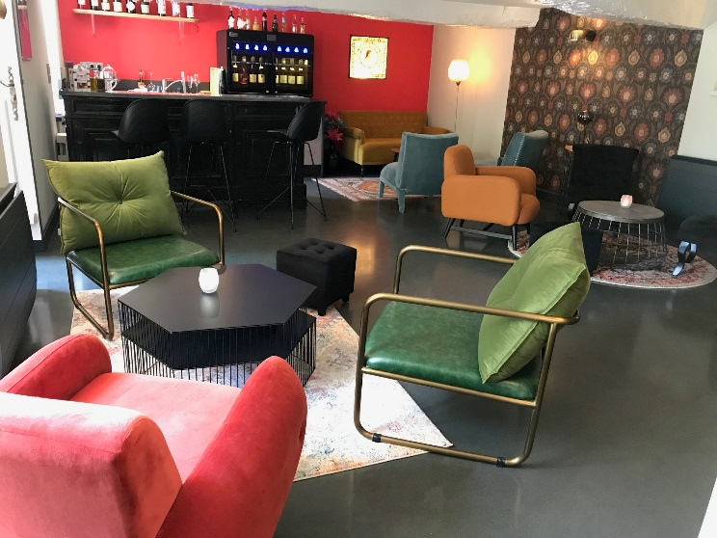
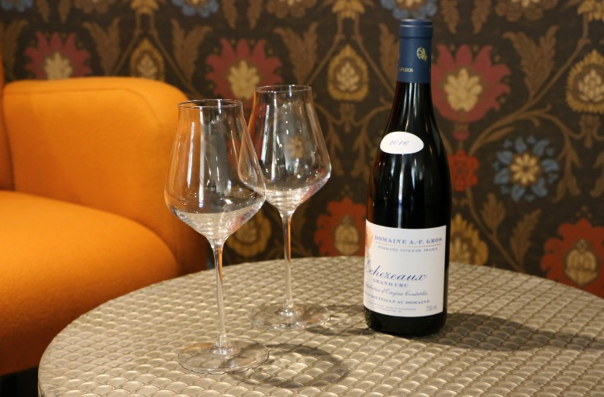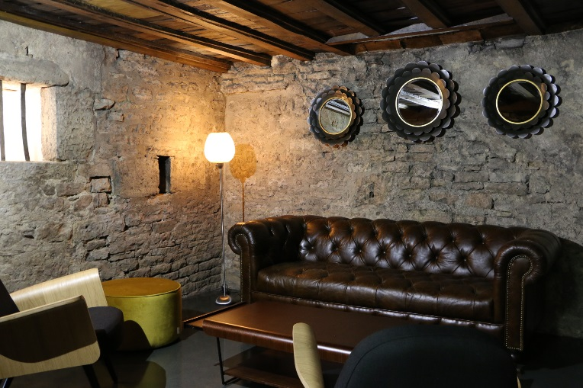

The shop resides in a historical manor of the Dukes of Burgundy within a 12th century chapel. Guests will enter the chapel passing the tasting room/ boutique leading to the wine bar.The bar will be open Wednesday and Thursday, from 11am to 6pm, Friday and Saturday from 11am to 9pm & Sunday from 11am to 6pm.

