Pommard, the 28th of September
"New Wine "Signature": The Bold Fusion of Creative Expression and the Burgundian Terroir

Domaine AF GROS is proud to announce the launch of its "Signature" wine. This unique wine embodies the passion, creativity, and expertise of Mathias Parent, the talented winemaker of the estate.
"Signature Mathias PARENT" is a wine without geographical indication (VSIG) that defies conventions and offers an authentic expression of the characteristics of the Burgundian terroir. This audacious project allows the Domaine to venture beyond the confines of appellation regulations and explore new vinicultural horizons.
One remarkable feature of this wine lies in its parcel blending process. Each year, Mathias Parent carefully selects the best pinot noir parcels from the estate to create a unique blend, reflecting his distinctive winemaking style. This meticulous process gives birth to a wine that unveils the subtleties of the Burgundian terroir while offering a distinctive flavor signature for each vintage.
Mathias Parent, a passionate and visionary winemaker, states: "With 'Signature Mathias PARENT,' we aimed to break free from the limitations imposed by appellations and grant ourselves the freedom to explore and express our creativity. It is a true homage to the Burgundian terroir and our commitment to winemaking excellence. Each bottle of 'Signature' reflects our dedication and our constant pursuit of perfection."
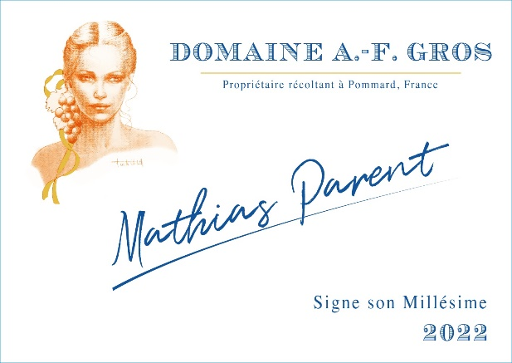

The launch of "Signature" marks a pivotal moment for Domaine AF GROS, ushering in a new era of innovation and distinction. This remarkable wine embodies the estate's dedication to authenticity and the pursuit of excellence. "Signature" will be available in limited quantities (only 1200 bottles for the 2022 vintage), offering wine enthusiasts the opportunity to experience this vinicultural masterpiece. Each bottle is the result of meticulous work, from the vineyards to the cellar, to create an unforgettable sensory experience. For this first vintage 2022, the wine is coming mainly from the bottom of our parcel in Savigny les Beaune1er cru le Clos des Guettes, a small part recently rejected administratively from the appellation area, despite its great terroir. We have 30% of whole bunches and 25% of new barrel.

Caroline PARENT Mathias PARENT"

