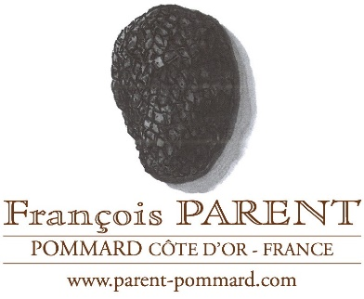

FRANÇOIS PARENT, Pommard
RH: Good, classic styling with a strong sense of identity.

François Parent, Grand Cru 2016 Corton-Charlemagne
Score 17.5/20
Finely focused like the Chassagne Morgeots, with a lovely mix of fruit, less creaminess and minerality to the aroma. On the palate, almost overwhelmingly spicy. Big and rich and full in the mouth – but not without freshness overall. Needs time. (JH)
Drink 2019-2029

François Parent 2016 Morey-St-Denis
Score 17+/20
Expressive, almost acrid smoke aromas from toasted oak, then crunchy black fruit with a rich, lengthy ripeness on the finish. Intense and broad. (RH)
Drink 2020-2030

François Parent 2016 Gevrey-Chambertin
Score 17+/20
Rosehip and redcurrant on the nose, in a fairly restrained style with tight tannins and bright acidity. Tangy and glossy with perhaps not quite enough flavour concentration to last a very long time, but plenty to satisfy in the medium term. (RH)
Drink 2019-2029

