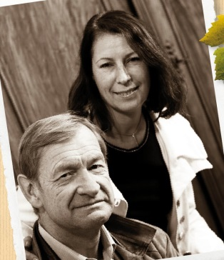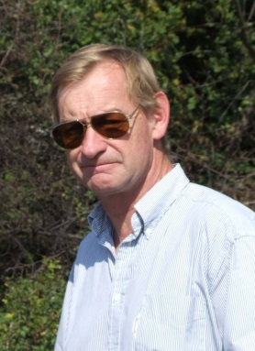

François PARENT

Centuries of tradition

Located in the heart of the prestigious terroirs of Burgundy, Maison François PARENT takes its root in Pommard. Even though it was created in 1998, after François inherited some vineyards from his family, the vineyards and the connection of the family with the culture of vines and production of wines are linked to a rich, several centuries long history. He is the 13th generation of wine grower in the Parent’s family in Pommard.
His great grandfather, Etienne Parent, who was a cooper in Beaune, befriended with Thomas Jefferson during his travel in Burgundy and was requested by the latter to provide him with “sound wine for drinking”.
François PARENT is also famous for being the winemaker of Domaine AF GROS, the Domaine of his spouse.He is known today all over the world for his highly extracted wines, their optimal expression of the pinot noir, and their unique combination of elegance and depth.

Philosophy

The Philosophy at Maison François PARENT is to produce wines with Complex but pure flavors, paying respect to their terroirs. To that end, everything is done in the vineyards and in the winery to get a concentrated fruit to capture that finesse and elegance, which are truly authentic. This means:

The culture of the soils: The culture of the vineyard is traditional, with careful Human Intervention, focused on observation and sustainability principles. François pays a special attention to viticulture, with selective pruning to optimize yield and vigour, along with adapted leaf pulling, green harvest when needed, and ploughing of the soils.
We use no pesticides and no insecticides, and we use sexual confusion.
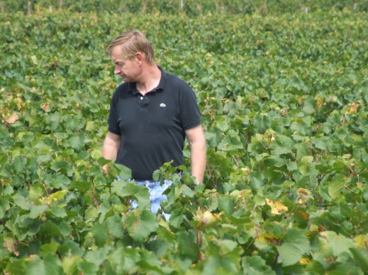

Harvest and winemaking practices:
The harvest is 100% manual.
The grapes are brought back to the winery in small cases to avoid any tamping down, in less than 20 minutes after they are cut.
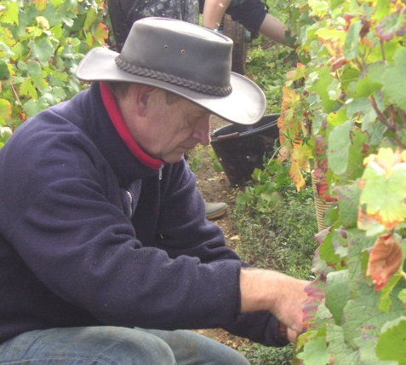
Comprehensive sorting in 4 steps:
- In the vineyard,
- With a dynamic sorting table at the arrival in the winery,
- Manual sorting by 6 persons. The clusters are 100% de stemmed.
- Final sorting out is done after de stemming.
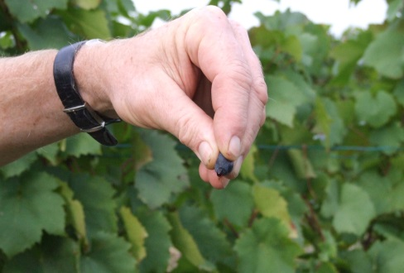

The new generation of de-stemmer that we use preserves the skin of the clusters (berries) so that the sugars will spread slowly and regularly in order to avoid any stop in the fermentation.
For the vinification, we use stainless steel tanks and some wood tanks.
Cold maceration for about 4-5 days to extract flavours and colour. During that time, we do some remontage (pump over) to keep a good contact between solid and liquid parts, and a homogeneous temperature of 5°C.
After 5 days, the alcoholic fermentation starts. Tanks are heated up to 25-30°C and we maintain this temperature over 10 days.
Pigeage (punch-down) are led depending on the level and structure of the wine (appellation).
For each tank, we do a total of 2 to 4 pigeage, usually at the beginning of the fermentation. We complete with 2-3 daily pumping over, during all the fermentation.
After a gentle pressing with a pneumatic press (about 2 hours at 2kg/cm²), wines are decanted during 2-3 days at 12°C, and are barrelled.
Malo-lactic fermentation is done in barrels. As the wines are kept at low temperature, this fermentation starts slowly and lasts about 45 days. We follow the evolution of its completion barrel by barrel to be as accurate as possible with the SO2.
SO2 protects from Brettanomyces and from an increase of the volatile acidity. It is added by dose of 7cl, once per month, during 3 months.

Elevage: The wines are aged between 12 to 18 months in French oak barrel. The oaks come mainly from forest of Troncey in Allier, forests of Bertranges and Fontainebleau. We work with 3 main coopers and ask them for high toasted barrels, including a burning of the head of the barrels.
Generics are aged in 5000 Liters tank (60%) and in oak barrels from 2-3 wines (40%).
Elevage is done during an average of 12 months for village wines (50% new oak), 15 months for the 1er crus (65% new oak) and 18 months for the Grands Crus (100% new oak).

The wines are racked and placed in tanks for the last 3 months of elevage so that the fine lees can settle down.
At this time, we don’t use SO2 anymore, we analyze the wines to check if the level of CO2 is good enough (650 mg/Liter) to preserve the freshness and the stability of the wines.
We also check the turbidity of the wines and if necessary, do a light filtration (lenticular filer system: cellulose sheets) but no fining.

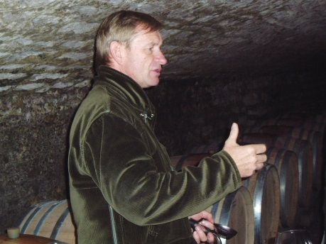

The wines are bottled by gravity. We pay attention to order our bottles with a bottleneck of 63 mm to avoid as much as possible leakage of the corks.

