MAISON PARENT-GROS
Domaine A-F GROS

Domaine AF GROS is one of the top estates of Burgundy. Anne Françoise is the daughter of Jean GROS. The estate was created in 1988, when her father decided to retire, and his domain was divided among Anne-Françoise (Domaine A.-F GROS), and her 2 brothers Michel (Domaine Michel GROS) and Bernard (Domaine GROS frère & soeur).
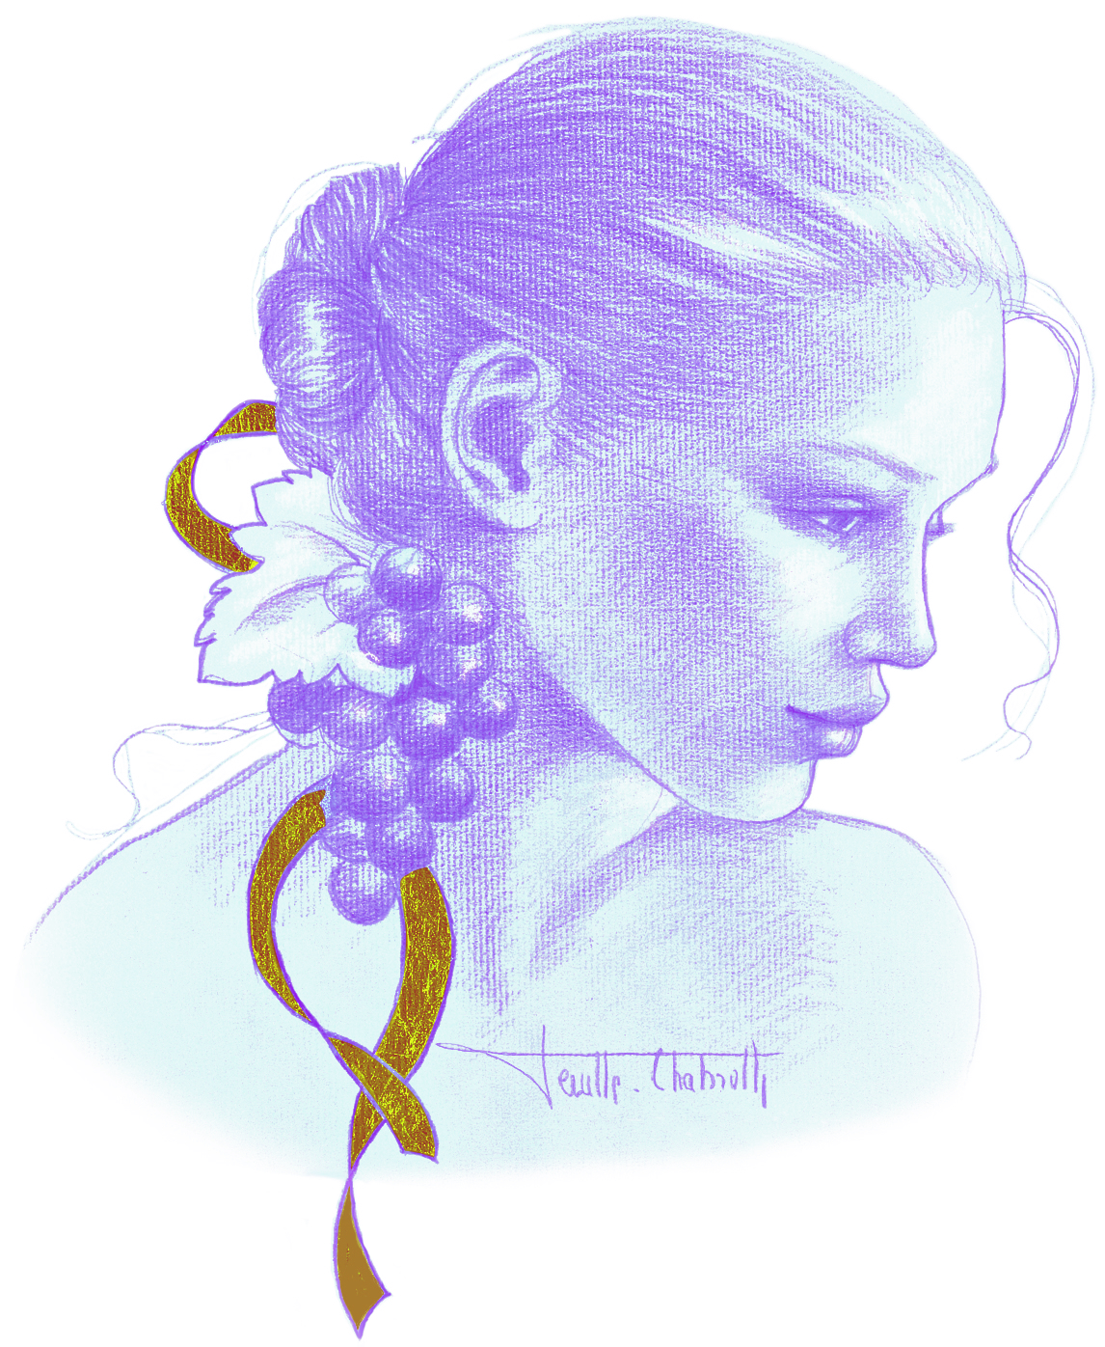
François PARENT, Anne –Francoise’s husband, is the winemaker. He is known today all over the world for his highly extracted wines, their optimal expression of the pinot noir, and their unique combination of elegance and depth. Today, 2 of their 3 children work with them on the estate, Caroline and Mathias. The estate covers 10 hectares, planted mainly in Pinot Noir, both in Cote de Beaune and in Cote de Nuits, and 4 hectares recently bought in Moulin a Vent (Beaujolais).
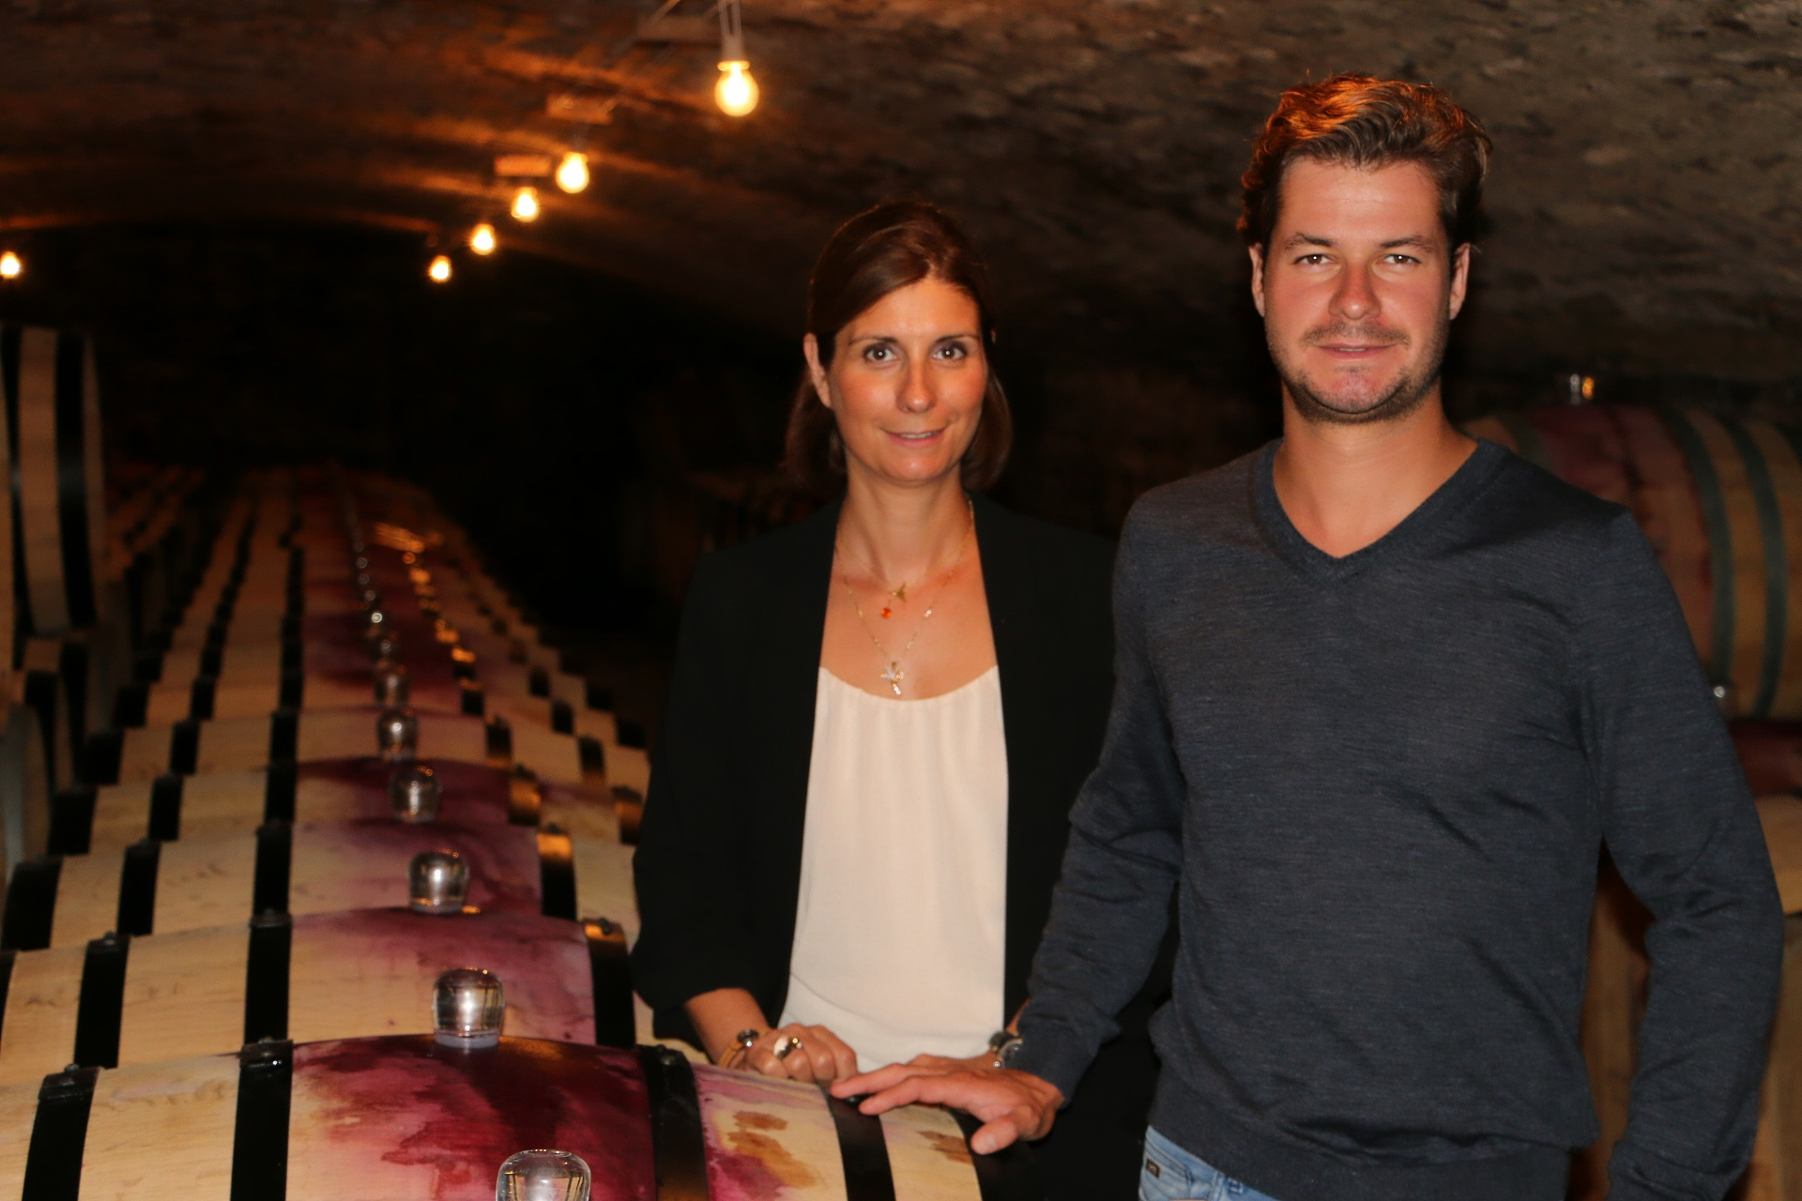
The culture of the soils: The culture of the vineyard is traditional, with careful Human Intervention, focused on observation and sustainability principles. François and Mathias pay a special attention to viticulture, with selective pruning to optimize yield and vigour, along with adapted leaf pulling, green harvest when needed, and ploughing of the soils.
We use no pesticides and no insecticides, and we use sexual confusion.
Harvest and winemaking practices:
The harvest is 100% manual.
The grapes are brought back to the winery in small cases to avoid any tamping down, and destemmed 10%.
Cold maceration for about 4-5 days to extract flavours and colour.
Malo-lactic fermentation is done in barrels. As the wines are kept at low temperature, this fermentation starts slowly and lasts about 45 days.
Elevage: The wines are aged between 12 to 18 months in French oak barrel
Elevage is done during an average of 12 months for village wines (50% new oak), 15 months for the 1er crus (65% new oak) and 18 months for the Grands Crus (100% new oak).

The wines are racked and placed in tanks for the last 3 months of elevage so that the fine lees can settle down.We check the turbidity of the wines but we don’t filter the wines anymore since vintage 2014. No fining neither.

The wines are bottled by gravity.

Caroline regularly communicates on social medias:
instagram @cparentgros
Twitter @cparentgros
Facebook du Domaine AF GROS.
#LeJeffersonClub

WINE BAR : LE JEFFERSON’S CLUB
Thomas Jefferson was one of the author of the United States Declaration of Independence, and the Third President of the United States.
When Thomas Jefferson was in France to serve as Ambassador, he embarked on a grand tour of France in 1787. He decided to came in Burgundy mainly for his health.
When in Beaune, he hired a wine advisor, Etienne PARENT who was a cooper and a wine merchant. Etienne was the forefather of Caroline and Mathias PARENT.
The two men became friends and Etienne PARENT introduced Jefferson to the wines of Pommard and helped him to shape his cellar. Later, he even shipped some wines to the White house. After Jefferson became President and even when he retired to Monticello, the two men continued to communicate, and records and correspondence exist.
Nowdays, Caroline and Mathias are still in touch with the Jefferson Foundation in Monticello.
His love for Burgundy wine was no secret, as his correspondence and writings confirm. From his letters to his connection in France, Etienne Parent, dated January 22, 1789:
For several weeks now, Sir, I have wanted to order from you a shipment of Meursault. But the season has been so rude that I thought it would be better to await milder weather. The delay has lasted to the point that I now find myself with a pressing need. I ask you therefore to send me immediately two hundred and fifty bottles of wine, Meursault “Goutte d’Or”. I have become so attached to that of Mr. Bachey of the 1784 vintage that if he still has any of it I would prefer it.*

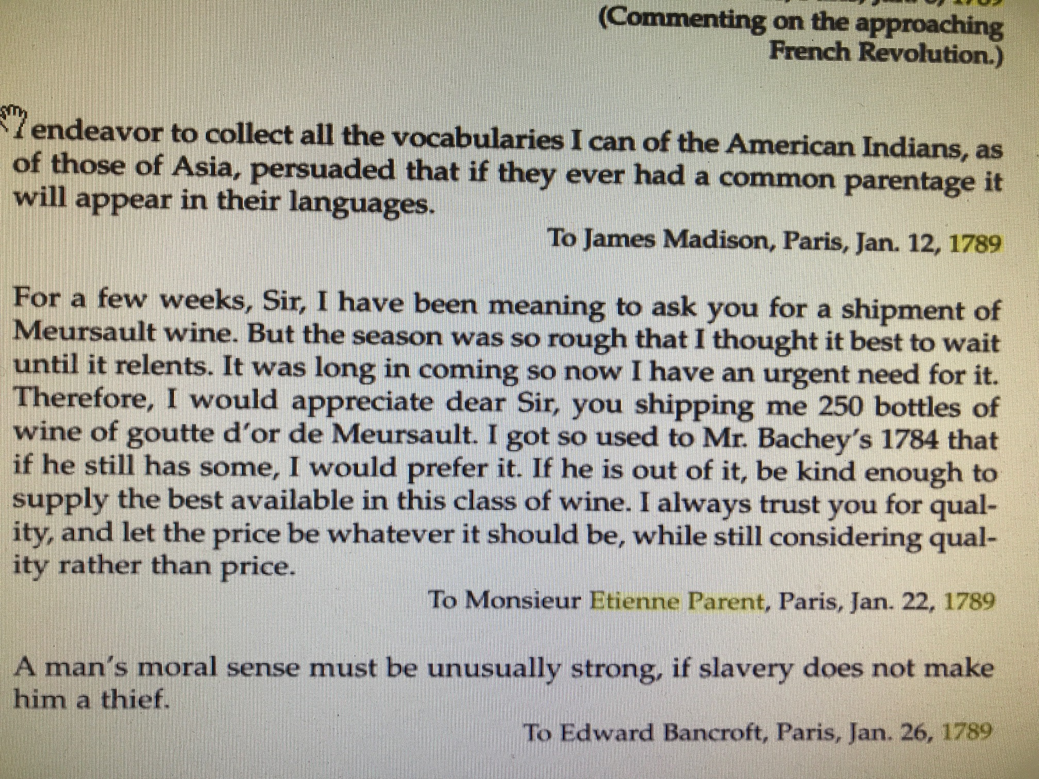

Extract of Thomas Jefferson: A Chronology of His Thoughts Par Thomas Jefferson, Jerry Holmes

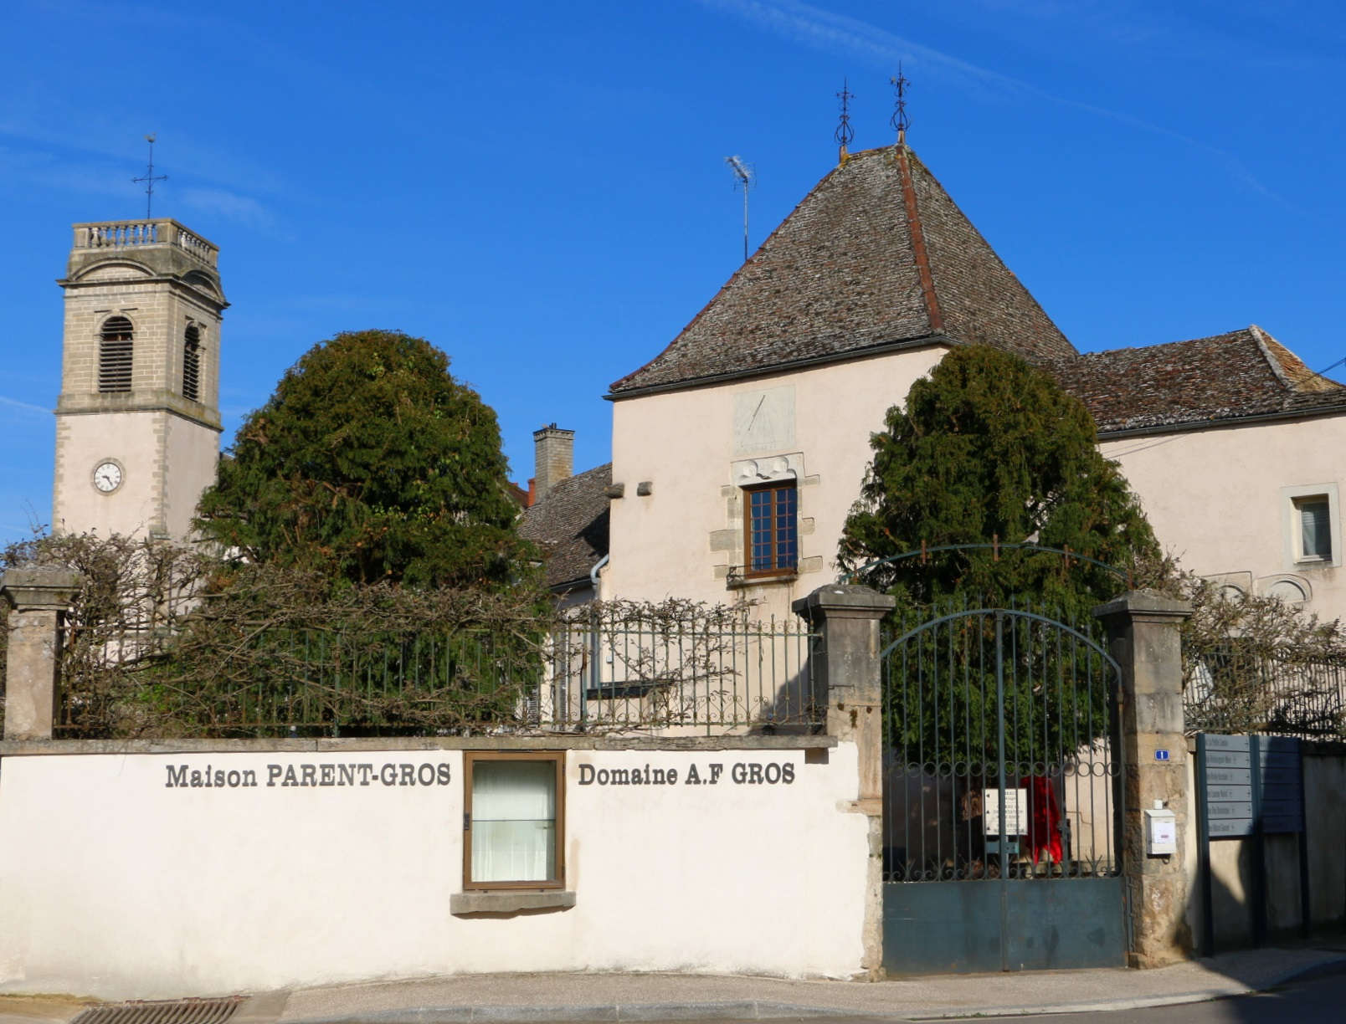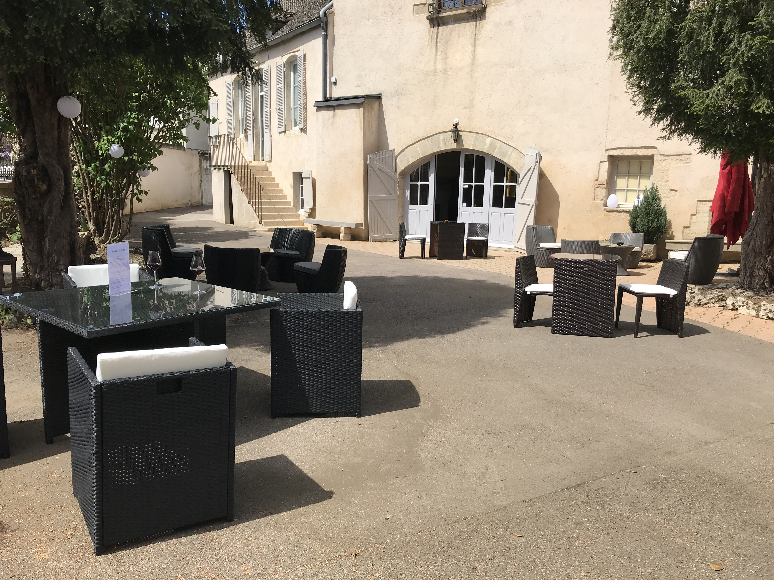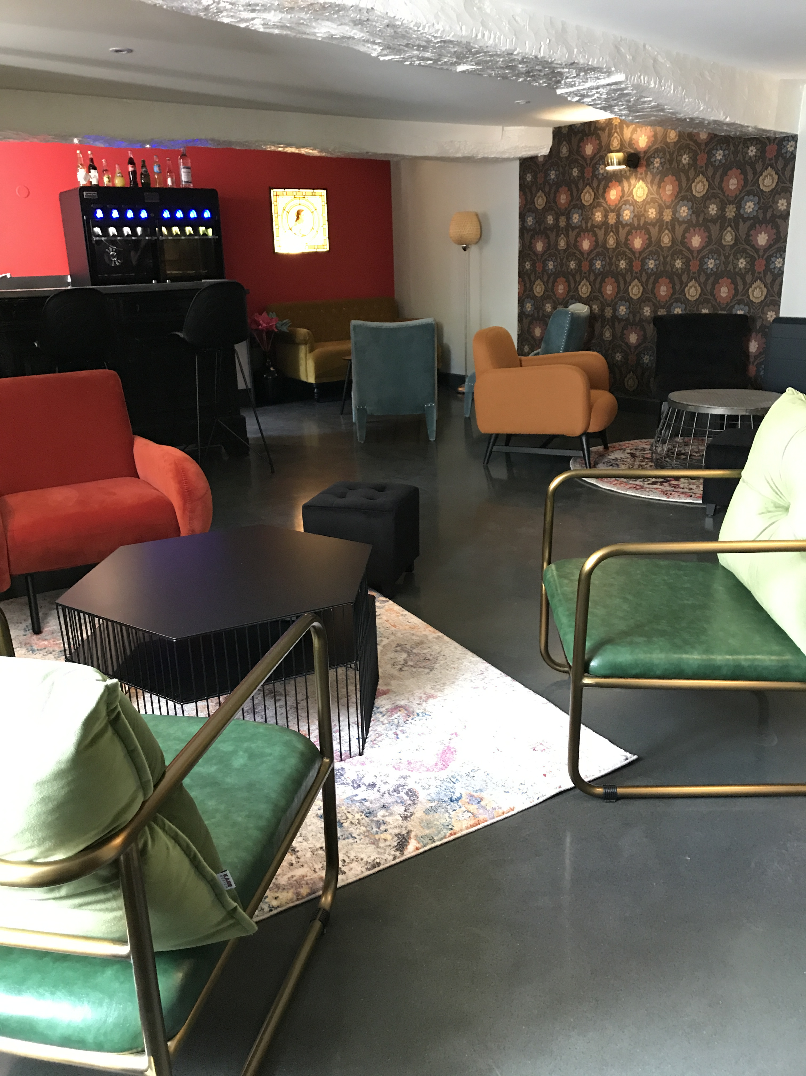

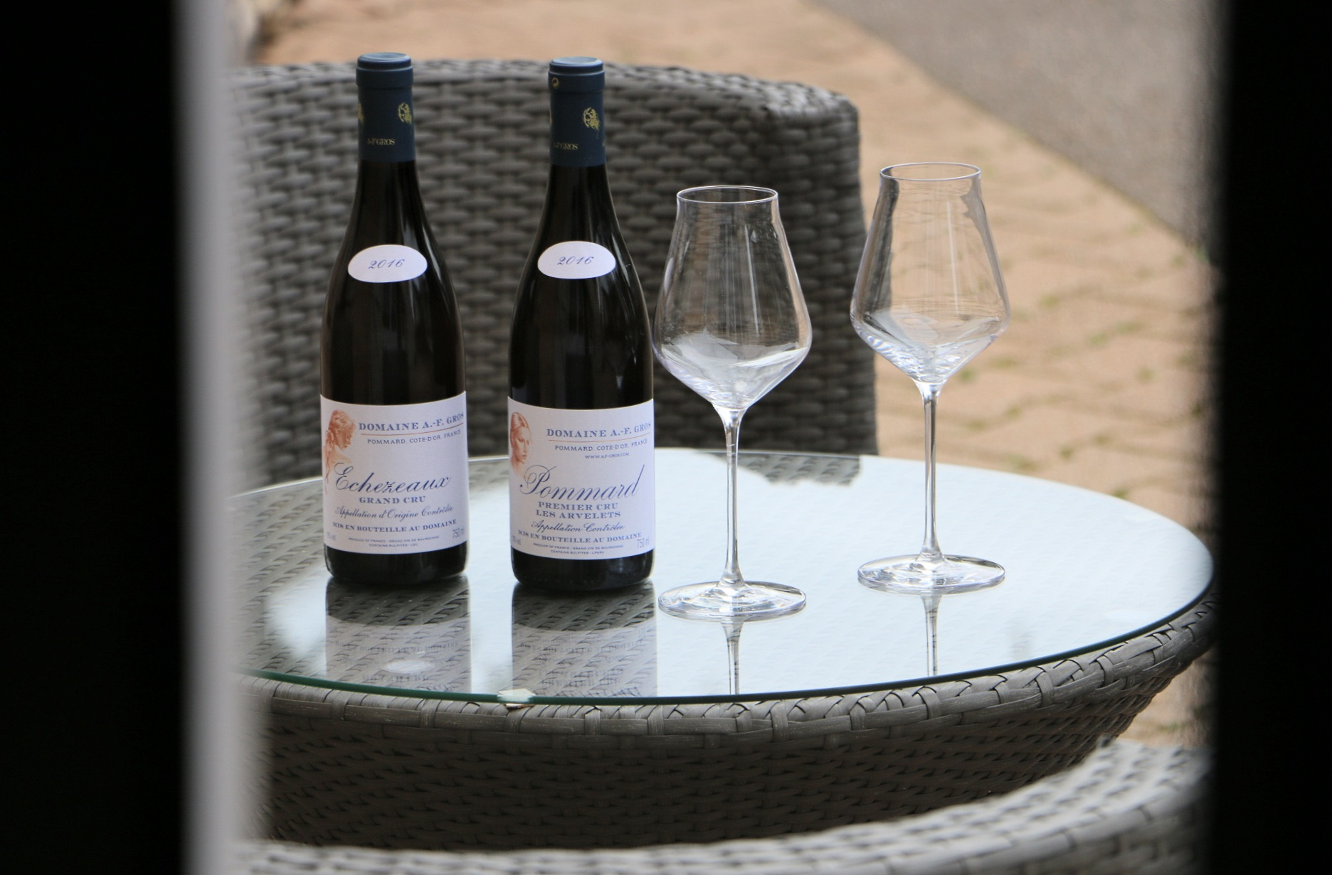

Caroline & Mathias PARENT-GROS
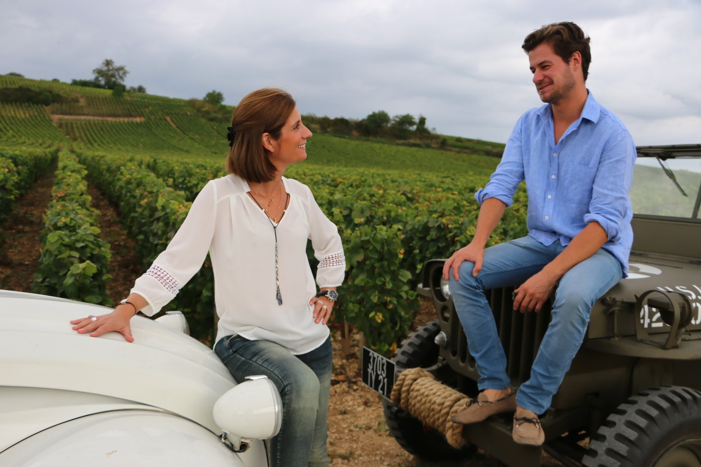
Mathias PARENT
Born in Burgundy 28 years ago, Mathias has stemmed and risen as a part of a lineage of tradition with superlative vineyard and winemaking skills. After several training periods in Australia and Oregon, he joined his father François PARENT at the winemaking of Domaine AF GROS in 201. His first vintage “in solo” was 2013.

Caroline PARENT
Born in Burgundy 41 years ago, in a family of producers from generations, Caroline studied in a Business School in Champagne, before going 2 years in Canada. This international experience followed by a banking experience, helped her when she started to work at the export department of Domaine AF GROS (her mother), and François PARENT (her father).
By regularly participating at some wine tours all over the world, and organizing some wine dinners, she learned about the marketing of wines.
In 2013, she joined the familial company to take over the commercial and administrative management of Domaine AF GROS and Maison PARENT-GROS.

