DOMAINE A.F. GROS
MAISON PARENT-GROS

ANNE-FRANÇOISE PARENT-GROS
Founded in 1988, Domaine A.F. Gros stands among the most distinguished estates of Burgundy. Anne-Françoise Parent-Gros, daughter of Jean Gros, created the domaine when her father retired and divided his historic holdings between his three children:
- Domaine A.F. Gros (Anne-Françoise)
- Domaine Michel Gros (Michel Gros)
- Domaine Gros Frère & Sœur (Bernard Gros)
This division marked the beginning of a new chapter, rooted in heritage yet guided by a singular vision.
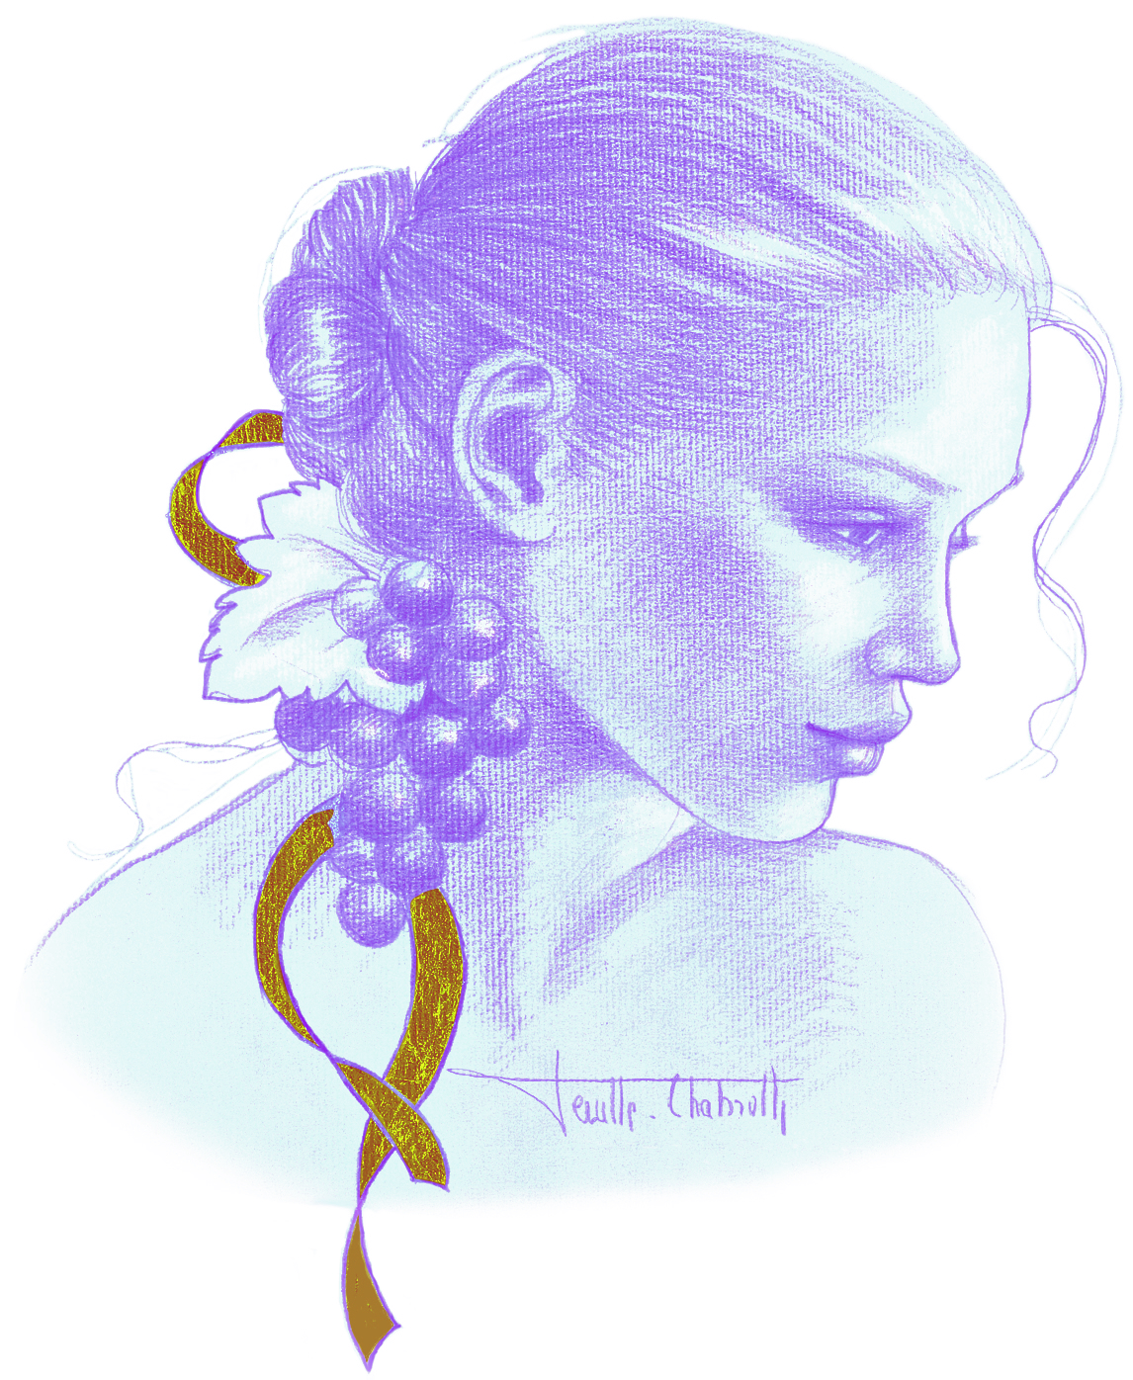
A FAMILY ESTATE
François Parent, Anne-Françoise’s husband, served as winemaker for many years. Internationally recognized for his highly extracted wines, he shaped a style renowned for its profound expression of Pinot Noir, combining elegance, depth, and structure.
Today, two of their three children are actively involved in the estate:
- Mathias Parent – in charge of viticulture and winemaking
- Caroline Parent – responsible for commercial development and administration

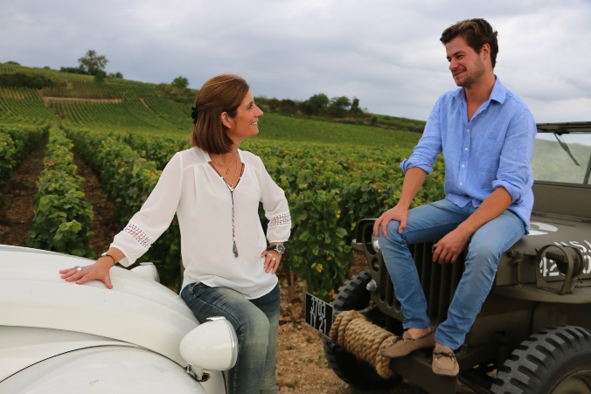
The domaine currently covers 15 hectares in Burgundy, planted primarily with Pinot Noir across the Côte de Nuits and Côte de Beaune, as well as 4 hectares in Moulin-à-Vent (Beaujolais) acquired more recently.
Starting in 2026, the estate will resume direct cultivation of four parcels in Nuits-Saint-Georges (Village), representing a total surface area of 0.50 hectares.

VITICULTURE PHILOSOPHY
The vineyard is cultivated according to traditional practices, guided by observation, precision, and sustainability. Particular attention is given to each stage of the vine’s development:
- Selective pruning to balance yield and vigor
- Drastic crown suckering
- Adapted leaf pulling
- Green harvesting when necessary
- Systematic ploughing of the soils
No pesticides or insecticides are used. Sexual confusion is employed for pest control.
Since 2018, no CMR products (carcinogenic, mutagenic, or toxic for reproduction) have been used in the vineyard.
Optimization of the Leaf Surface Area (Canopy)
Since 2024, the estate has significantly evolved its canopy management strategy with the objective of optimizing leaf surface area and improving phenolic maturity.
- Mechanical hedging has been abandoned.
- Vines are now woven and tucked throughout all village and Premier Cru vineyards, allowing a more balanced and extended vegetative cycle.
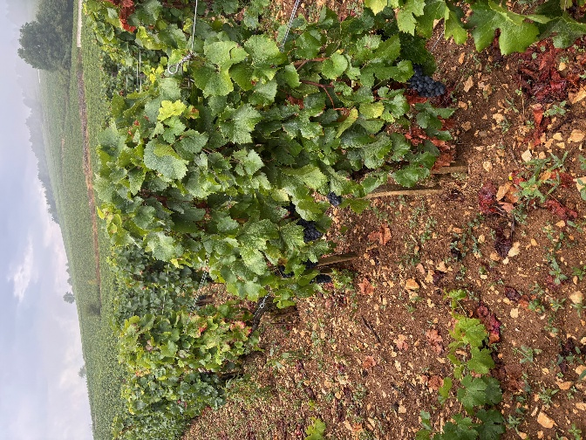
- In Grand Cru vineyards, the height of the stakes has been increased in order to extend the trellising system and lengthen the canopy.
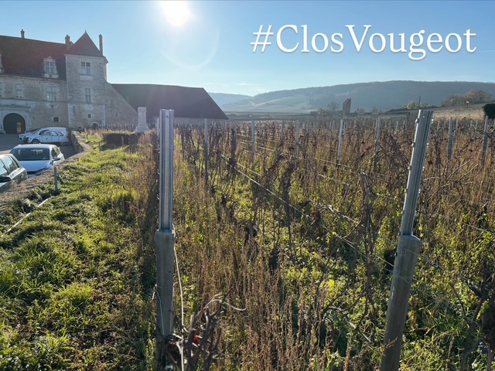
This approach enhances photosynthetic capacity, promotes slower and more complete ripening, and contributes decisively to the phenolic maturity and balance of the grapes.

VINIFICATION – RED WINES (CÔTE D’OR)
Harvest & Reception
- 100% manual harvesting
- Grapes transported in small cases
- Arrival at the winery within 20 minutes of cutting
Sorting Process (Three Stages)
- Sorting in the vineyard
- Dynamic sorting table upon arrival at the winery
- Manual sorting by six people
- Bourgogne hautes cotes de nuits red: 100% destemmed
- Other appellations: 50% to 75% whole clusters
(A new-generation destemmer is used to preserve berry skins, ensuring slow and regular sugar diffusion and preventing fermentation blockage.)
Fermentation
- Vats: concrete, stainless steel, and wood
- Fermentation begins 24 hours after vatting
- Duration: 10–12 days
Since vintage 2020, no pigeage is practiced. Only a light foulage is carried out at the end of fermentation.
During fermentation:
- 2–3 pump-overs daily
- 1 délestage per day
Pressing & Malolactic Fermentation
- Gentle pneumatic pressing (1h15, max. 17 PSI)
- Settling: 4–5 days at 12°C
- Barrel filling thereafter
Malolactic fermentation occurs in barrel, starting naturally in spring and lasting approximately 45 days. Each barrel is monitored individually to ensure precise SO₂ management.
SO₂ is added monthly (7 cl doses over three months) to protect against Brettanomyces and volatile acidity. CO₂ levels are adjusted if necessary.

ÉLEVAGE – RED WINES
- Aging: 12 to 18 months in French oak
- Oak origin: Châtillonnais and Fontainebleau forests
- Toasting: low and long, from three selected coopers
- Average: 30% new barrels
After aging, wines are racked and blended. SO₂ and CO₂ are adjusted. A CO₂ level of 650 mg/L is maintained to preserve freshness and stability.
No filtration since vintage 2014. No fining.
Bottling is carried out by gravity.
Evolution of Élevage
- From 2023: 50% ceramic vats / 50% barrels (new + barrels of 1 and 2 years)
- From 2025: 70% ceramic vats / 30% new barrels (no barrels of 1 and 2 years anymore)
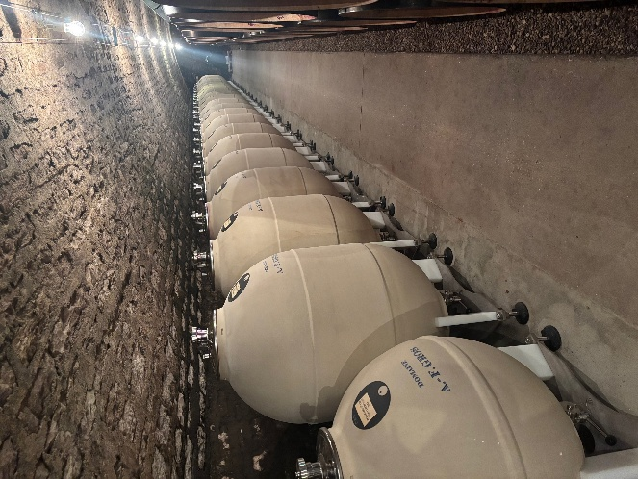

VINIFICATION – WHITE WINES (CÔTE D’OR)
- 100% manual harvesting
- Transport in small cases via air-conditioned trucks
Process
- Vibrating table sorting (water, insects, leaves removed)
- Manual sorting
- Pneumatic pressing: 25 PSI for 2 hours
- Cooling at 12°C
- Natural settling for 24 hours
Alcoholic and malolactic fermentations take place in barrel. No lees stirring.
Aging
- 12 months aging
- Approximately 30% new barrels
After racking and fining, SO₂ and CO₂ levels are adjusted. Bottling is done by gravity.

VINIFICATION – MOULIN-À-VENT
(Reference year without frost or hail)
- 100% manual harvesting
- Transport in small cases via air-conditioned trucks
Vinification by Parcel (Whole Clusters)
Traditional Whole-Cluster Fermentation
- Open tanks
- Daily pump-overs
- Daily cap crushing
- Vatting: approx. 15 days
- Pressing: pneumatic, 2 hours, max. 17 PSI
Aging
- Settling: 4–5 days
- Aging: 8–9 months
  - ~50% in a 5,000-liter oak foudre
  - Remainder in 228L barrels (3–4 years old)
Final blending takes place in stainless steel tanks for one month. SO₂ and CO₂ are adjusted before bottling.

THE EMBLEMATIC FACE LABEL OF THE DOMAINE
A true signature of the Domaine, the illustrated face featured on the label expresses the unique character of each appellation. Accordingly, the face depicted on the label differs from one category of appellation to another, reinforcing the individuality of every wine.
This series of sanguine drawings, whose warm ochre tones evoke the soils of Burgundy, was created by the artist Marie-Paule Deville-Chabrolle (www.deville-chabrolle.com), notably renowned for sculpting the bronze of Laetitia Casta (top model), chosen to embody one of the official representations of Marianne, the emblem of the French Republic.
This emblematic label is also a deliberate way of distinguishing Domaine A.F. Gros from the three other existing Gros family estates, those of Anne-Françoise’s two brothers and their cousin.

