OFFER “CAROLINE PARENT”
FOR GRUBIS
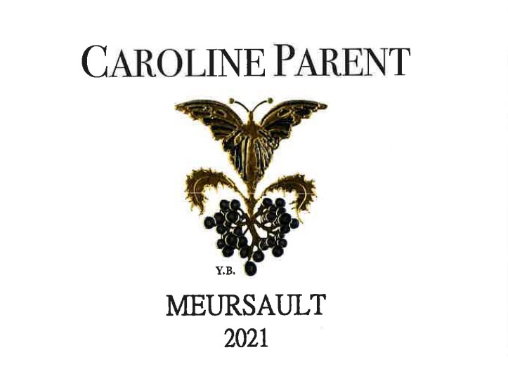

 |  | in € | in Bt
 |  | Price HT | Maxi availabilities
Bourgogne Chardonnay | 2022 | 22 | 180
Meursault 1er cru les charmes | 2022 | 124 | 18
Meursault 1er cru les Poruzot | 2022 | 99 | 90
Meursault | 2022 | 50 | 120

