CAROLINE PARENT
EXPORT WINE OFFER
Prices EXW Beaune – € HT per bottle
Valid until 31 December 2026
All prices are expressed per 750 ml bottle, ex-cellars Beaune (France). 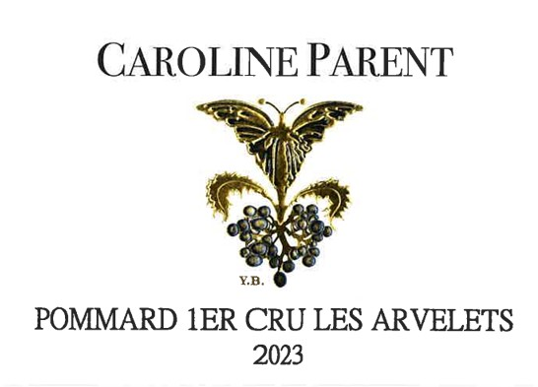 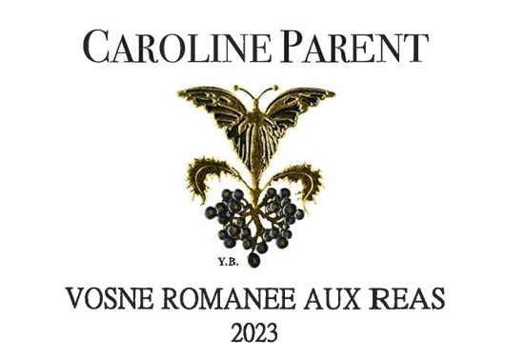

WHITE WINES
Appellation | Vintage | Price € HT | Max bottles
Bourgogne Chardonnay | 2022 | 22.00 | 84
Bourgogne Hautes-Côtes de Nuits Blanc | 2024 | 22.00 | 300

RED WINES – REGIONAL & VILLAGE
Appellation | Vintage | Price € HT | Max bottles
Bourgogne Hautes-Côtes de Nuits Rouge | 2023 | 18.00 | 480
Bourgogne Pinot Noir | 2023 | 17.00 | 600
Moulin-à-Vent En Mortperay | 2023 | 17.50 | 600
Moulin-à-Vent En Mortperay | 2022 | 16.25 | 300
Savigny-lès-Beaune | 2023 | 28.00 | 300
Monthélie | 2023 | 28.00 | 300
Gevrey-Chambertin | 2023 | 75.00 | 300
Gevrey-Chambertin | 2022 | 79.00 | 300
Chambolle-Musigny | 2023 | 69.00 | 48
Vosne-Romanée Aux Réas | 2023 | 69.00 | 48

PREMIER CRUS
Appellation | Vintage | Price € HT | Max bottles
Pommard 1er Cru Les Arvelets | 2023 | 89.00 | 60
Volnay 1er Cru Les Brouillards | 2023 | 76.00 | 120
Chambolle-Musigny 1er Cru Aux Échanges | 2023 | 161.00 | 60
Vosne-Romanée 1er Cru Les Beaumonts | 2022 | 239.00 | 180
Pommard 1er Cru La Chanière | 2022 | 90.00 | 60

GRANDS CRUS
Appellation | Vintage | Price € HT | Max bottles
Corton Grand Cru | 2023 | 147.00 | 60
Clos de Vougeot Grand Cru | 2023 | 269.00 | 48
Clos de Vougeot Grand Cru | 2022 | 269.00 | 60
Clos de Vougeot Grand Cru | 2021 | 275.00 | 6
Clos de Vougeot Grand Cru | 2020 | 190.00 | 18
Échezeaux Grand Cru | 2023 | 277.00 | 48
Échezeaux Grand Cru | 2022 | 277.00 | 24
Charmes-Chambertin Grand Cru | 2021 | 325.00 | 24

SALES CONDITIONS
Allocation Policy
Grands Crus are not sold alone.
They must be assorted with other appellations for an equivalent total financial value.
A reasonable proportion of regional or village wines is required in this balance.
Packaging
- Standard packaging available in 6 or 12 bottles (750 ml)
Orders & Validity
- Proforma invoices and order confirmations are valid for a maximum of 12 months
- After this period, availability is not guaranteed and wines may be released for reallocation if not shipped
Transport Conditions
All our wines are produced with the utmost care, from vineyard to bottle.
Transportation conditions are an integral part of wine quality.
➡️ Consequently, we refuse to load wines between April and October in non-air-conditioned trucks.

Contact: cparentgros@gmail.com / contact@af-gros.com Instagram @cparentgros

