

Caroline PARENT Pommard 1er Cru Les Arvelets

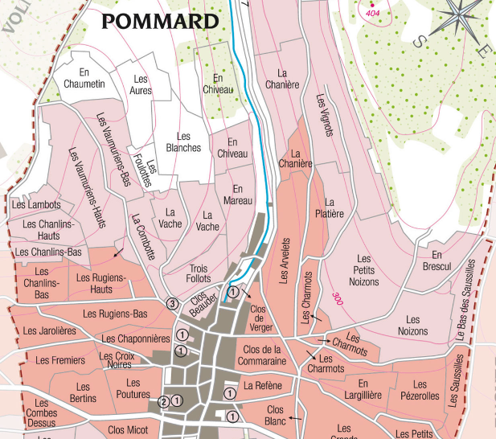
Winemaking
For the winemaking process, we use stainless steel tanks and oak barrels.
Fermentation starts 24h after the vatting and lasts 10 to 12 days.

30% of whole bunch. From 2020, no more pigeage (punch-down), but only a light “foulage” at the end of the fermentation to spread the sugar contained in the berries of the whole bunches. During the fermentation, 2-3 daily pumping over, and 1 daily “delestage”.

Malo-lactic fermentation is done in barrels.

Elevage: The wines are aged between 12 to 18 months in French oak barrel. The oaks come mainly from forests of Chatillonais and Fontainebleau. Maturing lasts 15 to 18 months - 30% in new barrels .

100% Pinot Noir
Our 0.31 ha vineyard is located in the Eastern part of the appellation, close to its geological fault. That area is known for its elegant and deep, rich wines.
Clay-limestone soils with good drainage at an average altitude of 300 meters.
Traditional vineyard management based on sustainability principles.
We engage in selective pruning, along with optimized leaf pulling, green harvest when needed, and ploughing of the soils.
The grapes, once cut, are brought back to the winery within 20 minutes to ensure freshness.
No CMR (carcinogenic, mutagenic, or toxic for reproduction) used in the vineyard.
100% manual harvesting.

Tasting notes
Deep, dark red color. Aromas of blackberry and blackcurrants. Often, wild and feline notes develop with age. At full maturity, it tends towards leather, chocolate and pepper.
It needs to be given time to open up to its fullest extent and to display its mouth-filling texture, its firm but delicate structure.

