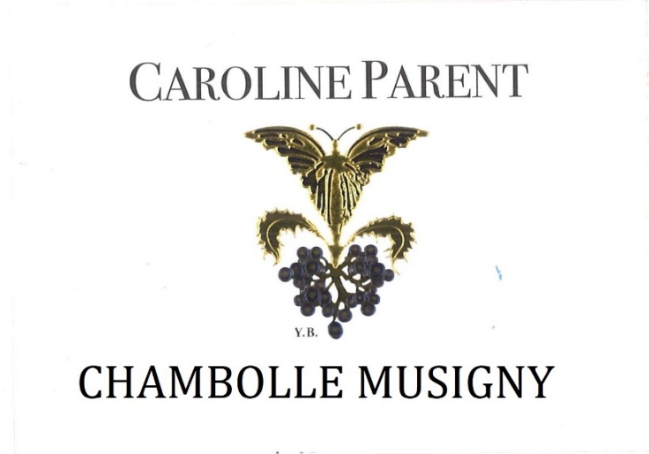
Caroline PARENT Chambolle Musigny

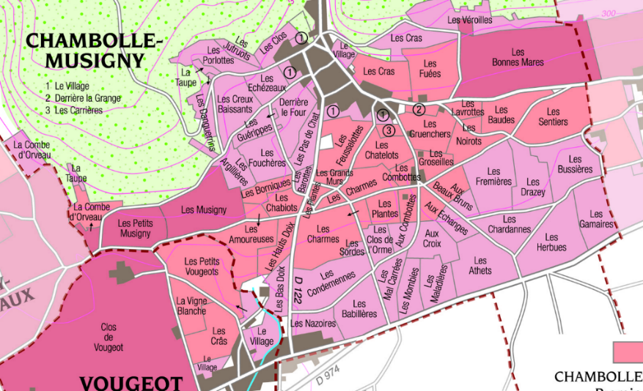
100% Pinot Noir
Our .39 ha vineyard is split between various parcels in the Southern part of the appellation.
Shallow soils, with gravel and limestone rocks that allow for aeration and deep root penetration.
Traditional vineyard management based on sustainability principles.
We engage in selective pruning, along with optimized leaf pulling, green harvest when needed, and ploughing of the soils.
The grapes, once cut, are brought back to the winery in less than 20 minutes.
No CMR (carcinogenic, mutagenic, or toxic for reproduction) used in the vineyard.
100% manual harvesting.

Tasting notes

Chambolle-Musigny has a distinct personality and features. Intense bouquet composed of violet and small red fruits (raspberry, strawberry). Rich, fragrant and complex, it lines the palate with silk and lace. Its delicate and fleshy texture is paired with a solid and durable structure. Fabulous with game and cheeses like Brillat Savarin, Citeaux or Reblochon.

Winemaking
Fermentation starts 24h after the vatting and lasts 10 to 12 days.
30% of whole bunch. From 2020, no more pigeage (punch-down), but only a light “foulage” at the end of the fermentation to spread the sugar contained in the berries of the whole bunches. During the fermentation, 2-3 daily pumping over, and 1 daily “delestage”.

Malo-lactic fermentation is done in barrels.

Elevage: The wines are aged between 12 to 18 months in French oak barrels. The oaks come mainly from forests of Chatillonais and Fontainebleau. Maturing lasts 15 to 18 months - 30% in new barrels

