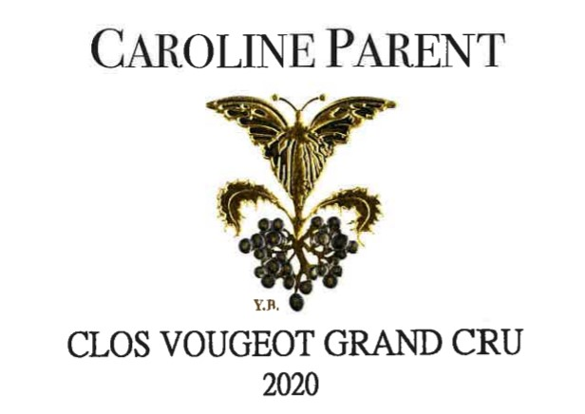
Caroline PARENT Clos Vougeot

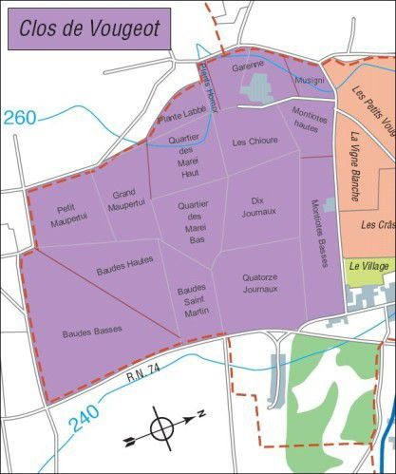
100% Pinot Noir

Our 0.5396Ha vineyard is located in les « Musigni » and « la Garenne ».

We engage in selective pruning, along with optimized leaf pulling, green harvest when needed, and ploughing of the soils.
The grapes, once cut, are brought back to the winery within 20 minutes to ensure freshness.
No CMR (carcinogenic, mutagenic, or toxic for reproduction) used in the vineyard.
100% manual harvesting.

Winemaking
Fermentation starts 24h after the vatting and lasts 10 to 12 days.
30% of whole bunch. From 2020, no more pigeage (punch-down), but only a light “foulage” at the end of the fermentation to spread the sugar contained in the berries of the whole bunches. During the fermentation, 2-3 daily pumping over, and 1 daily “delestage”.
Malo-lactic fermentation is done in barrels.
Elevage: The wines are aged between 12 to 18 months in French oak barrel. The oaks come mainly from forests of Chatillonais and Fontainebleau. Maturing lasts 15 to 18 months - 30% in new barrels .

