Caroline PARENT Echezeaux

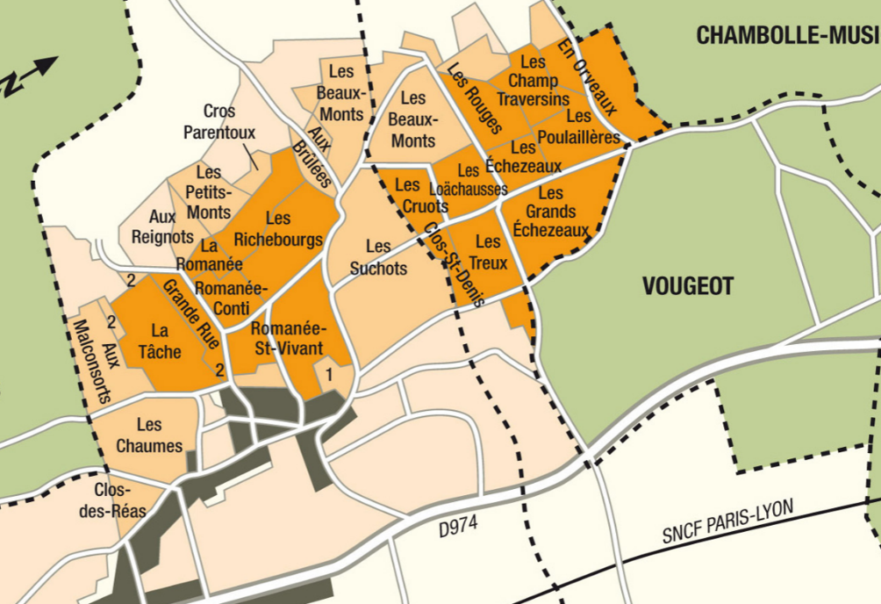
Winemaking
Fermentation starts 24h after the vatting and lasts 10 to 12 days.
50% of whole bunch. From 2020, no more pigeage (punch-down), but only a light “foulage” at the end of the fermentation to spread the sugar contained in the berries of the whole bunches. During the fermentation, 2-3 daily pumping over, and 1 daily “delestage”.
Malo-lactic fermentation is done in barrels.
Elevage: The wines are aged between 12 to 18 months in French oak barrel. The oaks come mainly from forests of Chatillonais and Fontainebleau. Maturing lasts 15 to 18 months - 50% in new barrels .

100% Pinot Noir

Our 0.26 ha vineyard is more than 100 years old and is located in the “Champs Traversins”.Shallow soils, 13% steep incline, with gravel and limestone rocks that allow for aeration and deep root penetration.
Traditional vineyard management based on sustainability principles.
We engage in selective pruning, along with optimized leaf pulling, green harvest when needed, and ploughing of the soils with a horse.

No CMR (carcinogenic, mutagenic, or toxic for reproduction) used in the vineyard.
100% manual harvesting.

Tasting notes

Deep ruby color, shading towards the darker tones of magenta and purple. Its bouquet is redolent of animal, spice notes, underbrush, and prune, evolving with age towards musk, leather, fur and mushroom. When young, its aromas suggest rose, violet and fresh cherry. The dense texture and tight grain of these wines fully open after 6 to10 years in the cellar.

