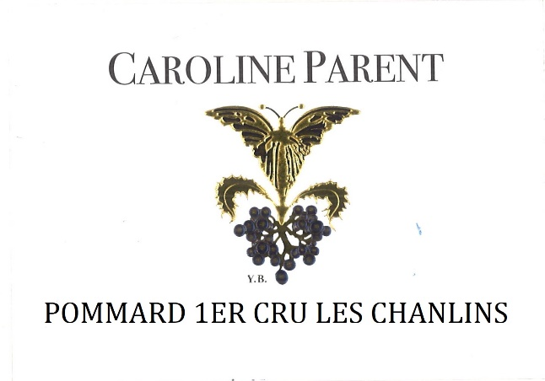
Caroline PARENT Pommard 1er Cru Les Chanlins

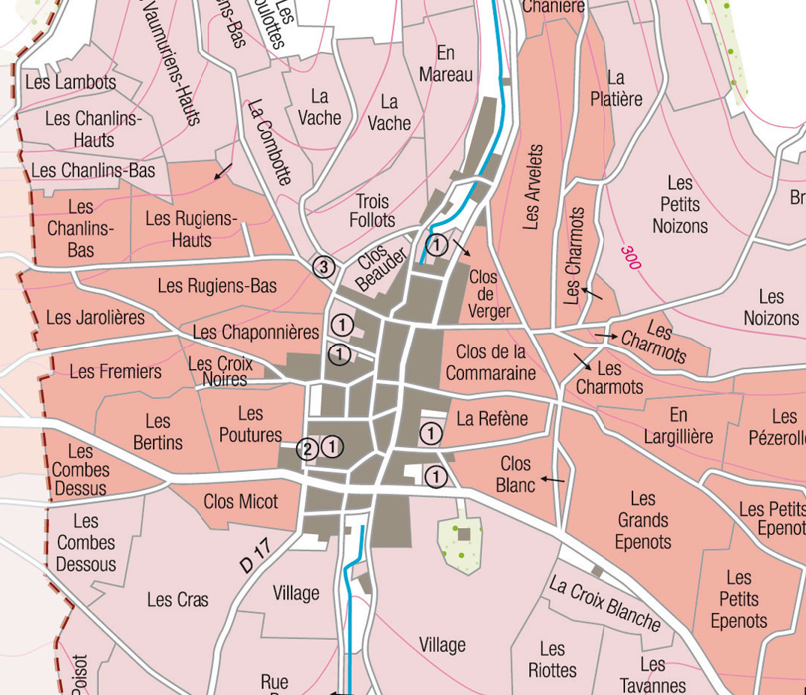
100% Pinot Noir
“Les Chanlins”, a premier cru bordering Volnay, is a continuation of Volnay Pitures (formerly known as Volnay Chanlins), the vineyard is steep with more limestone and pebbles rather than clay, producing classic wines which are typically generous and long lived.
Traditional vineyard management based on sustainability principles.
We engage in selective pruning, along with optimized leaf pulling, green harvest when needed, and ploughing of the soils.
The grapes, once cut, are brought back to the winery within 20 minutes to ensure optimal freshness.
No CMR (carcinogenic, mutagenic, or toxic for reproduction)
100% manual harvesting.

Winemaking
For the winemaking process, we use stainless steel tanks and oak barrels.
Fermentation starts 24h after the vatting and lasts 10 to 12 days.
30% of whole bunch. From 2020, no more pigeage (punch-down), but only a light “foulage” at the end of the fermentation to spread the sugar contained in the berries of the whole bunches. During the fermentation, 2-3 daily pumping over, and 1 daily “delestage”.
Malo-lactic fermentation is done in barrels.
Elevage: The wines are aged between 12 to 18 months in French oak barrel. The oaks come mainly from forests of Chatillonais and Fontainebleau. Maturing lasts 15 to 18 months - 30% in new barrels

Tasting notes
Deep, dark red color with mauve highlights. Aromas of blackberry, bilberry, or gooseberry, cherry pit, blackcurrants and ripe plum. At full maturity, it tends towards leather, chocolate and pepper.
It needs to be given time to open up to its fullest extent and to display its rich texture, its elegant structure, its fruit-filled mouth, and its ripe and smooth tannins.

