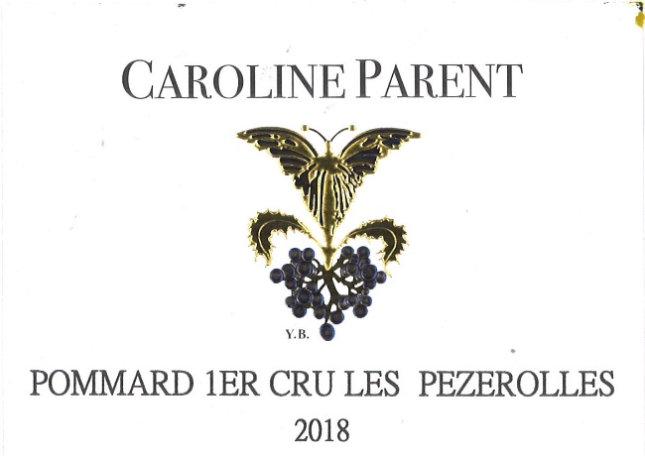
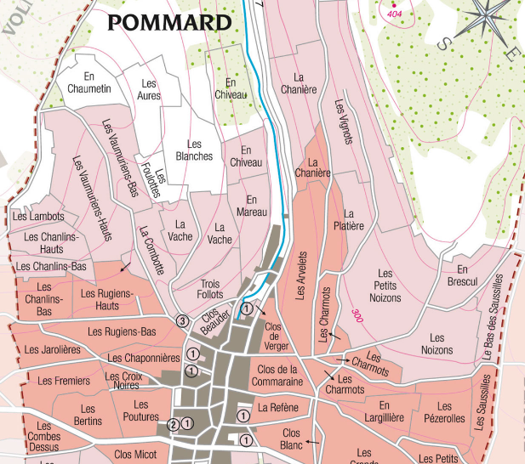
100% Pinot Noir
Our vineyard is located in the Eastern part of the appellation, close to its geological fault. The name comes from the old French "Poizerolles", which meant "chickpeas”, likely cultivated next to the vines in the Middle Ages. Clay-limestone soils with good drainage at an average altitude of 300 meters.
Traditional vineyard management based on sustainability principles.
We engage in selective pruning, along with optimized leaf pulling, green harvest when needed, and ploughing of the soils.
The grapes, once cut, are brought back to the winery within 20 minutes to ensure freshness.
No CMR (carcinogenic, mutagenic, or toxic for reproduction)
100% manual harvesting.

Caroline PARENT Pommard 1er Cru Les Pezerolles

Winemaking
For the winemaking process, we use stainless steel tanks and oak barrels.
Fermentation starts 24h after the vatting and lasts 10 to 12 days.
30% of whole bunch. From 2020, no more pigeage (punch-down), but only a light “foulage” at the end of the fermentation to spread the sugar contained in the berries of the whole bunches. During the fermentation, 2-3 daily pumping over, and 1 daily “delestage”.
Malo-lactic fermentation is done in barrels.
Elevage: The wines are aged between 12 to 18 months in French oak barrel. The oaks come mainly from forests of Chatillonais and Fontainebleau. Maturing lasts 15 to 18 months - 30% in new barrels .

Tasting notes
Its color is the deep, dark red with mauve highlights which caused Victor Hugo to speak of it as “night in combat with day”. Its aromas are redolent of blackberry, bilberry, or gooseberry, cherry pit and ripe plum. At full maturity, after 5 to 10 years of cellaring, it tends towards leather, chocolate and pepper. In exceptional years, the wine can age and improve much longer.

