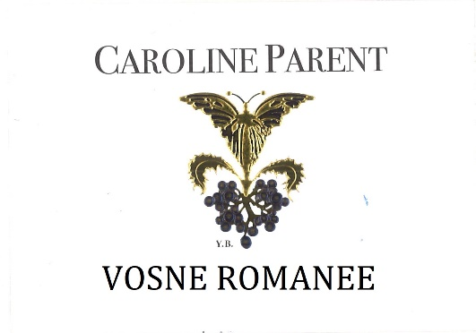
100% Pinot Noir
Our vineyard is located next to Clos des Reas.

The soils are limestones, fine-textured marls, and clays.

Traditional vineyard management based on sustainability principles.
We engage in selective pruning, along with optimized leaf pulling, green harvest when needed, and ploughing of the soils.
The grapes, once cut, are brought back to the winery very rapidly in temperature-controlled trucks.
No CMR (carcinogenic, mutagenic, or toxic for reproduction) used in the vineyard.
100% manual harvesting.

Caroline PARENT Vosne Romanée aux Réas

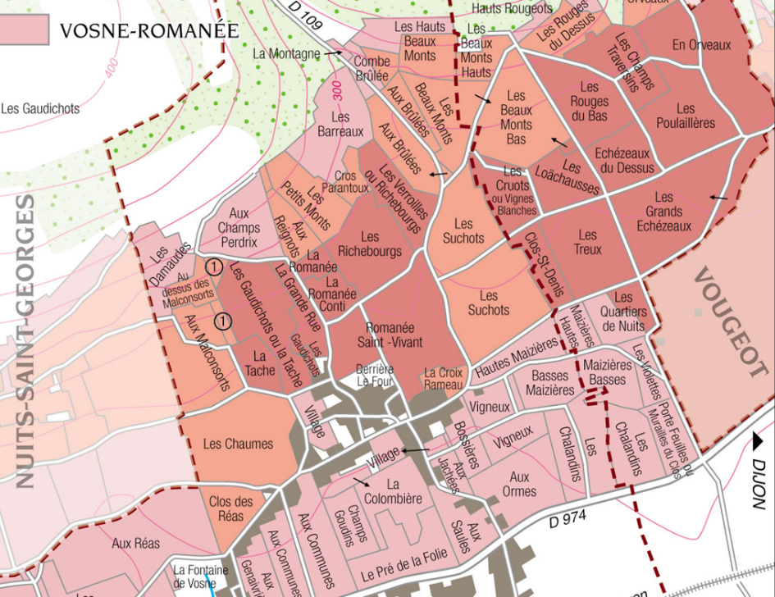
Winemaking
Fermentation starts 24h after the vatting and lasts 10 to 12 days.
30% of whole bunch. From 2020, no more pigeage (punch-down), but only a light “foulage” at the end of the fermentation to spread the sugar contained in the berries of the whole bunches. During the fermentation, 2-3 daily pumping over, and 1 daily “delestage”.
Malo-lactic fermentation is done in barrels.
Elevage: The wines are aged between 12 to 18 months in French oak barrel. The oaks come mainly from forests of Chatillonais and Fontainebleau. Maturing lasts 15 to 18 months - 30% in new barrels.

Tasting notes
Deep color between crimson and purple, dark and luminous. It develops aromas of violet and small fruits (Morello cherry, blackcurrant). When older, it leans towards underbrush, fallen leaves and truffle over animal notes. In the mouth, it has a rich structure, while its tannins are nonetheless delicate. Acidity and chewiness are harmoniously balanced, with licorice in the finish.

