
100% Pinot Noir
Grapes come from long term purchase contracts for 2 parcels « les corvées » and « la Justice » . Monitoring of the vineyard from June until the harvest.
100% Manual harvest
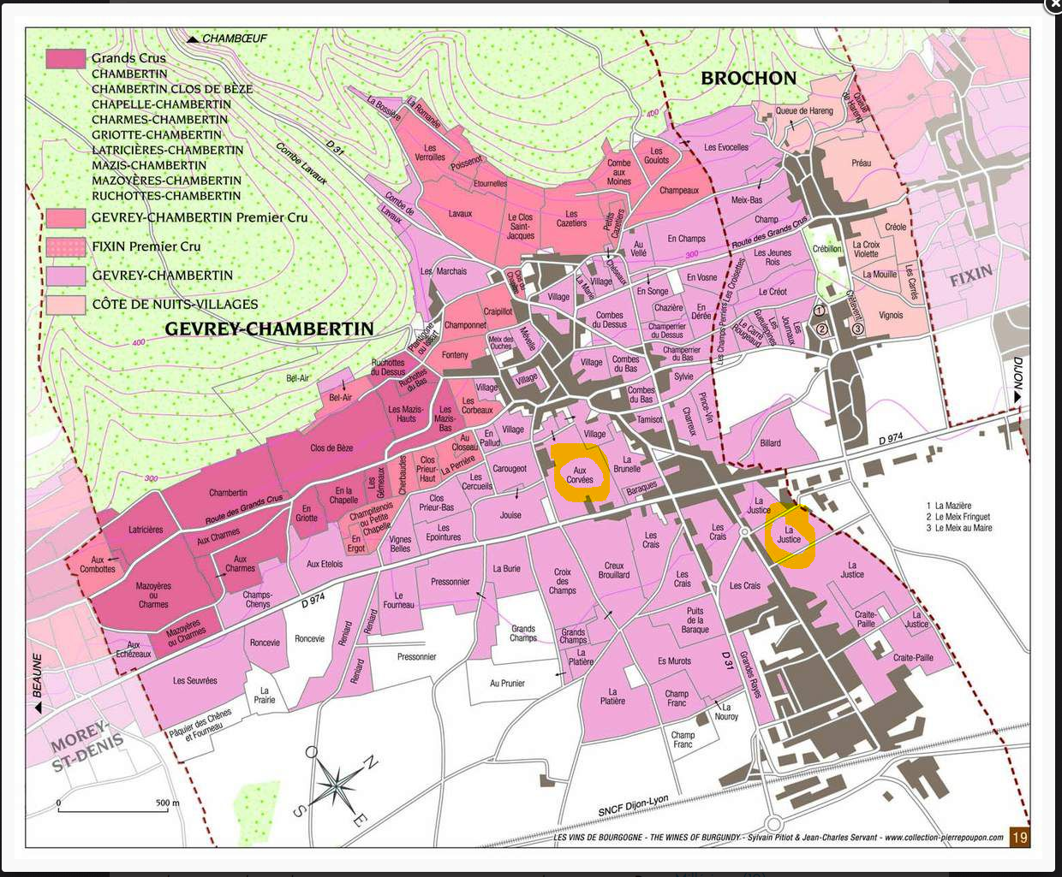
Caroline PARENT Gevrey Chambertin

Winemaking
Fermentation starts 24h after the vatting and lasts 10 to 12 days.

30% of whole bunch. From 2020, no more pigeage (punch-down), but only a light “foulage” at the end of the fermentation to spread the sugar contained in the berries of the whole bunches. During the fermentation, 2-3 daily pumping over, and 1 daily “delestage”.

Malo-lactic fermentation is done in barrels.

Elevage: The wines are aged between 12 to 18 months in French oak barrel. The oaks come mainly from forests of Chatillonais and Fontainebleau. Maturing lasts 15 to 18 months - 30% in new barrels .

