MEURSAULT 2023

CEPAGE : Chardonnay
AREA : 0.93 hectare
SOIL : Limestone/Clay
AGE OF THE VINE : Planted in 1924 and 2011 from assemblage of different lieux dits: Grands charrons, Narvaux and Pellans.
Pruning: 90 % GUYOT
CULTURAL METHOD : The culture of the vineyard is traditional, with careful Human Intervention, focused on observation and sustainability principles. Selective pruning to optimize yield and vigour, along with drastic crown suckering, adapted leaf pulling, green harvest when needed, and ploughing of the soils.
100% Manual harvesting
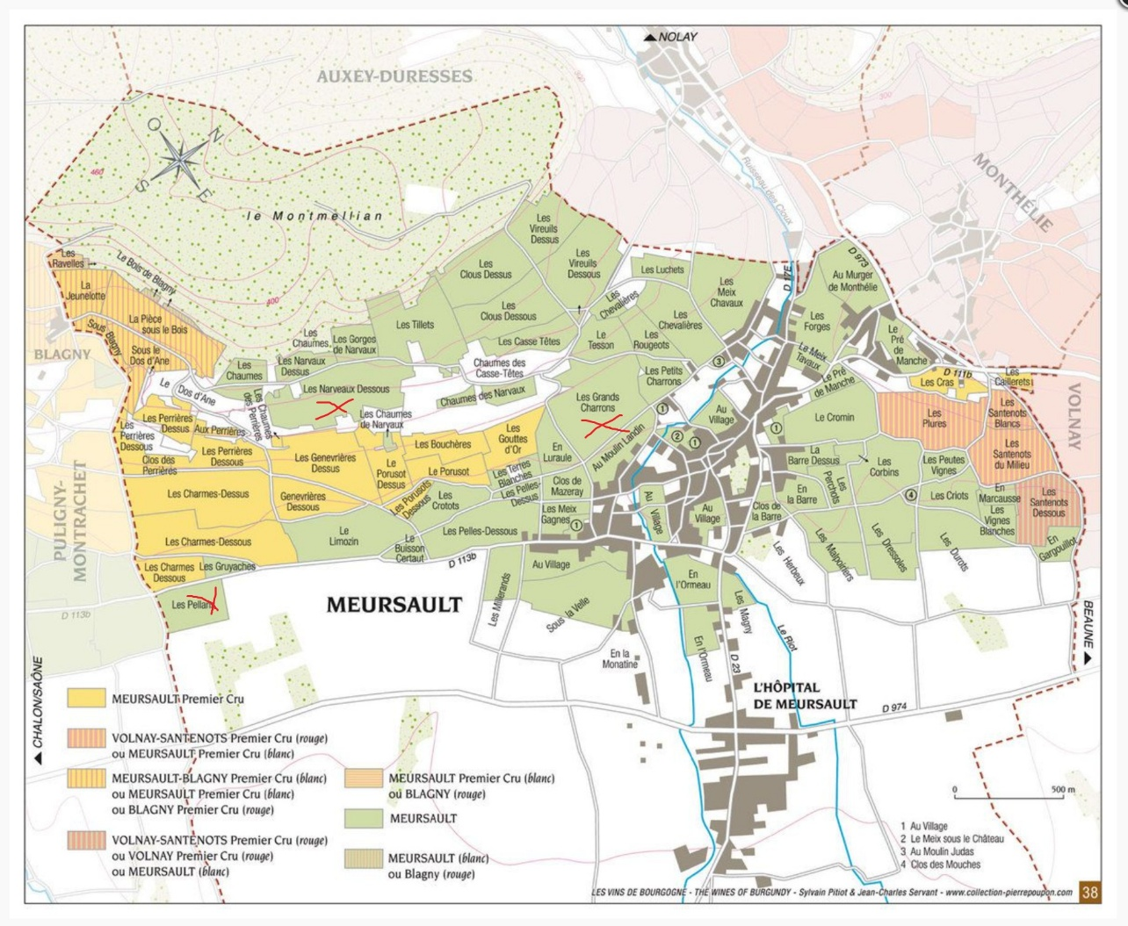
vinification and elevage
The clusters of grapes arrive at the winery in small cases, and in air-conditioned trucks. They are sorted manually then pressed. They are put in barrels where first occurs the alcohol fermentation, then the malolactic fermentation. No stirring of the lees.
Maturing is done for 12 months in oak barrels with few new barrels. Large barrels of 600 l (demi muids) are used. Racking and fining. Then 4 to 6 months in vats (inox cuve). No batonnage.

Tasting note
Intense and brilliant golden appearance. Rich and deep floral aromas with hints of honey. Balanced and persistent on the palate, notes of hazelnuts, acacia blossom, and vanilla.

