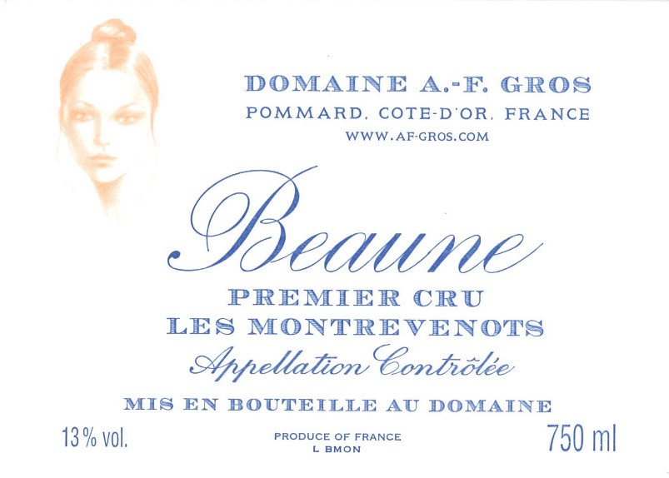

Domaine A.F Gros Beaune 1er Cru Montrevenots Blanc

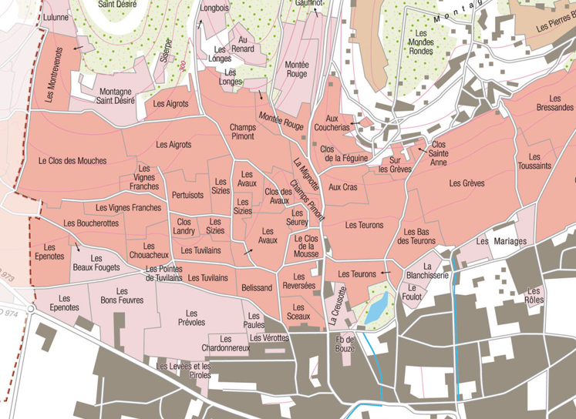
Winemaking

Grapes are rigorously sorted, then slowly pressed for 90 minutes. Racking from the steel tanks where they stay for 48 hours, then to the wood barrels, where the main fermentation immediately starts, followed by malo-lactic fermentation at a temperature between 18 & 20°C. Thereafter the barrels stay in the aging cellar for a year. Usually, fining, no filtration.
Bottling in December. 50% new oak.
50% futs neufs.

La fermentation alcooldémarre de suite puis la fermentation malolactique, les fûts sont laissés à une température de 18 a 20°C pendant cette période.
Ensuite, les fûts sont descendus en cave pendant 1 an.
Collage mais pas de filtration en 2017. Mise en bouteille en décembre.
50% futs neufs.

100% Chardonnay
Montrevenots 1er Cru is located near Pommard, perched on the southern side of the Montagne-Saint-Desire hill. The topography of the site allows the vines to make the most of the a.m. and early p.m. sunshine.
The soil is stony and lime-rich, with white marls – well suited to white wine production. It is near the source of the Lulunne stream.
Traditional vineyard management based on sustainability principles.
Selective pruning, along with leaf pulling, green harvest when needed, and ploughing of the soils.
The grapes, once cut, are brought back to the winery within 20 minutes to ensure freshness.
100% manual harvesting.

Tasting notes
This wine boasts a silky gold colour, flecked with green. It has a bouquet of almond, dried fruits, bracken, and white flowers. It may be enjoyed either young “on the fruit”
or later for its mouth-filling mellowness.

