

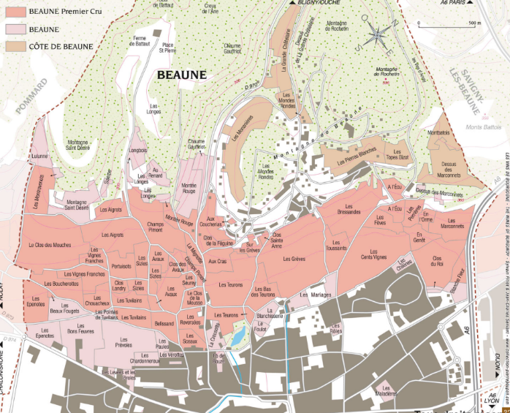
Tasting notes

With notes of violet, black cherry and black currant, and a final touch of wood, the Beaune 1er Cru les Boucherottes from Domaine AF GROS offers a great aromatic strength which predestines it to accompany musky and firm meats such as roasted, or braised game.
Pairs perfectly with Burgundy cheeses like Epoisses, and Soumaintrain.

Winemaking
For the winemaking process, we use stainless steel tanks and oak barrels.
Cold maceration (5°C) is done for about 3-5 days to extract flavor and color. During that time, we do some remontage (pump over) to keep a good contact between solid and liquid parts. After 5 days, the tanks are heated up to 25-30°C for over 10 days.
The wood for the oak barrels come primarily from forests of Chatillonais and Fontainebleau. The wine is aged for an average of 15 months (65% new oak).

100% Pinot Noir

This wine is from the Southern part of the appellation, a 0.30-acre parcel located next to Pommard, at an altitude of 260 meters.
High soil variability; brown limestone soils, white and yellow marls, iron deposits, yellow and red limestone, and clay elements.
We use traditional vineyard management based on sustainability principles.
We engage in selective pruning, along with optimized leaf pulling, green harvest when needed, and ploughing of the soils.
The grapes are brought back to the winery in small cases in less than 20 minutes after they are cut to avoid any tamping down.
No pesticides and no insecticides, use of sexual confusion.
100% manual harvesting.

Domaine A.F Gros Beaune 1er Cru Les Boucherottes

