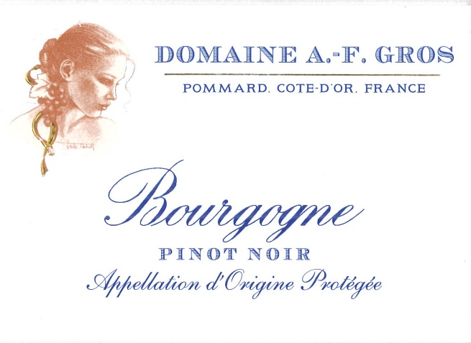
Domaine A.F Gros Bourgogne Pinot Noir

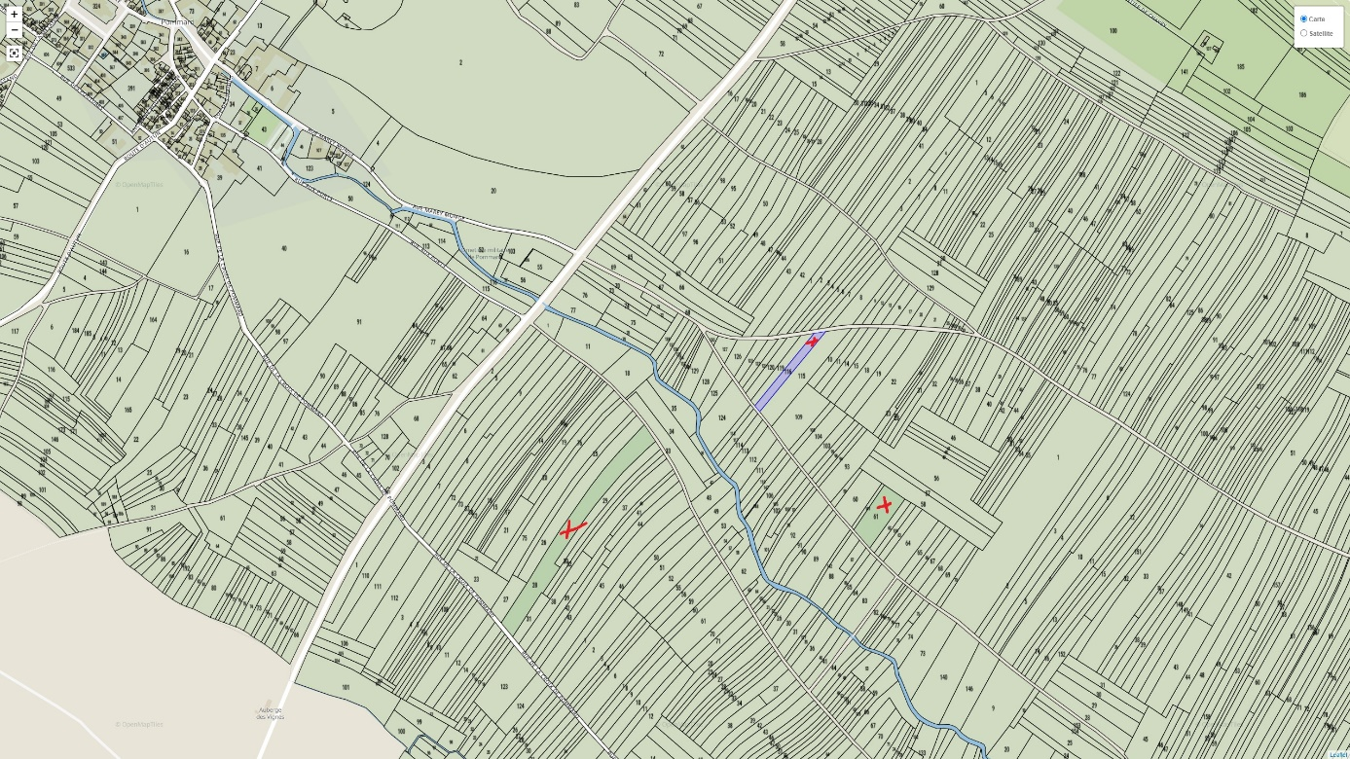
Winemaking
For the winemaking process, we use stainless steel tanks and oak barrels.
Cold maceration (5°C) is done for about 3-5 days to extract flavor and color. During that time, we do some remontage (pump over) to keep a good contact between solid and liquid parts. After 5 days, the tanks are heated up to 25-30°C for over 10 days.
The wood for the oak barrels come primarily from forests of Chatillonais and Fontainebleau. Half of this wine is aged in wood for an average of 12 months (10% new oak).

100% Pinot Noir
Our vineyard is located in the communes of Pommard and Volnay, over 3 parcels which totalize 0.7422Ha. Prior to 1936, these parcels were classified as Pommard AOP.
Traditional alluvial rich soils.

We use traditional vineyard management based on sustainability principles.
We engage in selective pruning, along with optimized leaf pulling, green harvest when needed, and ploughing of the soils.
Because of the altitude, the harvest starts an average 2 weeks after the rest of the estate.
The grapes, once cut, are brought back to the winery in less than 20 minutes. No CMR (carcinogenic, mutagenic, or toxic for reproduction)
100% manual harvesting.

Tasting notes

Rich crimson color at first then, with age, shading towards dark ruby. At first a bouquet of small red and black fruits (strawberry, cherry, blackcurrant, bilberry) later evolving into cooked prune, peppery notes, and notes of animal, underbrush, moss and mushroom. Lively and structured in the mouth with a well-rounded and supple backbone. Tannins and fruit go hand in hand and the chewiness matches the power of the secondary aromas.

