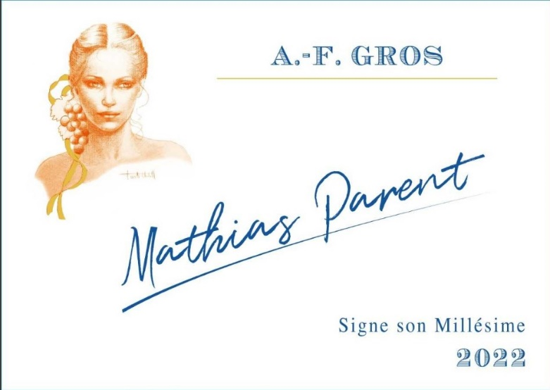
A.F Gros Signature Mathias PARENT
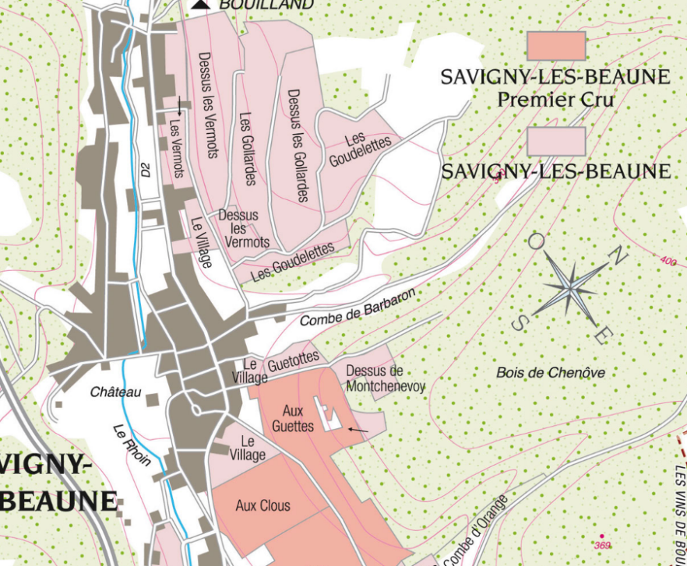

100% Pinot Noir

0.20 Ares located at the bottom part of our 0.67 ha vineyard located in the walled vineyard called “Aux Guettes”; has been spotted outside of the appellations area by the INAO. As a result, we cannot vinify the wine issued from this part along with our Savigny 1er cru le Clos des Guettes (as it was since 1995). We now have to harvest and vinify separately this very tiny parcel. We work it with the same passion and as meticulously as the top part of the Savigny: green harvest when needed, and ploughing of the soils.
The grapes, once cut, are brought back to the winery within 20 minutes to ensure freshness.
No CMR (carcinogenic, mutagenic, or toxic for reproduction) used in the vineyard.
100% manual harvesting.

Wines produced is VSIG

Winemaking
Fermentation starts 24h after the vatting and lasts 10 to 12 days.
100% destemmed in 2022. 25% whole bunches in 2023. During the fermentation, 2-3 daily pumping over, and 1 daily “delestage”.
Malo-lactic fermentation is done in barrels.
Elevage: The wines are aged between 12 to 18 months in French oak barrel. The oaks come mainly from forests of Chatillonais and Fontainebleau. Maturing lasts 15 to 18 months - 30% in new barrels .

