

Domaine A.F Gros Vosne Romanée Maizières
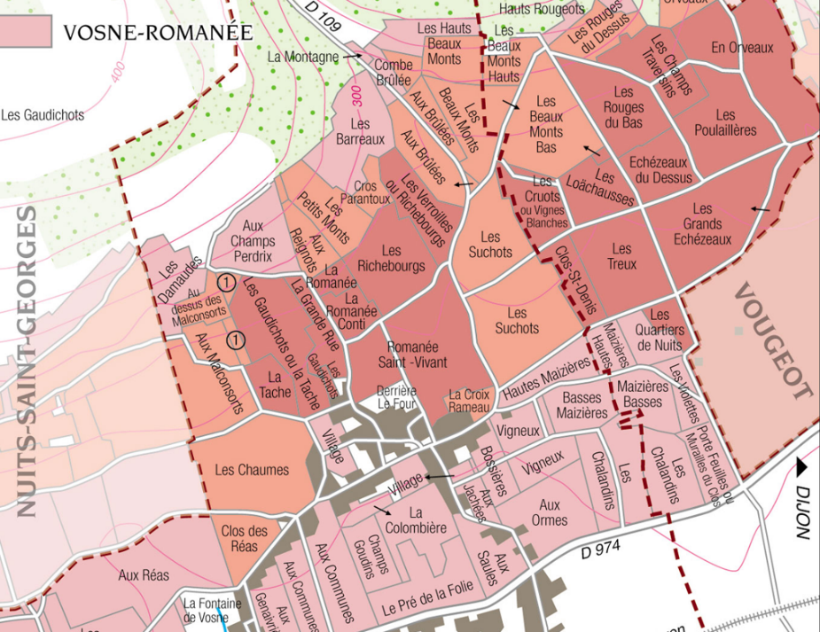
100% Pinot Noir
Our vineyard is located under the Suchots, one of the best climate of VR.
The soils are limestone mixed with clayey marls. Depth of soil varies from some tens of centimeters to 1 meter deep. The exposure is easterly.
Traditional vineyard management based on sustainability principles.
We engage in selective pruning, along with optimized leaf pulling, green harvest when needed, and ploughing of the soils.
The grapes, once cut, are brought back to the winery within 20 minutes to ensure freshness. No CMR (carcinogenic, mutagenic, or toxic for reproduction) used in the vineyard.
100% manual harvesting.

Winemaking
Fermentation starts 24h after the vatting and lasts 10 to 12 days.
30% of whole bunch. From 2020, no more pigeage (punch-down), but only a light “foulage” at the end of the fermentation to spread the sugar contained in the berries of the whole bunches. During the fermentation, 2-3 daily pumping over, and 1 daily “delestage”.
Malo-lactic fermentation is done in barrels.
Elevage: The wines are aged between 12 to 18 months in French oak barrel. The oaks come mainly from forests of Chatillonais and Fontainebleau. Maturing lasts 15 to 18 months - 30% in new barrels .

Tasting notes
Pure ruby color, with ripe fruit and spices in the bouquet, in addition to the red fruit aromas, These refined and well-blended aromas evolve with age into cherries-in-brandy, preserved fruits, leather and fur, and gamey/woodland scents. On the palate the wine is velvety and distinguished - the Pinot Noir at the top of its form. The wine may seem a little austere in its youth; it needs time in the bottle to develop structure and fleshy texture.

