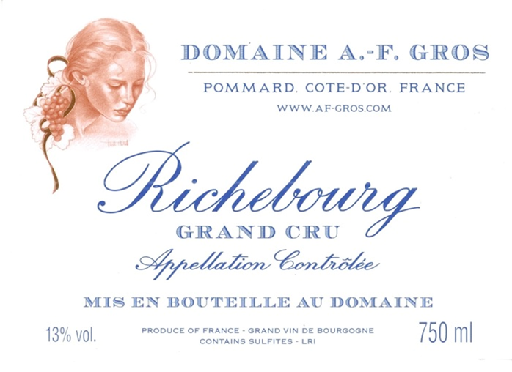

Domaine A.F Gros Richebourg

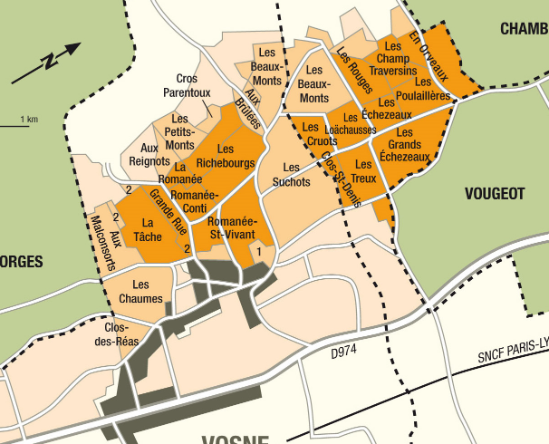
Winemaking
For the winemaking process, we use stainless steel tanks and oak barrels.
Fermentation starts 24h after the vatting and lasts 10 to 12 days.
50% of whole bunch. From 2020, no more pigeage (punch-down), but only a light “foulage” at the end of the fermentation to spread the sugar contained in the berries of the whole bunches. During the fermentation, 2-3 daily pumping over, and 1 daily “delestage”.
Malo-lactic fermentation is done in barrels.
Elevage: The wines are aged between 12 to 18 months in French oak barrel. The oaks come mainly from forests of Chatillonais and Fontainebleau. Maturing lasts 15 to 18 months - 50% in new barrels .

Tasting notes
Deep dark color, with hints of ruby. Bouquet of red fruit, superb mouth-fill. It has a clearly defined structure, full-bodied rather than flowery and at times a little wild.
It will stand aging for as long as 30-50 years. Round, elegant, its mature aromas evoke violet, humus and underbrush. Glorious ambassador of Burgundy’s royal reputation.
100% Pinot Noir
Our 0.472 Ha vineyard is located in the heart of the best appellations of Burgundy.
Vines are 15, 25 and 75 years old.
The sub-soil consists of limestone and white marl under clay-flint soils up to 40 cm in depth on a gently sloping site. The soil is quite light and gravelly, brown or reddish in color. It dates back to the Jurassic period, some 150 million years ago.
Traditional vineyard management based on sustainability principles.
We engage in selective pruning, along with optimized leaf pulling, green harvest when needed, and ploughing of the soils.
The grapes, once cut, are brought back to the winery within 20 minutes to ensure freshness. No CMR (carcinogenic, mutagenic, or toxic for reproduction)
100% manual harvesting.

