Bourgogne Pinot Noir A.F Gros

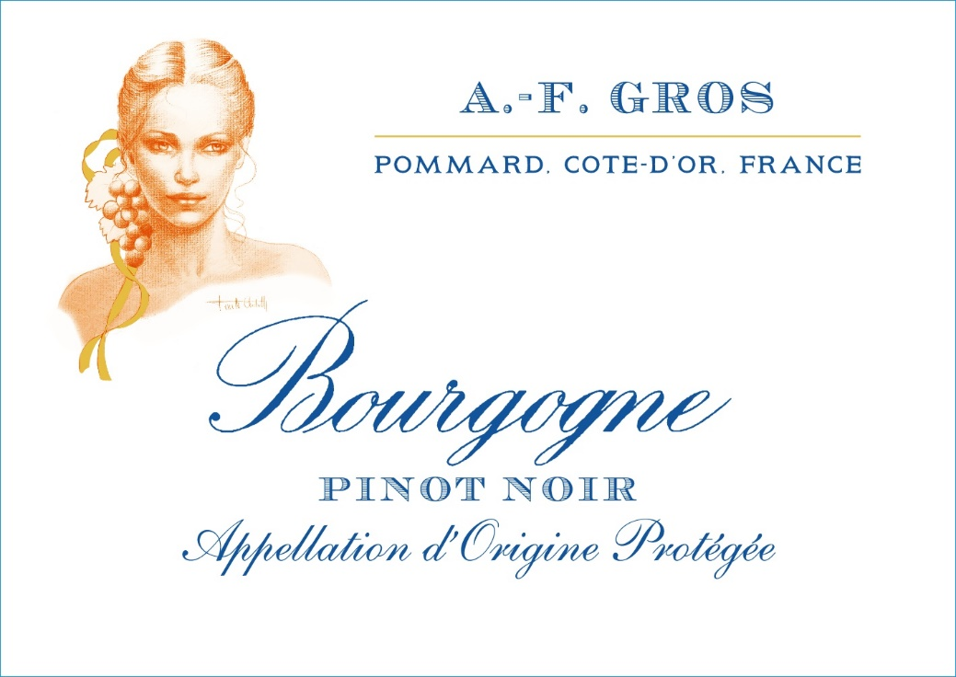
Tasting notes

Rich crimson color at first then, with age, shading towards dark ruby. At first a bouquet of small red and black fruits (strawberry, cherry, blackcurrant) later evolving into peppery notes. Lively and structured in the mouth with a well-rounded and supple backbone.
Winemaking
For the winemaking process, we use stainless steel tanks, ciment tanks and oak vats.
Vinification with 30% whole bunches during 10/12 days. No pigeage only daily pumping over for oxygenation.
The wood for the oak barrels come primarily from forests of Chatillonais and Fontainebleau. Half of this wine is aged in oak barrel for an average of 12 months (10% new oak) and 50% in ceramic Vats.

100% Pinot Noir

Purchase of Grapes from les Maranges

The grapes, once cut, are brought back to the winery in less than 20 minutes.100% manual harvesting.

