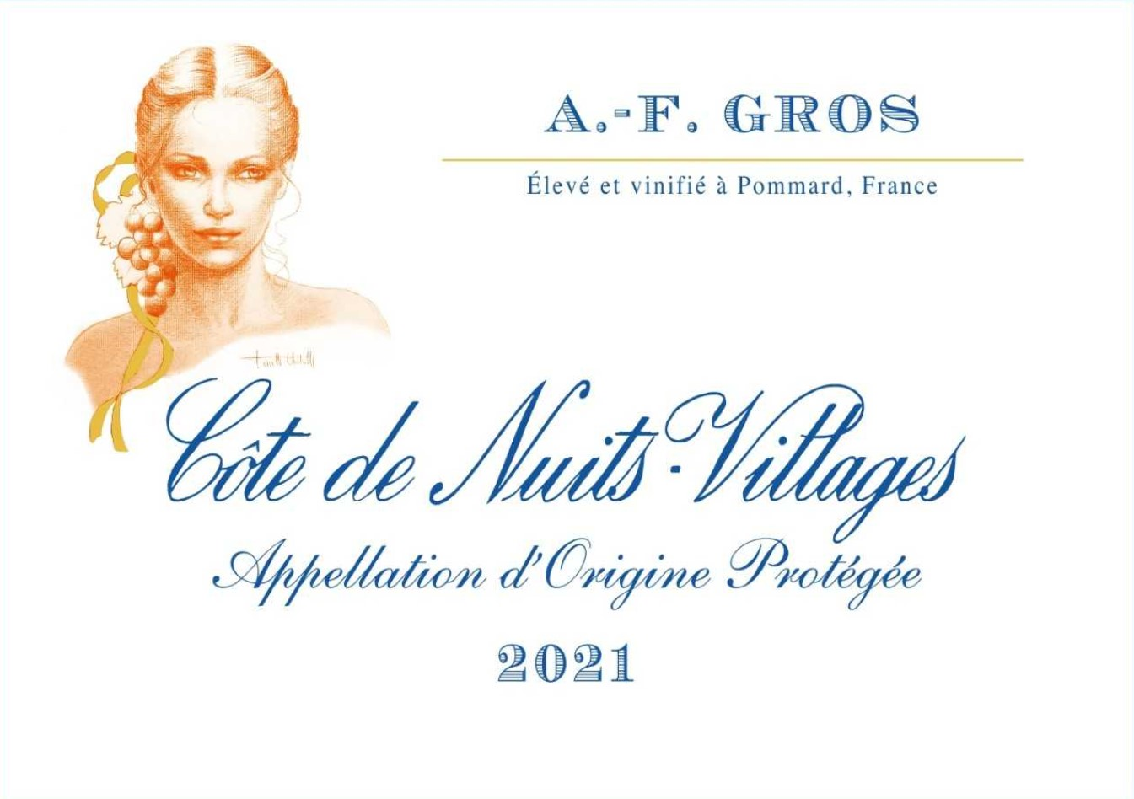
AF GROS Cote de Nuits Villages
Winemaking
For the winemaking process, we use stainless steel tanks and oak barrels. 100% destemmed.
Cold maceration (5°C) is done for about 3-5 days to extract flavor and color. During that time, we do some remontage (pump over) to keep a good contact between solid and liquid parts. After 5 days, the tanks are heated up to 25-30°C for over 10 days.
The wood for the oak barrels come primarily from forests of Chatillonais and Fontainebleau. The wine is aged for an average of 15 months.
30% in new barrels.

100% Pinot Noir

Purchase of Grapes from the village of Corgoloin» . Monitoring of the vineyard from June until the harvest.

100% Manual harvest

