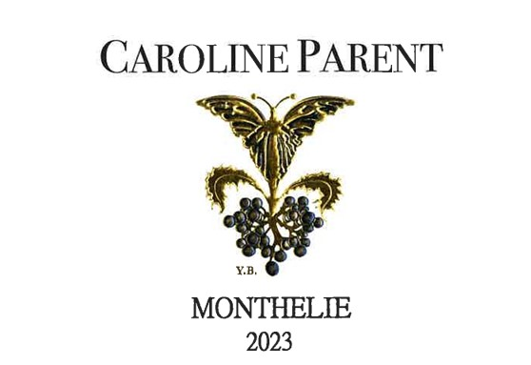
Caroline PARENT MONTHELIE
100% Pinot Noir
Purchase of Grapes – 50% whole bunches-
100% manual harvesting.

Tasting notes
This Monthelie 2023 comes from mineral soils, which lend the wine a clear, precise structure. The nose is fresh and expressive, dominated by red fruit aromas, complemented by delicate floral notes and a subtle herbal touch. On the palate, the wine is balanced and vibrant, with a bright, accessible profile. Best enjoyed after one to two years of bottle ageing, it is intended for relatively early drinking while retaining freshness and finesse.

Winemaking
For the winemaking process, we use stainless steel tanks and oak barrels.
Fermentation starts 24h after the vatting and lasts 10 to 12 days.
50% of whole bunch. From 2020, no more pigeage (punch-down), but only a light “foulage” at the end of the fermentation to spread the sugar contained in the berries of the whole bunches. During the fermentation, 2-3 daily pumping over, and 1 daily “delestage”.
Malo-lactic fermentation is done in barrels.
Elevage: The wines are aged between 12 to 18 months in French oak barrel. The oaks come mainly from forests of Chatillonais and Fontainebleau. Maturing lasts 15 to 18 months - 30% in new barrels .

