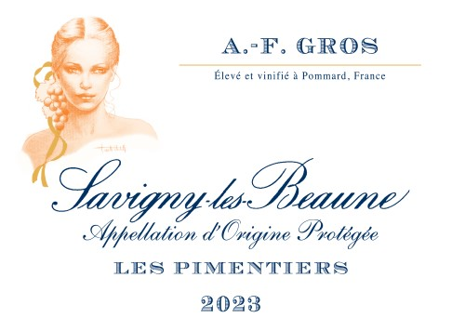
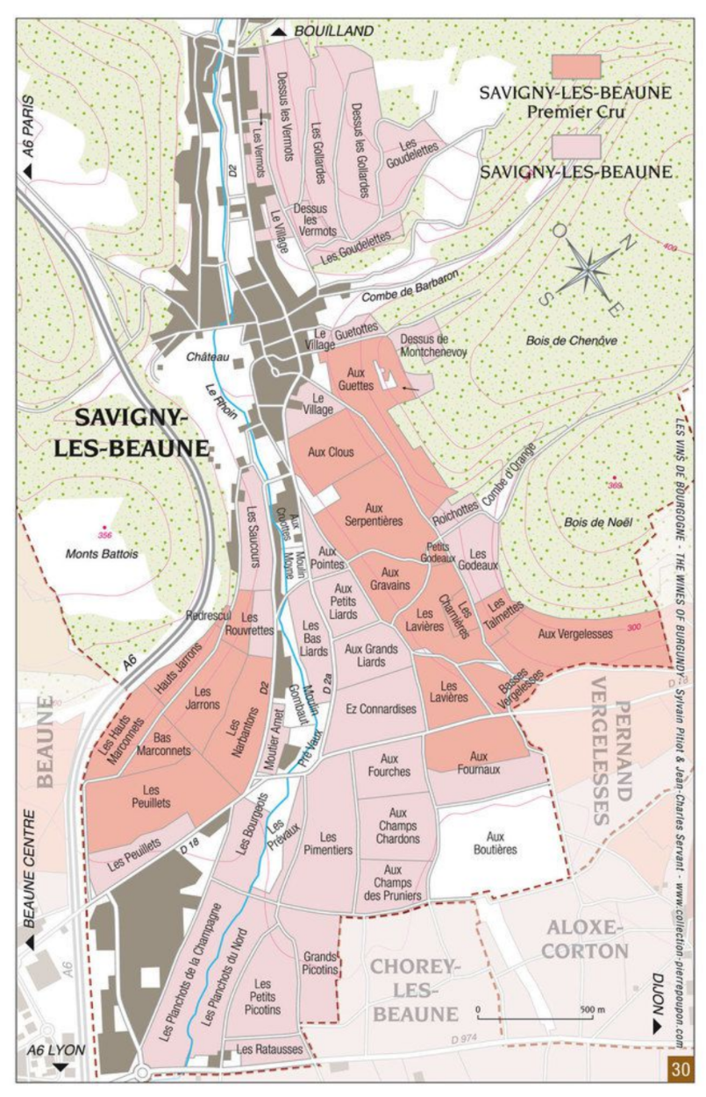
A.F Gros Savigny Les Beaune Les Pimentiers
100% Pinot Noir
Purchase of Grapes – 50% whole bunches-
100% manual harvesting.

Tasting Notes
This Savigny-lès-Beaune “Les Pimentiers” 2023 is grown on rich, heavier soils, giving the wine depth and substance. The aromatic profile is centred on dark fruits, with a generous and structured palate that shows breadth and a certain mass. Whole-cluster fermentation brings an additional layer of complexity, expressed through subtle white floral notes that lift the overall profile. The wine is ample and well-built, with the structure to benefit from several years of cellaring before reaching its full expression.

Winemaking
For the winemaking process, we use stainless steel tanks and oak barrels.
Fermentation starts 24h after the vatting and lasts 10 to 12 days.
50% of whole bunch. From 2020, no more pigeage (punch-down), but only a light “foulage” at the end of the fermentation to spread the sugar contained in the berries of the whole bunches. During the fermentation, 2-3 daily pumping over, and 1 daily “delestage”.
Malo-lactic fermentation is done in barrels.
Elevage: The wines are aged between 12 to 18 months in French oak barrel. The oaks come mainly from forests of Chatillonais and Fontainebleau. Maturing lasts 15 to 18 months - 30% in new barrels .

