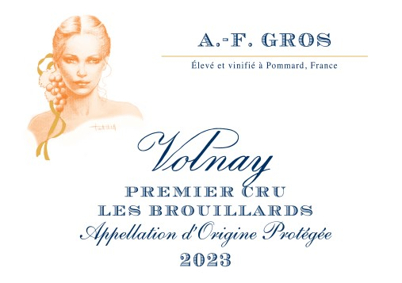
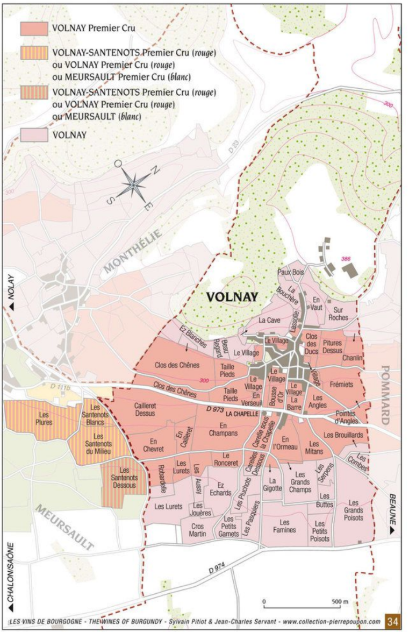
100% Pinot Noir
Purchase of Grapes – 50% whole bunches-
100% manual harvesting.

A.F Gros VOLNAY 1ER CRU LES BROUILLARDS

Winemaking
For the winemaking process, we use stainless steel tanks and oak barrels.
Fermentation starts 24h after the vatting and lasts 10 to 12 days.
50% of whole bunch. From 2020, no more pigeage (punch-down), but only a light “foulage” at the end of the fermentation to spread the sugar contained in the berries of the whole bunches. During the fermentation, 2-3 daily pumping over, and 1 daily “delestage”.
Malo-lactic fermentation is done in barrels.
Elevage: The wines are aged between 12 to 18 months in French oak barrel. The oaks come mainly from forests of Chatillonais and Fontainebleau. Maturing lasts 15 to 18 months - 30% in new barrels .

