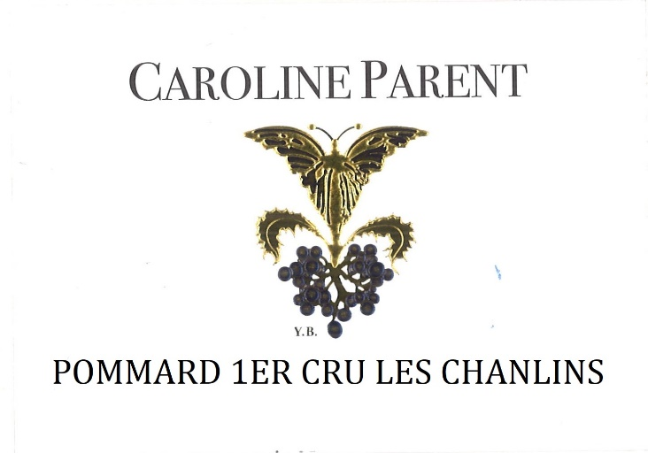

Caroline PARENT Pommard 1er Cru Les Chanlins

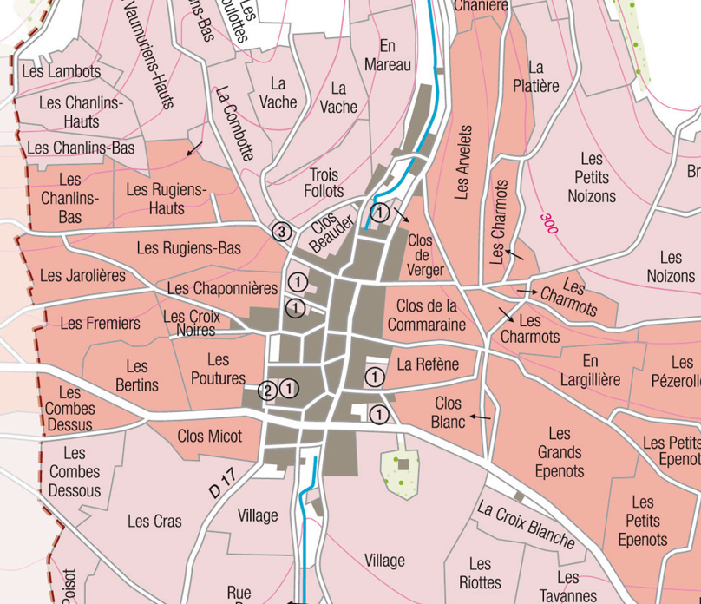
Tasting notes
Deep, dark red color with mauve highlights. Aromas of blackberry, bilberry, or gooseberry, cherry pit, blackcurrants and ripe plum. At full maturity, it tends towards leather, chocolate and pepper.
It needs to be given time to open up to its fullest extent and to display its rich texture, its elegant structure, its fruit-filled mouth, and its ripe and smooth tannins.
100% Pinot Noir
“Les Chanlins”, a premier cru bordering Volnay, is a continuation of Volnay Pitures (formerly known as Volnay Chanlins), the vineyard is steep with more limestone and pebbles rather than clay, producing classic wines which are typically generous and long lived.

Traditional vineyard management based on sustainability principles.
We engage in selective pruning, along with optimized leaf pulling, green harvest when needed, and ploughing of the soils.
The grapes, once cut, are brought back to the winery within 20 minutes to ensure optimal freshness.
100% manual harvesting.

Winemaking
For the winemaking process, we use stainless steel tanks and oak barrels.
Cold maceration (5°C) is done for about 3-5 days to extract flavor and color. During that time, we do some remontage (pump over) to keep a good contact between solid and liquid parts. After 5 days, the tanks are heated up to 25-30°C for over 10 days.
The wood for the oak barrels comes primarily from forests of Chatillonais and Fontainebleau. This wine is aged for an average of 18 months (50% new barrels).

