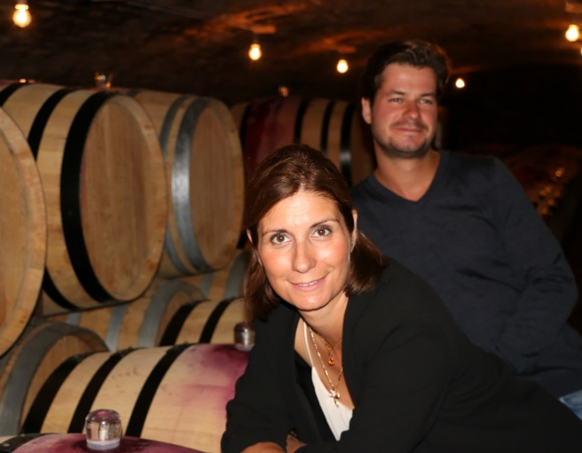
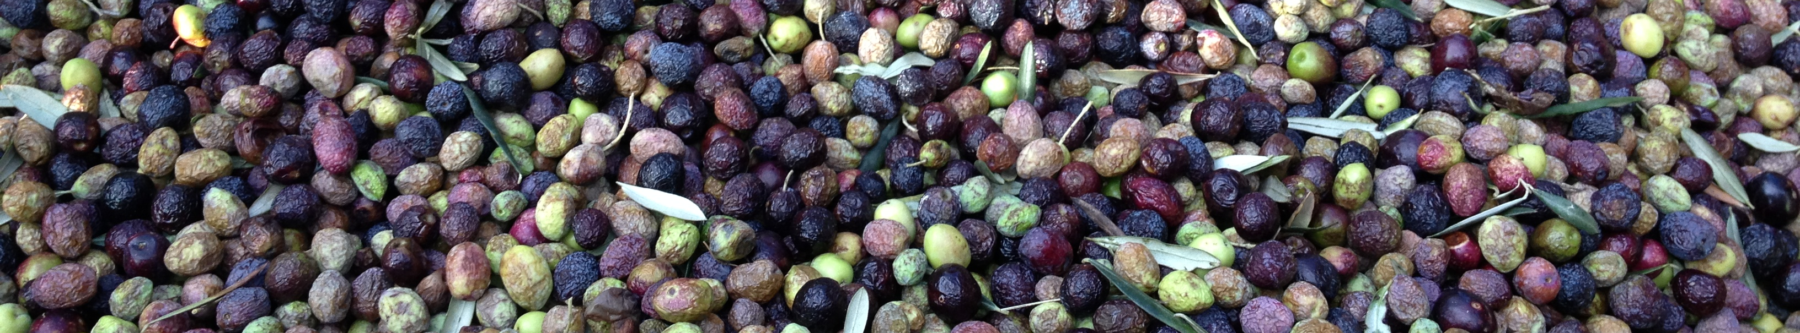
Known and recognized for their great wines of Burgundy, François et Anne-Françoise PARENT-GROS (Domaine AF GROS) have decided to produce, with the same passion and the same attention to detail, their own olive oil coming from their estate in Provence.
Today, it’s up to Mathias and Caroline to perpetuat the tradition.
Their olive grove was planted with a single variety of olives, the Verdale de Carpentras, in 2003 and lies next to a parcel of vines at Camaret sur Aigues in the Vaucluse, facing the mountain chain of the dentelles de Montmirail.
Picking is done by hand between end November and mid-December. The olives are then pressed at the local oil mill following ancestral methods to give birth to an extra virgin oil, totally natural, unfiltered and without added aromas.
As with wines, the richness of the vintage and the terroir create a concentrated olive oil where each harvest is expressed, sometimes through the nuanced notes of citrus and grapefruit, sometimes the remarkable and irresistible notes of truffles.
A real nectar, this Limited Edition in offered in a present box bearing a face emblematic of the Domain, watching over the destiny of a new signature product from AF GROS
