PATRICK GIRARDIN

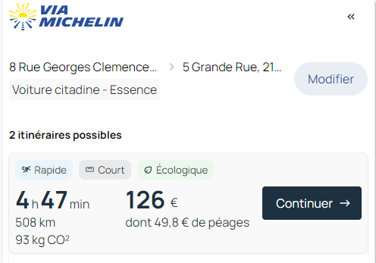

508 x2 = 1016km x 0.636 = 646.176€

