MOULIN A VENT
« En Mortperay »

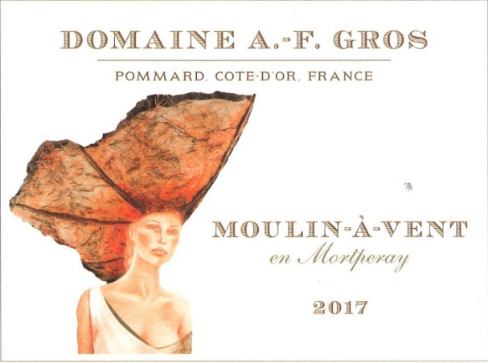
In 2017, Domaine AF GROS bought a parcel of 3.8Ha in Moulin à Vent “en Mortperay ». This is the 1st vintage of this new appellation for the Domaine.
Moulin-à-Vent’s weathered granite soils are thin, with sandy pockets, enriched by high mineral nutrients and a granite bedrock with seams of manganese, copper, iron and other metallic oxides. The eastern and southern exposure of the vineyards maximizes ripening, while the region’s frequent strong winds increase the concentration of the grapes.
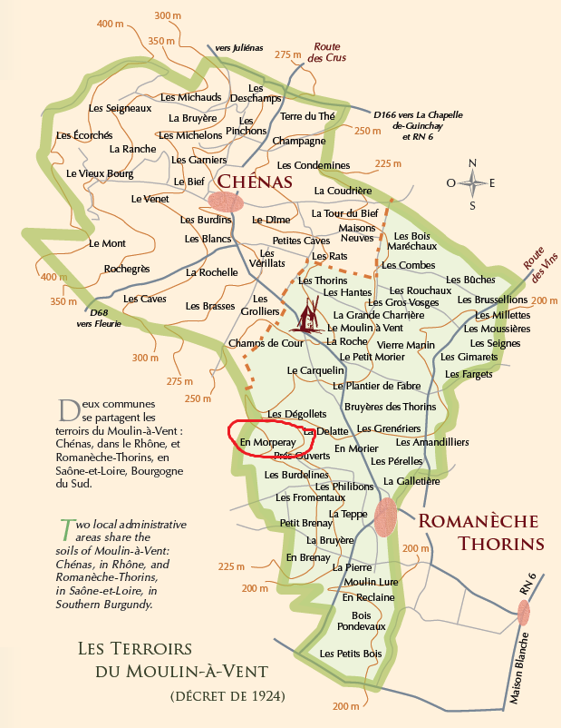
The culture of the soils: The culture of the vineyard is traditional, with careful Human Intervention, focused on observation and sustainability principles. Mathias pays a special attention to viticulture, with selective pruning to optimize yield and vigour, along with adapted leaf pulling, green harvest when needed, and ploughing of the soils.
Harvest and winemaking practices:
The harvest is 100% manual.
The grapes are brought back to the winery in Beaune, in small cases to avoid any tamping down, in temperature controlled trucks.
Strict sorting out, especially for vintage 2017 because of the hailstorm of July 20th which destroyed 70% of the crop.
- In the vineyard,
- With a dynamic sorting table at the arrival in the winery,
For vintage 2017, we put 20% of whole clusters.
The vinification is quite the same as for all our appellations and last about 10 days, with a lot of oxygenation and pumping over.
Wines are decanted during 4-5 days and barrelled.
Elevage is done 100% in barrel of 2-3 years during 7-8 months.

The wines are racked and placed in tanks for the last 3 months of elevage so that the fine lees can settle down.
We check the turbidity of the wines and if necessary, do a light filtration (lenticular filer system: cellulose sheets) but no fining.

The wines are bottled by gravity. We pay attention to order our bottles with a bottleneck of 63 mm to avoid as much as possible leakage of the corks.

