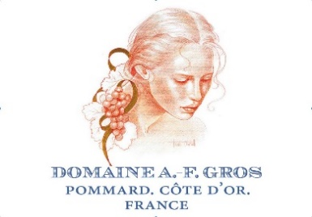

Dom A F Gros, aux Maizières 2011 Vosne-Romanée
Score 17+/20
Lovely mineral qualities, light and gentle but really shows the qualities of the appellation. Something of a scorched earth note. Very distinctive. (RH)
Drink 2015-2025

Dom A F Gros, Grand Cru 2011 Richebourg
Score 17+/20
Ripe but not indulgent red fruit, lip-smacking tannins and finely judged acid. Really long and memorable. Noble and elegant, but as with their Echezeaux, this vintage doesn’t quite express the full potential. (RH)
Drink 2016-2036

Dom A F Gros, Aux Réas 2011 Vosne-Romanée
Score 17/20
Not so evocative as their Maizières bottling, but still captures the gracefulness and poise of the appellation. Savoury and rather tannic on the finish. (RH)
Drink 2016-2026
Dom A F Gros, Les Pézerolles Premier Cru 2011 Beaune
Score 17/20
Dry, quite firm – very Pommard, then! It is gratifying when appellations are true to type. For me, it’s not as enticing as the Vosne-Romanées, but that's is personal bias. (RH)
Drink 2015-2025

Dom A F Gros, Grand Cru 2011 Échezeaux
Score 17/20
Plenty of luscious oak scent, and velvety red fruit in support. Spicy and rich and with just the right tannic complement. Doesn’t soar as high as Échezeaux can, but does have lovely fragrance, and the oak is really attractive. (RH)
Drink 2014-2026

Dom A F Gros, Clos des Guettes Premier Cru 2011 Savigny-lès-Beaune
Score 16.5/20
Earthy, open, satisfying nose – seems very advanced in development. Soft, furry tannins – very approachable. For the impatient! (RH)
Drink 2013-2020

Dom A F Gros, Les Boucherottes Premier Cru 2011 Beaune
Score 16.5/20
Delicate, lifted floral notes. Tannin bites back on the finish, but the mouthwatering acid works well with it. Tight structure but generously fruity in a savoury mode. (RH)
Drink 2013-2023
Dom A F Gros 2011 Chambolle-Musigny
Score 16/20
Classic and typical with tight structure and medium weight. Not terribly exciting, but nicely made and persistent on the finish. (RH)
Drink 2014-2020

Dom A F Gros 2011 Hautes-Côtes de Nuits
Score 15.5/20
Rather less enjoyable than the François Parent Bourgogne. Fruit is less fruity and fun – aimed at a more traditional or gastronomic palate, perhaps? (RH)
Drink 2013-2017

